**Food Delivery System - Documentation**

Requirements Specification

**Group members:**

Ardisa Beqja, David Keci, Era Mulla, Erisa Zaimi, Klea Haxhiu, Greisi Jaho

**Table of Contents**

**1. Executive Summary**

1.1 Project Overview

1.2 Purpose and Scope of this specification

**2. Product/ Service Description**

2.1 Product context

2.2 User Characteristics

2.3 Assumptions

2.4 Constraints

2.5 Dependencies

**3.** **Requirements**

3.1 Functional Requirements

3.2 Non-Functional Requirements

3.2.1 Product Requirements

3.2.1.1 User Interface Requirements

3.2.1.2 Usability

3.2.1.3 Efficiency

3.2.1.3.1 Performance Requirements

3.1.2.3.2 Responsiveness

3.2.1.1 Environmental Requirements

3.2.1.2 Operational Requirements

3.2.1.3 Development Requirements

3.2.3 External Requirements

3.2.3.1 Regulatory Requirements

3.2.3.2 Ethical Requirements

3.2.3.3 Legislative Requirements

3.2.3.3.1 Accounting Requirements

3.2.3.3.2 Security Requirements

3.3 Domain Requirements

**4.Software Design**

4.1 Use Cases

4.2 Use Cases Extended

4.3 BPMN

4.4 Data Flow Diagrams

4.5 Entity-Relationship Diagram

4.6 Activity Diagrams

4.7 State Diagram

4.8 Sequence Diagrams

4.9 Collaboration Diagrams

4.10 Class Diagram

5.Design-Patterns

**1. Executive Summary**

**1.1 Project Overview**

The food delivery industry has seen tremendous growth in recent years, and we aim to capitalize on this trend by providing a high-quality food delivery system that is both efficient and user-friendly. Our system will allow users to easily browse menus, place orders, and track their deliveries in real-time, making the process of ordering food as seamless as possible.

One of the core functionalities of our system is user authentication. This will ensure that only authorized users are able to access the system and place orders. Users will be required to create an account, which will allow them to save their delivery addresses, payment details, and favorite restaurants for future orders. This feature will also enable us to provide personalized recommendations to users based on their order history and preferences.

Another important feature of our system is restaurant search and selection. Users will be able to search for restaurants based on their location, cuisine, and ratings. They will also be able to view menus, reviews, and ratings of the restaurants before placing an order. This feature will allow users to make informed decisions when selecting a restaurant, which will enhance their overall experience with our system. Once a user has selected a restaurant, they will be able to browse the menu and select the items they wish to order. The system will provide users with a detailed description of each item, including ingredients, allergens, and nutritional information. Users will also be able to customize their orders by adding notes or special instructions. Once the user has finalized their order, they will be able to pay for it securely using a variety of payment options.

After the order has been placed, the user will be able to track its status in real-time. They will receive notifications when the order is accepted by the restaurant, when it is being prepared, and when it is on its way for delivery. This feature will provide users with peace of mind, knowing that they can track their orders every step of the way. Once the order has been delivered, the user will be able to rate and review the restaurant and the delivery service. This feature will allow other users to make informed decisions when selecting a restaurant, and it will also help us to improve the overall quality of our system. For restaurant owners and managers, our system will provide a restaurant management interface that will allow them to manage their menus, orders, and delivery settings. This feature will enable them to efficiently manage their operations and provide a high-quality service to their customers.

Finally, we will also provide a delivery management interface that will allow us to manage our fleet of delivery drivers. This feature will ensure that deliveries are made in a timely and efficient manner, and it will allow us to provide a high-quality service to our users.

In summary, our food delivery system will provide a convenient and efficient way for users to order food and for restaurants to manage their orders and delivery settings. With features such as user authentication, restaurant search and selection, menu browsing and item selection, order placement and payment, order tracking and delivery status, user ratings and reviews, restaurant management interface, and delivery management interface, we aim to deliver a user-friendly and reliable system that meets the needs of both customers and restaurant owners/managers.

**1.2 Purpose and Scope of this Specification**

The purpose of this specification is to provide a detailed description of the food delivery system project, its functionalities, and its intended audience. This document is intended for developers, project managers, and stakeholders who are involved in the development of the food delivery system.

Within the scope of these specifications are the requirements and functionalities related to the food delivery system project.

· A detailed description of the product features, including their functions and capabilities.

· A technical overview of the system processes and user interface

· The user and system requirements that have been identified for the product.

· A clear outline of the functional and non-functional components required for the product

· An explanation of how users will access and interact with the product, including specific use cases and scenarios

· Any dependencies or constraints that may impact the development or implementation of the product, such as technical limitations or regulatory requirements.

Out of scope are any requirements or functionalities that are not directly related to food delivery, such as:

· Inventory management: While inventory management is important for restaurants, it may not be directly related to the core functionality of a food delivery system.

· Reservation management: If the system is designed solely for food delivery, then managing reservations would likely be considered out of scope.

· Customer relationship management.

· Legislative requirements for the product

**2. Product/service description**

This software will allow users to communicate effectively with doctors and send photographs of their skin. Because a dermatologist can readily diagnose a skin concern using a photograph, this app will save patient’s time. The user can complete a form and submit the skin photo as well as any other health information that the doctor may require, such as previous medical documents.

The doctor can avoid providing medication that contains chemicals that could induce an allergic reaction in the patient if he or she has access to these files. After the doctor has made the diagnosis, he can contact the patient and issue a printable prescription. If the

patient approves to order the medications from the clinic, then the dermatologist can add the required medications to the patient’s cart, meanwhile the pharmacist will provide further details of the order.

**2.1 Product context**

Food Delivery System is a software that gathers a wide range of food services into one application and makes it easier for those who would like an outdoor meal in their cozy houses. We are creating this application keeping in mind busy individuals, families with young children, allergic people, those who love to keep track of their calories, planned or last-minute gift ideas and anyone who may have difficulty leaving their home.

We provide on our software, features that currently no system on the market provides such as, calorie counter, customizable menus and item description, personalized recommendations, multiple language support, group orders, making our app not only general, but also unique by having extra features.

The system provides a simple, well-organized, fast, and effective system as everyone gets their services in real time. This system is considered an independent system as it operates independently of any specific restaurant or food establishment and requires its own components, such as platform and delivery personnel, to function.

**2.2 User Characteristics:**

A) Customer

- Customers need to be 18+ in order to be provided with the service.

- May be female/male.

- Customers can have any income level, as long as they are able to afford to purchase and order food.

- Customers may have different educational levels, but generally they should be well-educated and have knowledge on how to use these kinds of systems.

- Customers should live and order food in areas where the delivery is possible and available.

- Different customers may have specific food preferences or requirements (vegan, vegetarian, gluten-free).

B) Restaurant

- Restaurants have to be specific about the cuisine options they offer.

- Location of the restaurant is crucial for delivering food to customers.

- The menu of each restaurant needs to be detailed (to have descriptions and pictures of the dish) and also include the price.

- Each restaurant profile needs to have ratings and reviews to help customers into choosing the right restaurant for their order.

C) Delivery person

- The person who will be responsible for the delivery needs to be over 18, female or male.

- Can use different ways of transportation as long as they provide their driver's license and vehicle registration.

- Should have good knowledge of the city and areas where food may be delivered, to take the fastest and safest routes.

- Needs to have good communication skills to interact with the customers.

- Delivery persons need to be healthy and physically fit to handle the job.

D) Administrator

- Administrator of the app should be qualified to maintain and keep the app up and running.

- Must have technical skills such as data analyzing, software development, database management and web technologies.

- They need to have excellent management skills to manage different operations and also the relationships between customers, restaurants and delivery persons.

- Should have good communication skills.

- Needs to be a strategic thinker and planner for the good of the business and app development.

- The admin should have strong problem-solving skills to address every problem the app may face along the way.

**2.3 Assumptions**

- Assumption about User: The food delivery system will be used by a wide variety of customers, including individuals, families, and businesses.

- Assumption about Platform: The food delivery system will be built as a web-based platform that can be accessed from any device with an internet connection.

- Assumption about Food Delivery Partners: The food delivery system will partner with multiple restaurants and food establishments to offer a diverse range of cuisines and menu items.

- Assumptions about Payment Methods: The food delivery system will offer a variety of payment methods, including credit/debit cards, PayPal, and other popular payment systems.

- Assumption about Delivery Range: The food delivery system will have a specified delivery range, beyond which orders will not be accepted.

- Assumptions about Delivery Time: The food delivery system will guarantee a certain delivery time, with options for express delivery at an additional cost.

- Assumption about Order Tracking: The food delivery system will allow users to track their orders in real-time, from preparation to delivery.

- Assumptions about Customer Service: The food delivery system will provide excellent customer service, with options for contacting support via phone, email, or live chat.

**2.4 Constraints**

The system will potentially have the following constraints:

**● Time**

The time available for building this project is twelve weeks. This amount of time will be split into pieces for different tasks like planning, modeling, developing which will take the most of it, meetings with the stakeholders (which will cost at minimum 3 hours per week) or the client and recreating parts of the project.

● **Budget**

The budget for this project consists of these important aspects:

The number of stakeholders: Our projects have six stakeholders which are writing the documentation, three developers, one program tester and one administrator for the system.

Equipment: Equipment needed for the project of creating an OS in “Food Delivery Service”, are 9 “hp”,” Dell” Laptops, one printer for the documents needed, requirements for other stakeholders.

Money: Money budget is $9800 +-, depending on the prices of the laptops and the need for more working people.

● **Technology**

The development team has the latest technology available on their laptops, or

language versions.

● **Scope**

This “Food Delivery Service”, will allow the user to order food online, pay by different methods, chat with the restaurant or delivery person, reserve a table in the restaurant, create their own profile with available recipes, diets or caloric-deficit counter, make gifts for their family or friends, make collaborations with other businesses or advertise this own business. A more detailed description is available in 3 1.2 sections.

● **Integration**

The system must integrate with the second-hand banks which will make the payment available through the credit cards.

● **Quality**

The quality of this project is of a high level since it will be tested by our program tester.

● **User Experience**

The software will be understandable for every type of user +18 years old. The reason for this minimum age is because it has to do with credit cards or working people in Albania. The requirements are simple and the software is designed in a way that attracts the eye of the user.

**2.5 Dependencies**

1. Internet connectivity - The system needs a good internet connection to work properly. This means that users need to have access to a stable internet connection to use the platform. Without a reliable internet connection, the platform won't be able to function as intended.

2. Location services - The system uses location services to find nearby restaurants that can deliver food to the user's location. This means that the platform needs permission to access the user's location to provide accurate information about nearby restaurants and their availability.

3. Payment processing systems - The system uses secure payment processing systems to allow users to pay for their orders safely and quickly. This means that the platform needs to integrate with trusted payment providers to ensure the safety and security of user financial information.

4. Database management systems - The system stores information about users, restaurants, menus, and orders in a database so it can be easily accessed and managed. This means that the platform needs a reliable and efficient database management system to store and manage all this data securely.

5. Delivery personnel - The system needs delivery drivers to deliver the food to customers. This means that the platform needs to partner with reliable delivery partners who can deliver orders promptly and efficiently.

6. Customer service support - The system has customer support available to help users with any problems or questions they have. This means that the platform needs to have trained customer support representatives who can address user concerns and issues effectively.

7. Third-party software integrations - The system may use other software tools to improve its performance and user experience. This means that the platform needs to integrate with third-party software solutions such as chatbots, recommendation engines, and social media platforms to enhance its functionality and improve the user experience.

8. Product inventory management systems - The system needs a way to make sure that restaurants have enough supplies to fulfill orders. This means that the platform needs to integrate with inventory management systems to keep track of restaurant supplies and ensure they have enough inventory to fulfill orders.

9. Restaurant partners - The system depends on partnerships with restaurants to provide food options to customers. This means that the platform needs to establish reliable and trustworthy relationships with restaurant partners to ensure a steady supply of food options for users.

10. User participation and engagement - The system needs users to place orders and give feedback to improve. This means that the platform needs to encourage user participation and engagement, such as by offering promotions, discounts, and loyalty programs.

11. System maintenance and updates - The system needs to be maintained and updated regularly to keep it working well and secure. This means that the platform needs to have a team of developers and IT professionals who can maintain and update the platform regularly to fix bugs, address security vulnerabilities, and add new features and functionality.

**3. Requirements**

**3.1 Functional Requirements**

|  |  |  |  |  |  |
| --- | --- | --- | --- | --- | --- |
| No. | Requirements | Comment | Priority | Date | Made By |
| 1. | The system must display menus for multiple restaurants. | The system must be able to display menus, enabling users to select from a variety of options | 1 | 16/04/2023 | Erisa Zaimi  Klea Haxhiu |
| 2. | The system shall allow customers to search for specific dishes by name or category. | The system must provide users with the ability to browse from different categories. | 2 | 16/04/2023 | Erisa Zaimi  Klea Haxhiu |
| 3. | The system should display details including descriptions and prices. | The system should display comprehensive information. | 1 | 16/04/2023 | Erisa Zaimi  Klea Haxhiu |
| 4. | The system must allow customers to add or remove dishes/orders from the cart. | It gives the customer the flexibility on making changes to their order. | 1 | 16/04/2023 | Erisa Zaimi  Klea Haxhiu |
| 5. | The system must allow customers to specify the quantity of each dish in the cart. | It enables customers to order multiple quantities of a specific order. | 1 | 16/04/2023 | Erisa Zaimi  Klea Haxhiu |
| 6. | The system should allow customers to modify their orders before finalizing them. | It enables the customers to make changes to their orders until a certain point in the ordering process. | 1 | 16/04/2023 | Erisa Zaimi  Klea Haxhiu |
| 7. | The system should prompt the customers for their delivery address and contact information. | It enables the delivery of the order to the correct location. | 2 | 16/04/2023 | Erisa Zaimi  Klea Haxhiu |
| 8. | The system should allow the customer to select from multiple payment options. | It enables customers to pay for their orders using a variety of payment methods. | 2 | 16/04/2023 | Erisa Zaimi  Klea Haxhiu |
| 9. | The system must provide a confirmation of the order to the customer. | It receives assurance to the customers that their order has been received and is being processed. | 1 | 16/04/2023 | Erisa Zaimi  Klea Haxhiu |
| 10. | The system must notify the restaurant of the order and its details. | A notification to begin preparing the order. | 1 | 16/04/2023 | Erisa Zaimi  Klea Haxhiu |
| 11. | The system should allow the restaurant to update the order status. | It enables information for the customers on the progress of their orders. | 1 | 16/04/2023 | Erisa Zaimi  Klea Haxhiu |
| 12. | The system must be capable of real-time order tracking. | It enables customers to track the progress of their orders in real-time. | 3 | 16/04/2023 | Erisa Zaimi  Klea Haxhiu |
| 13. | The system must provide accurate information about the status of the order. | It enables the customers to know when their food will be delivered. | 1 | 16/04/2023 | Erisa Zaimi  Klea Haxhiu |
| 14. | The system should enable the customers to contact the delivery personnel. | Customers can contact the delivery personnel in case of any concern related to the delivery. | 1 | 16/04/2023 | Erisa Zaimi  Klea Haxhiu |
| 15. | The system must provide the user with a choice of transportation modes. | The transportation modes include walking, motorbike, or car. | 3 | 16/04/2023 | Erisa Zaimi  Klea Haxhiu |
| 16. | The system must display the prices for each transportation mode. | It allows the customer to increase or decrease the price by selecting different options. | 1 | 16/04/2023 | Erisa Zaimi  Klea Haxhiu |
| 17. | The system must enable customers to choose a specific date and time for delivery. | It allows the customers to adjust the delivery date, time. | 1 | 16/04/2023 | Erisa Zaimi  Klea Haxhiu |
| 18. | The system must support delivery scheduling for larger orders. | It allows the customers to specify special delivery instructions or requirements. | 2 | 16/04/2023 | Erisa Zaimi  Klea Haxhiu |
| 19. | The system must display all payment information clearly and accurately to the user, including transaction history and receipts. | It helps build trust and confidence in the system. It ensures that users have access to payment-related info, which can be important for record-keeping | 1 | 16/04/2023 | Erisa Zaimi  Klea Haxhiu |
| 20. | Users are required to create an account to leave a review. | This allows us to verify the authenticity of the reviews and prevent spam or fake reviews. | 2 | 16/04/2023 | Erisa Zaimi  Klea Haxhiu |
| 21. | Users are required to create an account to leave a review. | This allows us to verify the authenticity of the reviews and prevent spam or fake reviews. | 2 | 16/04/2023 | Erisa Zaimi  Klea Haxhiu |
| 22. | The system should notify the restaurants or delivery personnel when they receive new reviews. | This will notify the restaurants and the delivery personnel on what they should improve or keep up with by receiving honest reviews from the clients. | 2 | 16/04/2023 | Erisa Zaimi  Klea Haxhiu |
| 23. | Implement a moderation system to review and approve all reviews. | We make sure that what we post meets our guidelines and is not inappropriate. | 2 | 16/04/2023 | Erisa Zaimi  Klea Haxhiu |
| 24. | The system must provide clear and easily accessible contact information for customer support. | We make sure that the software is practical and adaptable for all. | 2 | 16/04/2023 | Erisa Zaimi  Klea Haxhiu |
| 25. | Ensure that the data is kept confidential and secure. | Any personal information is only used for the purpose of resolving the customer's issue. | 1 | 16/04/2023 | Erisa Zaimi  Klea Haxhiu |
| 26. | The system provides reward options, discounts on future orders, free items, or promotions. | We value and appreciate our loyal customers. | 3 | 16/04/2023 | Erisa Zaimi  Klea Haxhiu |
| 27. | The app must offer a rewards program that incentivizes users to order from the app frequently. | This will increase the usage of the app. | 3 | 16/04/2023 | Erisa Zaimi  Klea Haxhiu |
| 28. | Users must be able to search for discounts or filter search results by discounts. | It must be easy for the customers to surf in the system so they get informed and find what they desire. | 3 | 16/04/2023 | Erisa Zaimi  Klea Haxhiu |
| 29. | The app must allow users to share their food orders on popular social media platforms. | Everyone may be able to share their experience. Sharing must be easy and intuitive. | 2 | 16/04/2023 | Erisa Zaimi  Klea Haxhiu |
| 30. | The system should display ratings and reviews, so the users can easily see them. | They should be sorted by date or helpfulness, so it makes it easier for the customers to get an idea of our service. | 2 | 16/04/2023 | Erisa Zaimi  Klea Haxhiu |
| 31 | The app shall allow users to reserve a table. at any date or hour. | It gives the user the flexibility to reserve a table. | 1 | 16/04/23 | David Keçi  Greisi Jaho |
| 32 | The app shall allow the restaurant to post available dates and hours for reservations. | We make sure that the user gets the needed information about the available dates and hours. | 2 | 16/04/23 | David Keçi  Greisi Jaho |
| 33 | The restaurant shall be able to view and manage reservations made through the app. | We make sure that the restaurant is allowed to manage the reservation and accept or decline them. | 2 | 16/04/23 | David Keçi  Greisi Jaho |
| 34 | The app should allow the user to search depending on prices, most visited restaurants, and best-rated restaurants. | We make sure that the user can have the flexibility of searching about a restaurant depending on their preferences on prices, popularity, or else. | 1 | 16/04/23 | David Keçi  Greisi Jaho |
| 35 | The app should allow the user to unite a group order in only one and split the bill. | We make sure that the users can order different meals, group the order and split the bill. | 1 | 16/04/23 | David Keçi  Greisi Jaho |
| 36 | The app should allow the user to apply for the lucky bill once a year, so the user can win the big price. | We make sure that the user experiences the lucky bill, once a year and wins one of our prices. | 3 | 16/04/23 | David Keçi  Greisi Jaho |
| 37 | The app must allow customers to order food using smart devices such as Alexa, Google, or Apple Watch. | We make sure that the system is integrated with smart devices such as Alexa, Google, etc. | 1 | 16/04/23 | David Keçi  Greisi Jaho |
| 38 | The app must provide restaurant owners with a dashboard to manage their menus, and prices. | We make sure that the restaurant has the ability to manage their orders by controlling them in the dashboard provided. | 1 | 16/04/23 | David Keçi  Greisi Jaho |
| 39 | The app must provide restaurant owners with a dashboard to manage their availability, and order history. | We make sure that the restaurant has the ability to manage their reservations by controlling them in the dashboard provided. | 1 | 16/04/23 | David Keçi  Greisi Jaho |
| 40 | The app should provide a dashboard for delivery personnel to track their earnings and performance. | We make sure that the delivery personnel has the ability to manage their earnings and performance by tracking them in the dashboard provided. | 2 | 16/04/23 | David Keçi  Greisi Jaho |
| 41 | The app should provide a dashboard for delivery personnel to track their metrics such as on-time deliveries and customer ratings**.** | We make sure that the delivery personnel has the ability to manage their deliveries, and addresses by controlling them in the dashboard provided. | 2 | 16/04/23 | David Keçi  Greisi Jaho |
| 42 | The app must allow the administrator to maintain and update the food delivery platform. | We make sure that the app gives the administrator the ability to manage and update the food delivery platform. | 1 | 16/04/23 | David Keçi  Greisi Jaho |
| 43 | The app should allow customers to request customized packaging and labeling for their orders, such as adding a personal message or instructions for the delivery personnel. | We make sure that the system allows the user to give packing and order specifications such as customized packing or specific details. | 3 | 16/04/23 | David Keçi  Greisi Jaho |
| 44 | The app should allow the administrator to manage restaurants on the platform, ensuring their compliance with system standards and updating menus and prices. | We make sure that the system allows the administrator to manage restaurants depending on their standards, performance, or ratings. | 1 | 16/04/23 | David Keçi  Greisi Jaho |
| 45 | The app should allow the administrator to manage the delivery personnel, ensuring that they are properly trained and equipped to deliver orders on time. | We make sure that the system allows the administrator to manage the delivery personnel depending on their performance, work, and ratings. | 1 | 16/04/23 | David Keçi  Greisi Jaho |
| 46 | The app should suggest meals personalized for users. | This makes it easier for users to choose their meals. | 2 | 16/04/23 | Ardisa Beqja  Era Mulla |
| 47 | The system should provide the users with suggested meals based on their most frequent orders. | This would help the users in ordering something faster. | 1 | 16/04/23 | Ardisa Beqja  Era Mulla |
| 48 | The app should allow users to create gift meals by combining different things from multiple restaurants. | This would help to have all orders gathered into one when having different cravings. | 3 | 16/04/23 | Ardisa Beqja  Era Mulla |
| 49 | The system must include the price of each product put into the gift meals by the user. | This would help the users to know how much their order will cost at the end. | 1 | 16/04/23 | Ardisa Beqja  Era Mulla |
| 50 | R_28IIf users want to create meals by collecting from more than one restaurant, the system should make it possible by paying extra for the costs. | This would help the (users) restaurants and benefit them from gift meals. | 2 | 16/04/23 | Ardisa Beqja  Era Mulla |
| 51 | The users should choose items from different shops and add or remove them from the cart. | This would help to make the experience easier. | 1 | 16/04/23 | Ardisa Beqja  Era Mulla |
| 52 | The app must offer customizable menus for users who want to make changes to the dishes. | This would be very helpful for users who are allergic or have dietary restrictions. | 1 | 16/04/23 | Ardisa Beqja  Era Mulla |
| 53 | The system must show each product's calories to the user. | It enables the user with the right necessary information to watch the calories when having a diet and not only. | 3 | 16/04/23 | Ardisa Beqja  Era Mulla |
| 54 | The users should put the amount of desired calories they want for their meal. | It helps the user to search for and decide on their meal faster. | 2 | 16/04/23 | Ardisa Beqja  Era Mulla |
| 55 | The app must add all the calories of food the users put into the cart and make it visible to them. | This would help in knowing how many calories the whole order has. | 2 | 16/04/23 | Ardisa Beqja  Era Mulla |
| 56 | The app must allow users, in this case, restaurants, the opportunity to advertise their business. | It enables restaurants to advertise their business on the first or second page by paying an extra amount of money. | 3 | 16/04/23 | Ardisa Beqja  Era Mulla |
| 57 | The app must have a messaging or chat feature that allows customers to communicate directly with delivery personnel | Allowing customers to communicate with delivery personnel can greatly enhance the overall customer experience by providing a means to address any changes or special requests | 1 | 16/04/23 | Ardisa Beqja  Era Mulla |
| 58 | The app must notify delivery personnel in real-time of any changes or special requests made by the customer and provide them with clear instructions on how to proceed with the updated order. | Real-time notification of changes or special requests made by customers, along with clear instructions for delivery personnel, can help ensure accurate and timely deliveries and improve overall customer satisfaction. | 2 | 16/04/23 | Ardisa Beqja  Era Mulla |
| 59 | The app must have a messaging or chat feature that enables customers to communicate directly with delivery personnel. This feature should be easy to use and accessible from the app's main interface. | Providing an easy-to-use messaging or chat feature that allows customers to communicate directly with delivery personnel can help ensure timely and accurate deliveries | 2 | 16/04/23 | Ardisa Beqja  Era Mulla |
| 60 | The app must ensure that customer messages are delivered to delivery personnel in real-time to facilitate quick and accurate responses to changes or special requests. This may involve integrating push notifications or | Real-time messaging technologies can ensure that delivery personnel are promptly notified of any changes or special requests made by customers | 2 | 16/04/23 | Ardisa Beqja  Era Mulla |
| 61 | The app must provide clear guidelines for customers regarding what types of changes or special requests can be accommodated, and what the appropriate process is for making such requests. This information should be easily accessible within the app. | It can help manage customer expectations, improve order accuracy, and reduce confusion or misunderstandings during the ordering and delivery process. | 1 | 16/04/23 | Ardisa Beqja  Era Mulla |
| 62 | The app should provide a mechanism for delivery personnel to confirm receipt of customer messages and update the status of the order accordingly. | It improves transparency and ensures that customers are informed and satisfied throughout the delivery process. | 1 | 16/04/23 | Ardisa Beqja  Era Mulla |
| 63 | The app must have a secure and reliable database to store customers' previous orders, with a user-friendly interface for accessing and reviewing this information. This database should be designed to handle large volumes of data. | A secure and scalable database that stores customers' order histories can improve customer retention and loyalty by facilitating faster and more personalized ordering experiences. | 1 | 16/04/23 | Ardisa Beqja  Era Mulla |
| 64 | The app must allow customers to easily reorder their favorite dishes directly from their order history, with the ability to modify their selections or add new items as needed. This feature should be intuitive and should not require customers to re-enter payment or delivery information if this data is already on file. | Streamlining the reordering process by allowing customers to modify their selections and retain their payment and delivery information leads to a seamless and enjoyable ordering experience | 1 | 16/04/23 | Ardisa Beqja  Era Mulla |
| 65 | The app must provide customers with the ability to rate and review their past orders, which can help other users discover new dishes and provide valuable feedback to the restaurant. | Enabling customers to rate and review their past orders can improve transparency and trust, and facilitate the discovery of new dishes and restaurants | 3 | 16/04/23 | Ardisa Beqja  Era Mulla |
| 66 | The app must provide a language selection feature that allows users to easily switch between supported languages. | Providing a language selection feature can improve accessibility and user experience for customers who speak different languages, leading to higher engagement and satisfaction. | 3 | 16/04/23 | Ardisa Beqja  Era Mulla |
| 67 | The app should have a user-friendly interface that supports all languages, with clear and consistent translations throughout the app. | A well-designed and properly translated interface can also help build trust with users and increase the perceived professionalism and credibility of the app | 2 | 16/04/23 | Ardisa Beqja  Era Mulla |
| 68 | The app must provide customer support in all supported languages to ensure that users can receive assistance in their preferred language. | Offering customer support in all supported languages can increase accessibility and help resolve issues or concerns for all users | 2 | 16/04/23 | Ardisa Beqja  Era Mulla |
| 69 | The app should be designed to support new languages, with the ability to easily add and update translations as needed to ensure ongoing localization. | Building flexibility into the app's language support can help ensure its relevance and accessibility across diverse user populations | 2 | 16/04/23 | Ardisa Beqja  Era Mulla |
| 70 | The app must provide a table reservation feature that allows users to select the date and time they would like to reserve a table. | The app should provide real-time updates on table availability and allow users to modify or cancel their reservations if needed. | 2 | 16/04/23 | Ardisa Beqja  Era Mulla |
| 71 | The app should allow users to view real-time availability for each restaurant and provide them with confirmation of their reservation. | It provides convenience and a seamless experience for users looking to reserve a table. | 2 | 16/04/23 | Ardisa Beqja  Era Mulla |
| 72 | The app must ensure that reservation information is securely stored and communicated to the restaurant in a timely and accurate manner. | It modifies their table reservations as needed, with clear guidelines on any applicable fees or penalties. | 3 | 16/04/23 | Ardisa Beqja  Era Mulla |

**3.2 Non-Functional Requirements**

**3.2.1 Product Requirements**

**3.2.1.1 User Interface Requirements**

**The food delivery service consists of three main user interfaces: the Customer Interface, the Restaurant Interface, and the Delivery Personnel Interface.**

**1. Customer Interface:**

- The Customer Interface provides an intuitive platform for customers to browse through a list of restaurants, view menus, and place orders effortlessly.

- Customers can track the status of their orders in real-time, ensuring transparency and timely delivery.

- Multiple secure payment options are available, allowing customers to choose their preferred method for a convenient checkout process.

- Customers can share their feedback by providing ratings and reviews for restaurants and delivery personnel, contributing to the overall user experience.

**2. Restaurant Interface:**

- The Restaurant Interface empowers restaurant owners and managers to manage their menus, prices, and availability efficiently.

- The interface offers a comprehensive order management system, displaying incoming orders and providing tools to update order status and communicate with customers.

- Detailed analytics and reports provide valuable insights into order volumes, popular items, and customer feedback, assisting restaurant owners in making informed business decisions.

- Seamless communication channels facilitate effective interactions between restaurant staff, customers, and delivery personnel.

**3. Delivery Personnel Interface:**

- The Delivery Personnel Interface ensures smooth order assignment and management for delivery personnel.

- Delivery personnel can access essential order details, including delivery addresses and special instructions, simplifying the delivery process.

- Real-time navigation assistance guides delivery personnel with optimal routes and directions, improving efficiency and timely deliveries.

- Communication tools enable seamless interactions between delivery personnel, customers, and restaurant staff, fostering effective collaboration throughout the delivery journey.

These user interfaces are designed to provide a user-friendly experience, with intuitive layouts, easy navigation, and responsive design across various devices and platforms. By focusing on the unique needs of each user role, the food delivery service aims to deliver a seamless and satisfactory experience to all stakeholders involved.

**3.2.1.2 Usability**

Usability is a critical aspect of the food delivery service, ensuring that the interface is user-friendly, intuitive, and efficient. The following subtopics encompass the usability requirements of the system:

1. Navigation and Ease of Use: The user interface should have clear and intuitive navigation, allowing users to easily browse through different sections, view menus, and place orders without confusion or difficulty. The interface should be designed with a logical flow, minimizing the need for extensive user guidance.

2. Consistency and Familiarity: The interface should follow consistent design patterns and conventions, ensuring that users can quickly understand how to interact with the system. Familiar user interface elements, such as standard icons, buttons, and menus, should be used to enhance usability and reduce the learning curve.

3. Responsiveness and Speed: The interface should be highly responsive and perform efficiently, providing fast-loading times and smooth transitions between pages. Delays or lags in response can frustrate users and negatively impact their experience.

4. Mobile-Friendly Design: Given the prevalence of mobile devices, the interface should be optimized for mobile screens, ensuring that users can access and use the food delivery service seamlessly on their smartphones or tablets. The interface should be responsive and adapt to different screen sizes.

5. Error Handling and Feedback: The system should provide clear and concise error messages when users encounter any issues or input incorrect information. Feedback should be provided in real-time, informing users about the progress of their actions, such as order confirmation or delivery status updates.

6. Accessibility Considerations: The interface should be designed with accessibility in mind, catering to users with different abilities. This includes providing appropriate color contrast, text size options, and support for assistive technologies to ensure equal access to all users.

**3.2.1.3 Efficiency**

Efficiency is an essential aspect of the food delivery service, focusing on the system's performance and resource utilization. The following subtopics outline the efficiency requirements of the system:

1. Fast Order Processing: The system should be optimized for efficient order processing, minimizing any delays or bottlenecks in the ordering and fulfillment process. This includes swift order confirmation, timely notifications, and seamless coordination between restaurants, delivery personnel, and customers.

2. Quick Search and Filtering: The interface should provide fast and accurate search functionality, allowing customers to easily find restaurants, specific dishes, or cuisine types. Additionally, filtering options should be available to help users narrow down their choices based on preferences such as price range, dietary restrictions, or delivery time.

3. Optimal Resource Utilization: The system should efficiently manage and allocate its resources, including server capacity, network bandwidth, and database operations. This ensures that the system can handle a high volume of concurrent user requests without significant performance degradation.

4. Minimal Load Times: The interface should have minimal load times for pages and content, ensuring that users can swiftly access information, menus, and order details. This includes optimizing image sizes, leveraging caching mechanisms, and employing efficient data retrieval techniques.

5. Streamlined Checkout Process: The checkout process should be streamlined and optimized for speed and simplicity. Customers should be able to easily review their order, select payment options, and complete the transaction swiftly, reducing any unnecessary steps or complications.

6. Performance Monitoring and Optimization: The system should include mechanisms to monitor and analyze its performance, allowing for proactive identification and resolution of any performance bottlenecks. This may involve regular performance testing, load balancing, and optimization of database queries and server-side operations.

**3.2.1.3.1 Performance Requirements**.

● Software will be based on app and web. For users (customers, restaurants) it will be app based, and as for the admin, it will be web based.

● The system has a response time of within 2 seconds for various interactions and operations.

● System is able to handle increasing workloads, while it accommodates more users, data or transactions.

● To use the app, a stable internet connection is needed.

**3.1.2.3.2 Responsiveness.**

Responsiveness requirements focus on ensuring that the system provides a timely and interactive user experience. These requirements define how quickly the system responds to user interactions and how smoothly it should handle user input.

● System provides a responsive user interface, with minimal delays.

● System handles user input responsively, accepting and processing input is done without delays.

● Real-time data updates are provided timely.

● The system provides feedback to users to indicate that their action is being processed.

● The system handles errors or exceptions. Responsiveness requirements include how quickly systems detect and respond to errors.

**3.2.1.1 Environmental Requirements**

1. The system should be compatible with popular web browsers such as Chrome, Firefox, and Safari

2. The system should support mobile devices, including smartphones and tablets, for on-the-go access.

3. The system should integrate with mapping services, such as Google Maps, to provide accurate location information and delivery tracking.

4. The system should be able to handle a large volume of concurrent users and orders during peak hours.

**3.2.1.2 Operational Requirements**

1. Users should be able to create an account, browse menus, and place food orders through the system.

2. The system should provide real-time order tracking, allowing users to monitor the status of their deliveries.

3. The system should support multiple payment options, including credit/debit cards, mobile wallets, and cash on delivery.

4. The system should send notifications to users regarding order confirmations, estimated delivery times, and updates on the delivery status.

5. Restaurant partners should have a separate interface to manage menus, update availability, and view incoming orders.

6. Delivery personnel should have access to a mobile app or interface to accept orders, navigate to the delivery locations, and update order statuses.

**3.2.1.3 Development Requirements**

1. Users should be able to create an account, browse menus, and place food orders through the system.

2. The system should provide real-time order tracking, allowing users to monitor the status of their deliveries.

3. The system should support multiple payment options, including credit/debit cards, mobile wallets, and cash on delivery.

4. The system should send notifications to users regarding order confirmations, estimated delivery times, and updates on the delivery status.

5. Restaurant partners should have a separate interface to manage menus, update availability, and view incoming orders.

6. Delivery personnel should have access to a mobile app or interface to accept orders, navigate to the delivery locations, and update order statuses.

**3.2.3 External Requirements**

**3.2.3.1 Regulatory Requirements**

In order to ensure the compliance and safety of the Food Delivery System, it is imperative to implement stringent regulatory measures. A key area of focus is data protection and privacy, which requires strict adherence to applicable data protection laws and regulations. This includes compliance with the General Data Protection Regulation (GDPR) or any other relevant data protection laws in the jurisdiction where the system operates. The Food Delivery System must prioritize the privacy of user data, ensuring that personal information, order history, and payment details are securely stored and protected from unauthorized access or misuse. The system should implement robust security measures to safeguard user information, employing encryption techniques, access controls, and regular security audits to maintain data integrity.

**3.2.3.2 Ethical Requirements**

Our Food Delivery System is designed with a strong focus on ethical requirements to protect user privacy and maintain transparency. The following bullet points outline our ethical commitments:

● Users' personally identifiable information, such as names, contact details, and sensitive data, will never be sold or exchanged with external institutions, businesses, or non-profit organizations.

● We strictly adhere to privacy regulations and ensure compliance with data protection laws, including the General Data Protection Regulation (GDPR) or other relevant legislation in the jurisdiction of operation.

● Users have full control over their personal information and can grant or revoke consent for us to disclose their data to third parties.

● In cases where users have given explicit consent, we may share their personally identifiable information with authorized third parties as per their preferences.

These ethical requirements emphasize our commitment to user privacy, data protection, and responsible handling of personally identifiable information within the Food Delivery System.

**3.2.3.3 Legislative Requirements**

Legislation and regulatory frameworks play a crucial role in establishing rights, obligations, and accountability within the food delivery system. The following legislative requirements should be considered:

1. Establishment of Legal Authority: A specific legislation governing the food delivery system should be in place to define the legal authority and responsibilities of key stakeholders, including food delivery platforms, restaurants, and users. This legislation outlines the scope of their obligations and ensures accountability in areas such as food safety, quality standards, and consumer protection.

2. Compliance with Health and Safety Regulations: The food delivery system must adhere to existing health and safety regulations to guarantee the quality and hygiene of the food being delivered. This includes compliance with food handling, storage, and transportation standards, as well as regulations related to allergen information and labeling requirements.

3. Consumer Protection Laws: Legislation should incorporate consumer protection measures to safeguard the rights and interests of users ordering food through the system. This includes provisions for accurate food descriptions, transparent pricing, fair dispute resolution processes, and protection against misleading or fraudulent practices by restaurants or delivery platforms.

4. Data Protection and Privacy: Legislation should address the collection, storage, and use of user data within the food delivery system. It should establish guidelines for the protection of personal information, consent mechanisms for data usage, and procedures for handling data breaches or unauthorized access to user data.

**3.2.3.3.1 Accounting Requirements**

Our food delivery system is a sophisticated software application that connects customers with restaurants, facilitating seamless communication and fast transactions. It tracks transactions, notifies customers about fees and payments, and alerts restaurants when transactions are completed. With an intuitive interface, customers can easily browse menus, customize orders, and review details before confirming. Secure payment options are available, and transaction records are meticulously maintained for customers and restaurants to track and analyze. Overall, our system enhances the ordering process, improves efficiency, and ensures customer satisfaction.

**3.2.3.3.2 Security Requirements**

Securing the data within our food delivery system is a top priority to protect the privacy and confidentiality of our users, which include customers, restaurants, administration and delivery personnel. We have implemented the following security requirements:

● Data protection: Personal information of users, such as names, addresses, contact details, and preferences, is stored securely using industry-standard encryption techniques. This ensures that sensitive data remains confidential and protected from unauthorized access.

● Payment Security: Our system incorporates robust payment security measures to safeguard users' financial information during transactions. We comply with industry standards, such as Payment Card Industry Data Security Standard (PCI DSS) compliance, to protect credit card details and maintain the integrity of payment processes.

● Access Control: User access within the system is strictly controlled and limited to authorized individuals. Strong authentication measures, such as unique usernames and passwords, are enforced. Additionally, role-based access control ensures that users can only access the specific functionalities relevant to their roles.

● Data Tracking and Auditing: We maintain comprehensive logs of system activities, including user interactions and data changes, to track and monitor any suspicious or unauthorized activities. Regular audits are conducted to ensure compliance with security protocols and identify potential vulnerabilities.

● Comment Management: To maintain an appropriate and safe environment for users, our system incorporates comment management features. We employ automated filters and moderation techniques to review and approve comments before they are displayed publicly. This helps prevent the display of inappropriate or harmful content.

● Regular Security Updates: We continually update and patch our system to address emerging security threats and vulnerabilities. This includes promptly applying security patches and keeping up-to-date with the latest industry best practices to ensure that our users' data remains protected.

By adhering to these security requirements, we strive to provide a secure and trustworthy food delivery system, maintaining the confidentiality of user data, securing payment transactions, and ensuring appropriate comment management within the platform.

**3.3 Domain Requirements**

This app operates in the food delivery industry, serving as a convenient platform to streamline the process of ordering and enjoying food. Users accessing the app as guests have the ability to browse and explore a wide selection of restaurants and their menus. However, in order to fully utilize the app's features, users are required to sign up for an account. A stable internet connection is essential for all users to ensure seamless access to the app's functionalities. The app serves as a comprehensive solution, managing not only the core operations related to food delivery but also offering additional functions to enhance the overall experience. Users can effortlessly browse through various restaurant options, view detailed menu items with descriptions and prices, and place orders with customizable preferences. The app supports multiple payment options, ensuring a secure and convenient transaction process. Real-time order tracking keeps users informed about the status and estimated delivery time of their orders. Additionally, users can save multiple delivery addresses for quick selection and provide specific instructions for their orders. The app also allows users to rate and review restaurants, providing valuable feedback to both the service providers and other users. With promotional offers and discounts, users can enjoy special deals and savings on their favorite meals. Should any issues arise, a customer support system is readily available to address queries and concerns. Overall, this food delivery service app aims to provide a seamless and satisfying experience for users, connecting them with a diverse range of restaurants and ensuring the timely delivery of delicious meals.

**4. Software Design**

**4.1 Use Cases**

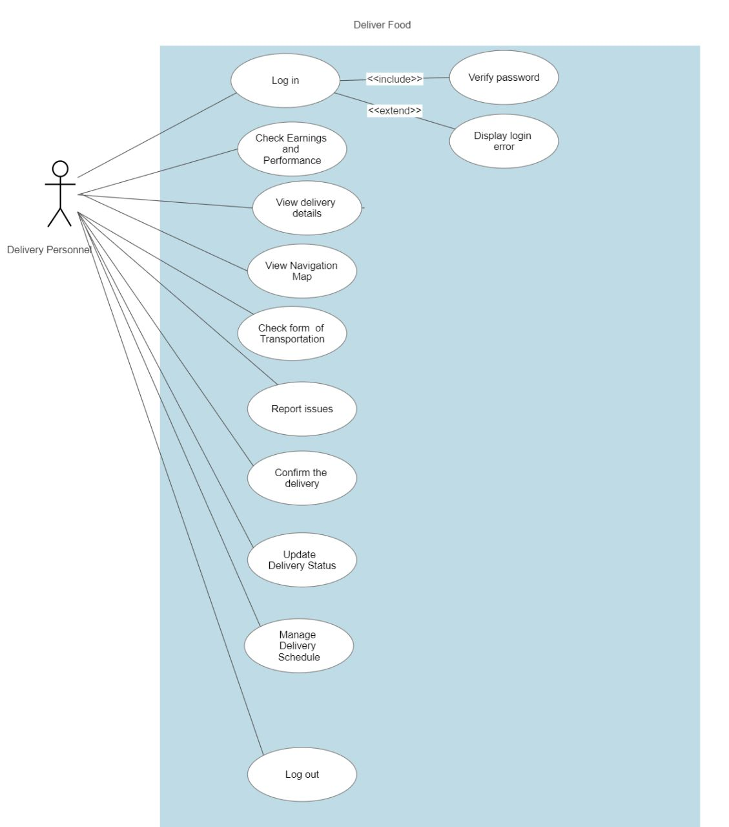**Delivery Personnel Use-Case diagram**

**Customer Use-Case diagram**

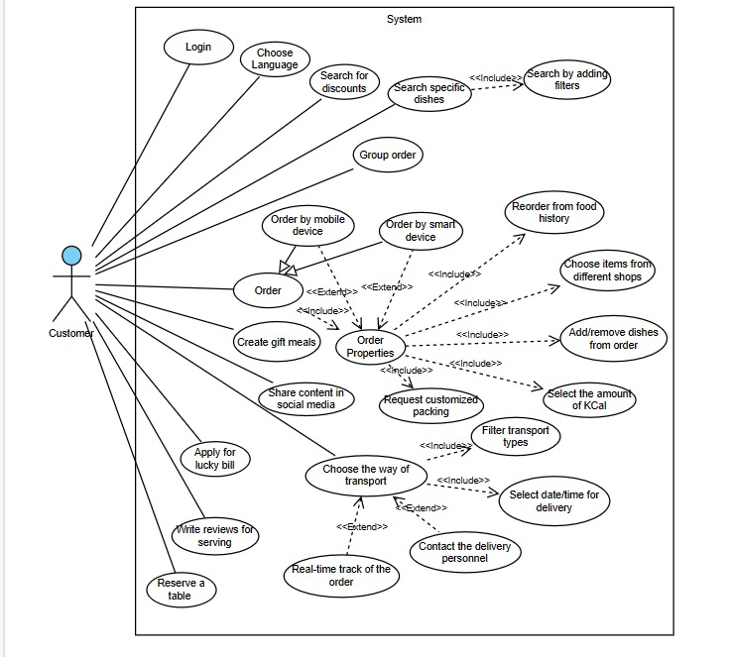

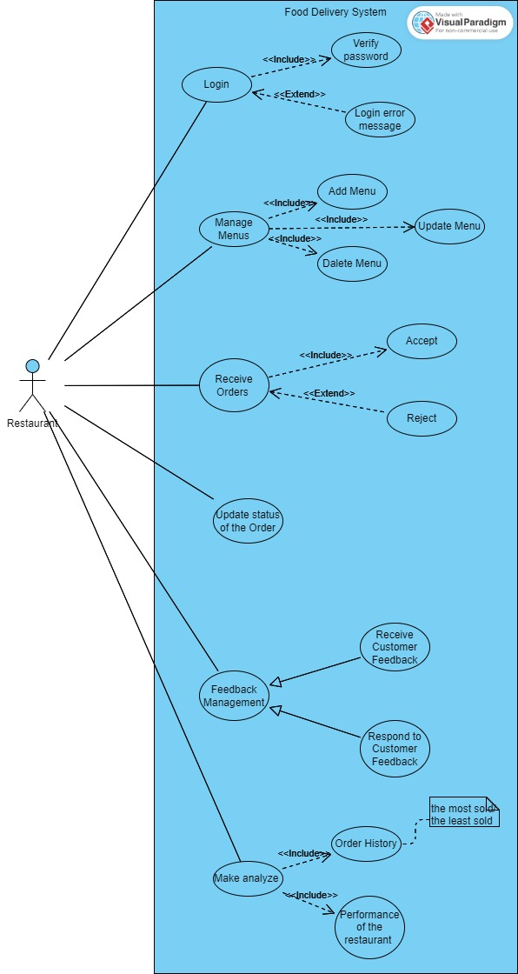**Restaurant Use-Case diagram**

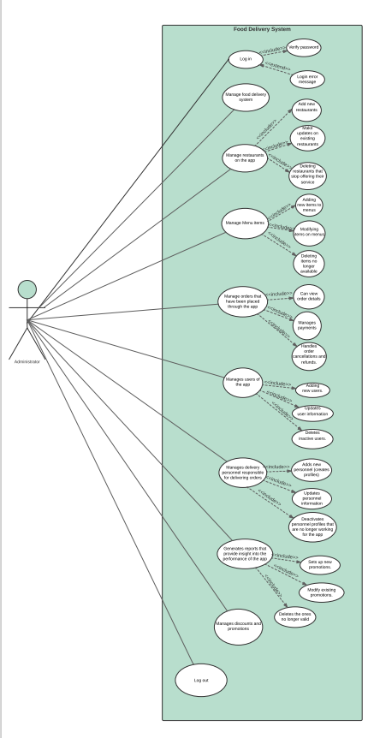**Administrator Use-Case diagram**

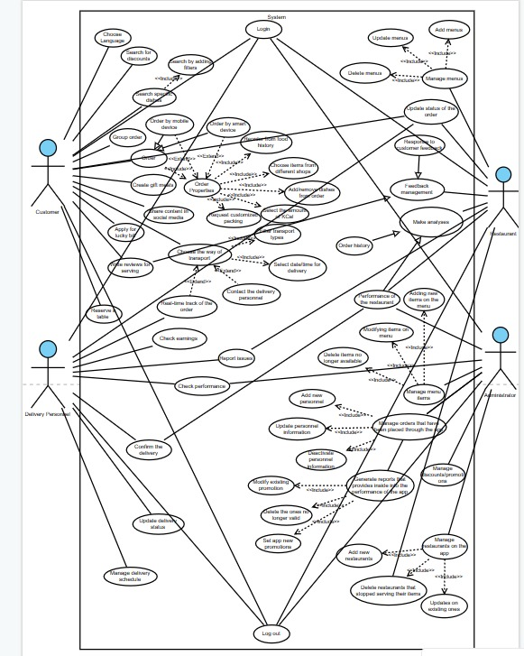**General Use-Case diagram**

**4.2 Use Cases Extended**

|  |  |
| --- | --- |
| Use Case(UC_ADM) | Manage food delivery system |
| Scope | Food Delivery App |
| Level | Admin |
| Intention Context | The intention of managing a food delivery system is to ensure efficient and timely delivery while maintaining food quality and customer satisfaction. |
| Minimum Guarantees | An error occurs during the delivery of the food |
| Success Guarantees | It consistently delivers orders accurately and ensures customer satisfaction and loyalty |
| Primary Actor | Admin |
| Stakeholders interest | It includes maintaining a profitable business model for restaurants, ensuring prompt and efficient service for customers, and establishing a reliable platform for delivery drivers to earn income and support their livelihoods. |
| Precondition: | It must have a robust technological infrastructure in place, including a user-friendly mobile or web application, secure payment processing, and a reliable communication system to coordinate orders between restaurants, delivery drivers, and customers. |

|  |  |
| --- | --- |
| Use Case(UC_ADM) | Manage restaurants on the app |
| Scope | Food Delivery App |
| Level | Admin |
| Intention Context | It involves providing a user-friendly interface for restaurants to easily update their menu, manage orders, add new restaurants and update existing ones |
| Minimum Guarantees | Admin cannot manage/modify the restaurants |
| Success Guarantees | Admin has access to create, add , update and delete restaurants |
| Primary Actor | Admin |
| Stakeholder’s interest | It empowers restaurants to expand their customer base, streamline operations, and enhance their online presence for increased revenue and business growth. |
| Precondition: | It must have a well-designed and intuitive interface that enables restaurants to easily navigate and update their menu, manage inventory, and handle customer orders efficiently. |

|  |  |
| --- | --- |
| Use Case(UC_ADM) | Manage Menu items |
| Scope | Food Delivery App |
| Level | Admin |
| Intention Context | It involves adding new items to menus, modifying and deleting items |
| Minimum Guarantees | Admin cannot manage/modify the items |
| Success Guarantees | Admin has access to create, add , update and delete items |
| Primary Actor | Admin |
| Stakeholder’s interest | Is to ensure accurate and up-to-date representation of available food options, enabling customers to make informed choices while facilitating efficient order management for restaurants. |
| Precondition: | It must have a comprehensive and easily configurable system that allows restaurants to add, modify, and remove menu items, along with options for categorization, pricing, and descriptions, ensuring accurate and timely updates across all platforms and channels. |

|  |  |
| --- | --- |
| Use Case(UC_ADM) | Manage orders that have been placed through the app |
| Scope | Food Delivery App |
| Level | Admin |
| Intention Context | It can view order details, manage payments and Handle order cancellations and refunds |
| Minimum Guarantees | Admin cannot manage/modify the orders |
| Success Guarantees | Admin has access to create, add , update and delete orders |
| Primary Actor | Admin |
| Stakeholder’s interest | Is to ensure efficient order processing, accurate tracking, and timely delivery, resulting in customer satisfaction, repeat business, and positive reviews, while also providing restaurants with streamlined operations and increased revenue opportunities. |
| Precondition: | The order must be placed |

|  |  |
| --- | --- |
| Use Case(UC_Delivery) | Log in |
| Scope | Food Delivery App |
| Level | User Level |
| Intention Context | Firstly, the delivery needs to log in to the application and later use it. |
| Minimum Guarantees | The system must verify the delivery log in credentials |
| Success Guarantees | The delivery guy is granted access to the appropriate system features based on their assigned permissions. |
| Primary Actor | The delivery |
| Stakeholder’s interest | They want to ensure secure access to the system. |
| Precondition: | The delivery has a valid account in the system and knows their credentials |

|  |  |
| --- | --- |
| Use Case (UC_Delivery) | Check Earnings and Performance |
| Scope | Food Delivery System |
| Level | User Level |
| Intention Context | After log in he can access the system in order to check the earnings and performance |
| Minimum Guarantees | Display accurate earnings information |
| Success Guarantees | The information is accurate and up to date |
| Primary Actor | The delivery guys |
| Stakeholder’s interest | To ensure secure access to the earnings and performance data |
| Precondition: | The delivery had done one or more deliveries and is logged into the system |

|  |  |
| --- | --- |
| Use Case(UC_Delivery) | View Details |
| Scope | Food Delivery App |
| Level | User Level |
| Intention Context | The delivery has access to view details about the order: address, customer information and order details |
| Minimum Guarantees | The data is not accurate |
| Success Guarantees | The delivery guy is granted access to the appropriate system features based on their assigned permissions. |
| Primary Actor | The delivery |
| Stakeholder’s interest | The data is accurate, and the users are authorized so the order won't be wasted . |
| Precondition: | The customer must order and put accurate data about themselves |

|  |  |
| --- | --- |
| Use Case (UC_Delivery) | View Navigation Map |
| Scope | Food Delivery System |
| Level | User Level |
| Intention Context | To keep real track of the food delivery |
| Minimum Guarantees | The instructions to guide to the correct location will be reliable |
| Success Guarantees | The customer and the delivery both have a reliable navigation and to arrive in time |
| Primary Actor | The delivery |
| Stakeholder’s interest | By tracking the food and making aware the customer of how far their order is |
| Precondition: | It must be notified for the start of the delivery |

|  |  |
| --- | --- |
| Use Case(UC_Delivery) | Check Form of Transportation |
| Scope | Food Delivery System |
| Level | Use Level |
| Intention Context | According to how far the order is made the transportation will rely on it. |
| Minimum Guarantees | The service will be late due to traffic or the area. |
| Success Guarantees | The service will be right on time |
| Primary Actor | The delivery |
| Stakeholder’s interest | Fast service |
| Precondition: | The delivery guy will be available at that time |

|  |  |
| --- | --- |
| Use Case (Delivery Person) | Report Issues |
| Scope: | Food Delivery App |
| Level: | Delivery Person level |
| Intention Context : | Delivery person reports an issue if it happens. |
| Minimum Guarantees : | It can not report an issue. |
| Success Guarantees : | Delivery person report issues. |
| Primary Actor : | Delivery Person |
| Stakeholder’s Interest : | It is important that the restaurant knows if there is a problem . |
| Precondition : | Delivery Person should have an account. |

|  |  |
| --- | --- |
| Use Case (Delivery Person) | Update Delivery Status. |
| Scope: | Food Delivery App |
| Level: | Delivery Person level |
| Intention Context : | Delivery person updates delivery status. |
| Minimum Guarantees : | It can not update status  . |
| Success Guarantees : | Delivery person update status. |
| Primary Actor : | Delivery Person |
| Stakeholder’s Interest : | It is important that the customer knows where the product process is. |
| Precondition : | Delivery Person should have an account. |

|  |  |
| --- | --- |
| Use Case (Delivery Person) | Manage delivery schedule. |
| Scope: | Food Delivery App |
| Level: | Delivery Person level |
| Intention Context: | Delivery person manage delivery schedule. |
| Minimum Guarantees: | It cannot manage delivery schedules. |
| Success Guarantees: | Delivery person manages delivery schedules. |
| Primary Actor: | Delivery Person |
| Stakeholder’s Interest: | To manage delivery schedule. |
| Precondition: | Delivery Person should have an account. |

|  |  |
| --- | --- |
| Use Case (Restaurant) | Log in |
| Scope: | Food Delivery App |
| Level: | Restaurant level |
| Intention Context : | The Restaurant staff logs in and operates inside the system. |
| Minimum Guarantees : | Restaurant cannot log in. |
| Success Guarantees : | Restaurant staff can enter his data and log in to operate in the system. |
| Primary Actor : | Restaurant |
| Stakeholder’s Interest : | Restaurant  login is very important because it should be validated for the system to achieve its main goal. |
| Precondition : | Restaurants should be connected with the internet and would have the access to login into the app. |

|  |  |
| --- | --- |
| Use Case (Restaurant) | Manage Menus |
| Scope: | Food Delivery App |
| Level: | Restaurant level |
| Intention Context : | The restaurant has access to manage menus(update, delete, add) |
| Minimum Guarantees : | Restaurant does not have access to the menus. |
| Success Guarantees : | Restaurant has access to menus and can change them. |
| Primary Actor : | Restaurant |
| Stakeholder’s Interest : | Restaurant managing the menu is so important because it needs to notify customers for new updates. |
| Precondition : | Restaurant should have an account. |

|  |  |
| --- | --- |
| Use Case (Restaurant) | Receive Orders |
| Scope: | Food Delivery App |
| Level: | Restaurant level |
| Intention Context : | The restaurant can receive order from customers |
| Minimum Guarantees : | Restaurants do not get notification of customers. |
| Success Guarantees : | Restaurants accept customer order. |
| Primary Actor : | Restaurant |
| Stakeholder’s Interest : | Restaurant receiving orders is so important because it is the fundamental thing that it does. |
| Precondition : | Restaurant should have an account. |

|  |  |
| --- | --- |
| Use Case (Restaurant) | Feedback Management |
| Scope: | Food Delivery App |
| Level: | Restaurant level |
| Intention Context : | Restaurant receive feedback from customers for the products |
| Minimum Guarantees : | Restaurant do not receive a feedback. |
| Success Guarantees : | Restaurants get a feedback. |
| Primary Actor : | Restaurant |
| Stakeholder’s Interest : | Restaurant receiving feedback is important because it helps restaurant improving their quality . |
| Precondition : | Restaurant should have an account. |

|  |  |
| --- | --- |
| Use Case (Restaurant) | Make analyses |
| Scope: | Food Delivery App |
| Level: | Restaurant level |
| Intention Context : | Restaurant make analyses about performance |
| Minimum Guarantees : | Restaurants can not make analyses. |
| Success Guarantees : | Restaurant gets information about performance. |
| Primary Actor : | Restaurant |
| Stakeholder’s Interest : | Is important to get analyses because it helps restaurants to know how they are doing. |
| Precondition : | Restaurant should have an account. |

|  |  |
| --- | --- |
| Use Case (Customer) | Log in |
| Scope: | Food Delivery App |
| Level: | Customer level |
| Intention Context : | The customer logs in and operates inside the system. |
| Minimum Guarantees : | Customer cannot log in. |
| Success Guarantees : | Customer can enter his data and log in to operate in the system. |
| Primary Actor : | Customer |
| Stakeholder’s Interest : | Customer’s  login is very important because it should be validated for the system to achieve its main goal. |
| Precondition : | Customer should be connected with the internet and would have the access to login into the app. |

|  |  |
| --- | --- |
| Use Case (Customer) | Choose Language |
| Scope: | Food Delivery App |
| Level: | Customer level |
| Intention Context : | The customer chooses a language for the system to interact with. |
| Minimum Guarantees : | Customer cannot choose the language. |
| Success Guarantees : | Customer can choose the language and interact with the system. |
| Primary Actor : | Customer |
| Stakeholder’s Interest : | Customer’s choice of language is very important because it is the way to create a relationship between the system and customer. |
| Precondition : | Customer should have access in the system, should be registered and have the ability to read in one of the listed languages. |

|  |  |
| --- | --- |
| Use Case (Customer) | Search for discounts |
| Scope: | Food Delivery App |
| Level: | Customer level |
| Intention Context : | The customer searches for discounts made in different dishes or restaurants. |
| Minimum Guarantees : | Customer cannot search for discounts. |
| Success Guarantees : | Customer can search for discounts made and satisfy its experience even more |
| Primary Actor : | Customer |
| Stakeholder’s Interest : | Customer’s search for discounts is important since it attract the customer’s interest in ordering more. |
| Precondition : | Customer should have access in the system, should be registered so he/she can experience discounts. |

|  |  |
| --- | --- |
| Use Case (Customer) | Search specific dishes |
| Scope: | Food Delivery App |
| Level: | Customer level |
| Intention Context : | The customer search for a specific dish that he/she want to order. |
| Minimum Guarantees : | Customer cannot search for a specific dish. |
| Success Guarantees : | Customer can search for a specific dish and get the needed information about it. |
| Primary Actor : | Customer |
| Stakeholder’s Interest : | Customer’s search of a specific dish is important because it allow the customer to get directly where he/she wants to and get satisfied. |
| Precondition : | Customer should have access in the system, should be registered and should write the exact name of the dish. |

|  |  |
| --- | --- |
| Use Case (Customer) | Group Order |
| Scope: | Food Delivery App |
| Level: | Customer level |
| Intention Context : | The customer can order within a group of people, and get separate bill. |
| Minimum Guarantees : | Customer cannot order within a group because the separate bill isn’t functional |
| Success Guarantees : | Customer can order within a group order and receive a split bill. |
| Primary Actor : | Customer |
| Stakeholder’s Interest : | Customer’s group order it is important because it is a great way to be part of a group of people making |
| Precondition : | The Customer should have valid accepted payment, should be more than one person to order too. |

|  |  |
| --- | --- |
| Use Case (Customer) | Order |
| Scope: | Food Delivery App |
| Level: | Customer level |
| Intention Context : | The customer order by adding these features: reorder from history, add items, remove items, specify delivery information, select the amount of Cal. |
| Minimum Guarantees : | Customer cannot order their meal and nothing of the features. |
| Success Guarantees : | Customer can order a meal and apply the features that come with ordering: reorder from history, add items, remove items, specify delivery information, select the amount of Kal. |
| Primary Actor : | Customer |
| Stakeholder’s Interest : | Customer’s ordering is the most important feature of this system, because of the reason of building it. |
| Precondition : | Customer should have access in the system, should be registered and should have a valid payment method. |

|  |  |
| --- | --- |
| Use Case (Customer) | Create gift meals |
| Scope: | Food Delivery App |
| Level: | Customer level |
| Intention Context : | The customer can create gift meals by adding items from different shops. |
| Minimum Guarantees : | Customer cannot create a gift meal because the feature of adding items from different shops is not available.. |
| Success Guarantees : | Customer can create a gift meal and customize it depending on their preferences. |
| Primary Actor : | Customer |
| Stakeholder’s Interest : | Customer’s create of a gift meal is important because it i a very rare feature which will be preferred by the users. |
| Precondition : | Customer should have access in the system, should be registered and should have a valid payment method. |

|  |  |
| --- | --- |
| Use Case (Customer) | Choose the way of transport |
| Scope: | Food Delivery App |
| Level: | Customer level |
| Intention Context : | The customer can choose the way of transport and the price of each way. |
| Minimum Guarantees : | Customer cannot choose the way of transport that is more likable by him/her. |
| Success Guarantees : | Customer can choose the way of transport that meets its requirement of the delivery. |
| Primary Actor : | Customer |
| Stakeholder’s Interest : | Customer’s choosing the way of transport is very important because it is related to the main goal of this system. |
| Precondition : | Customer should have access in the system, should be registered and should have a valid payment method. |

|  |  |
| --- | --- |
| Use Case (Customer) | Reserve a table |
| Scope: | Food Delivery App |
| Level: | Customer level |
| Intention Context : | The customer can reserve a table in a restaurant through the app. |
| Minimum Guarantees : | Customer can not reserve a table through the app in their desired date and time. |
| Success Guarantees : | Customer can reserve a table  through the app in their desired date and time. |
| Primary Actor : | Customer |
| Stakeholder’s Interest : | Customer’s reserving a table through the app is important enough since it does grow the interest of two main actors to use the app and interact with the system. |
| Precondition : | Customer should have access in the system, should be registered and should have a valid payment method. |

|  |  |
| --- | --- |
| Use Case (Customer) | Write reviews for serving |
| Scope: | Food Delivery App |
| Level: | Customer level |
| Intention Context : | The customer can write reviews for different features of the system, so the actors can improve their servings. |
| Minimum Guarantees : | Customer can not write reviews so they can not describe their experience with the system, |
| Success Guarantees : | Customer can write reviews and of course create a better environment for all users. |
| Primary Actor : | Customer |
| Stakeholder’s Interest : | Customer’s writing reviews is very important since it is a “grade” for the system, restaurants, delivery, meals and everything else. |
| Precondition : | Customer should have access in the system, should be registered and should have a valid payment method. |

|  |  |
| --- | --- |
| Use Case (Customer) | Apply for lucky Bill |
| Scope: | Food Delivery App |
| Level: | Customer level |
| Intention Context : | The customer can apply for lucky bill, once a year and earn the winning ticket. |
| Minimum Guarantees : | Customer can not apply for lucky bill, and not see the process. |
| Success Guarantees : | Customer can apply for lucky bill and win the big price . |
| Primary Actor : | Customer |
| Stakeholder’s Interest : | Customer’s applying for a lucky bill is important since it has to do with the interaction between the customer and the system in a different way. |
| Precondition : | Customer should have access in the system, should be registered and should have a valid payment method. |

|  |  |
| --- | --- |
| Use Case (Customer) | Share content in social media |
| Scope: | Food Delivery App |
| Level: | Customer level |
| Intention Context : | The customer can share the food content on their social media. |
| Minimum Guarantees : | Customer cannot share the content. |
| Success Guarantees : | Customer can choose what content to share and take feedbacks about it. |
| Primary Actor : | Customer |
| Stakeholder’s Interest : | Customer’s sharing food content on social media, is important because of creating a bigger interactive between people and the system. |
| Precondition : | Customer should have access in the system, should be registered and should have a valid payment method. |

**4.3 BPMN**

**-Delivery Management Process**

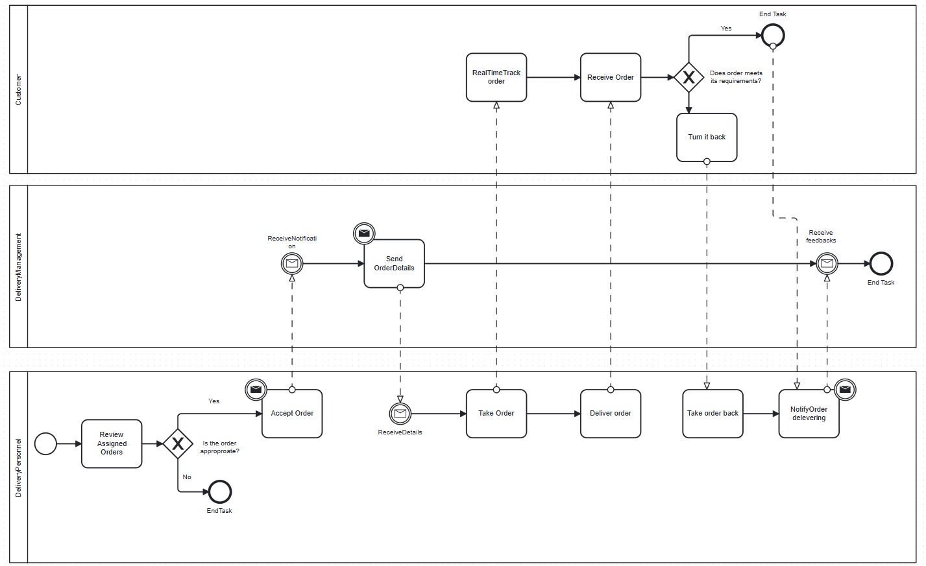

**-Place Order Process**

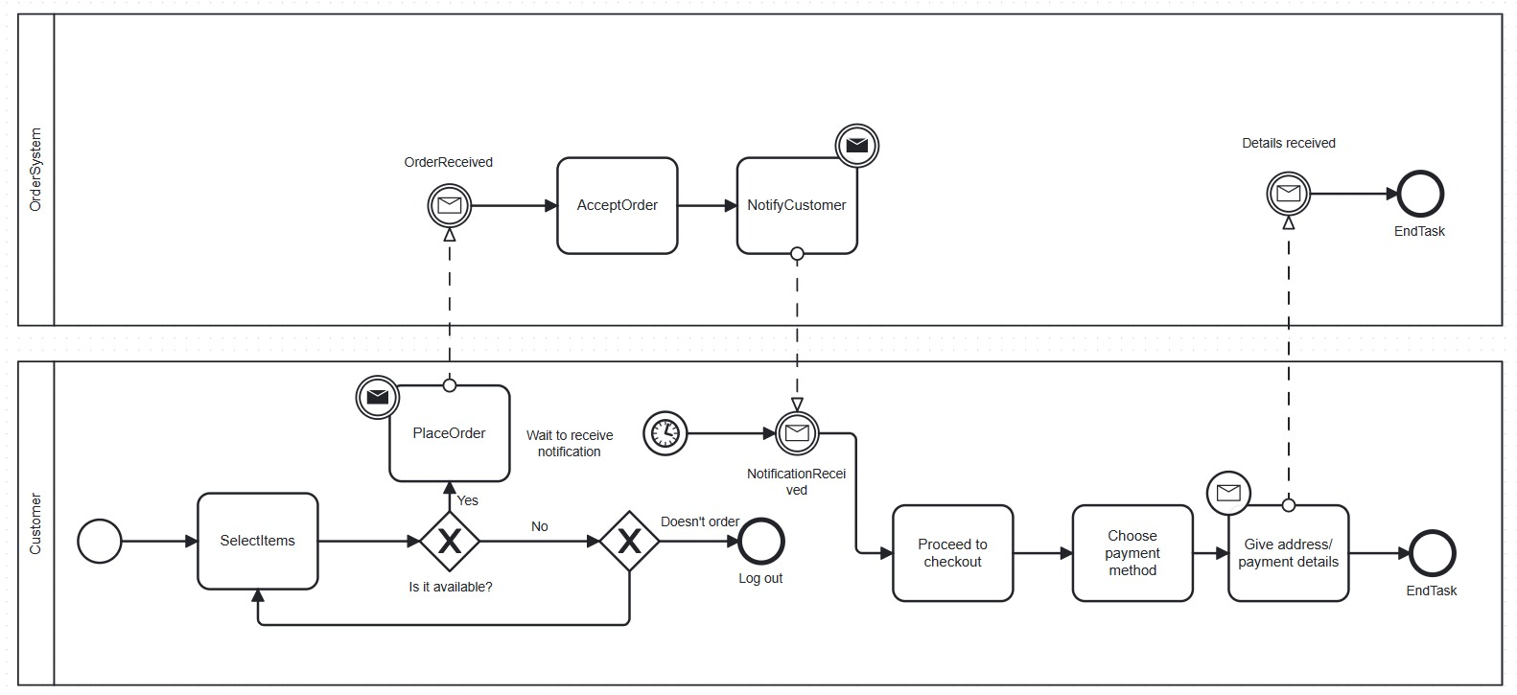

**-Loyalty Points BPMN**

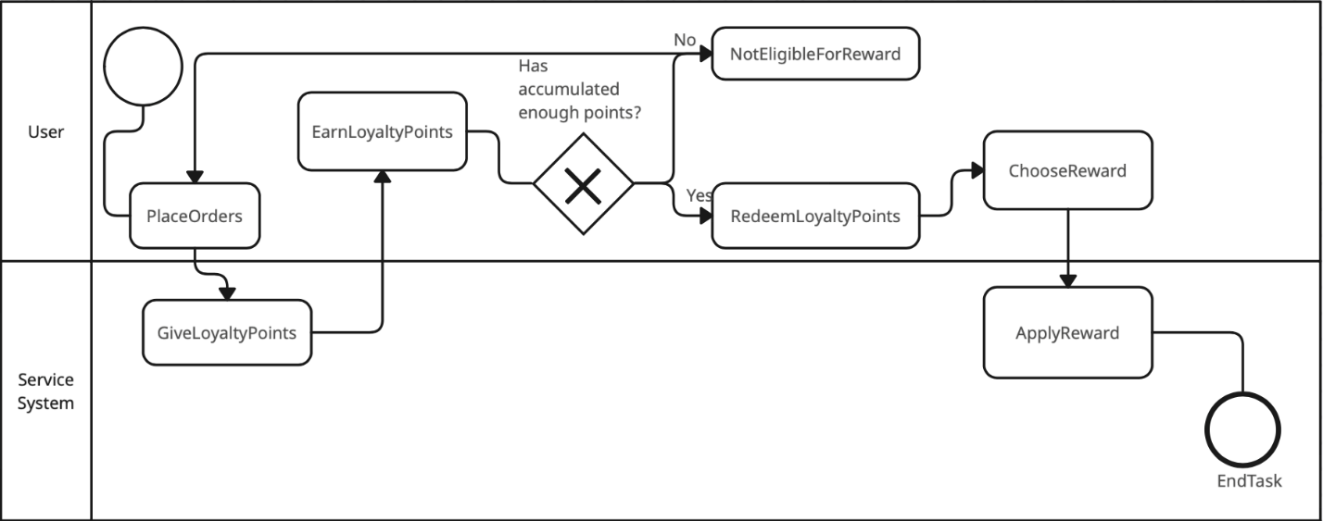

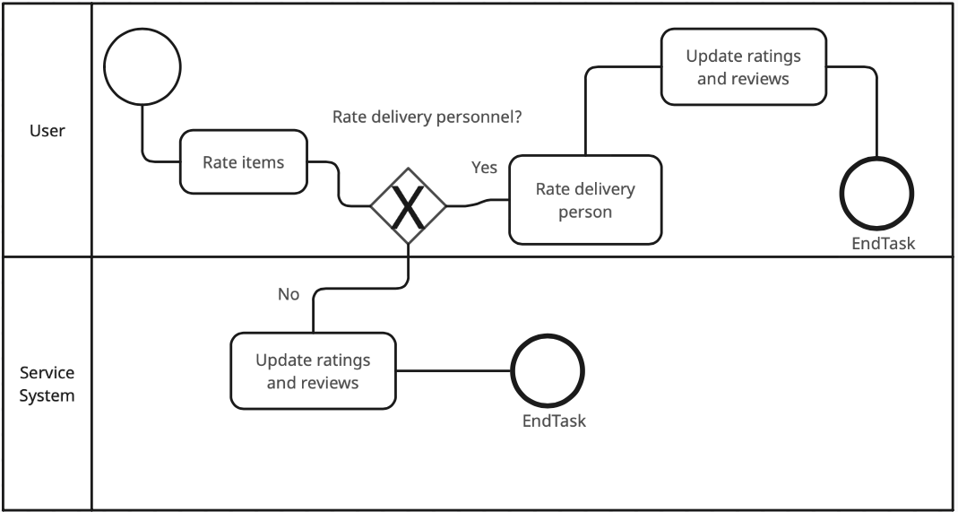**-Rating And Reviews BPMN**

**4.4 Data Flow Diagrams**

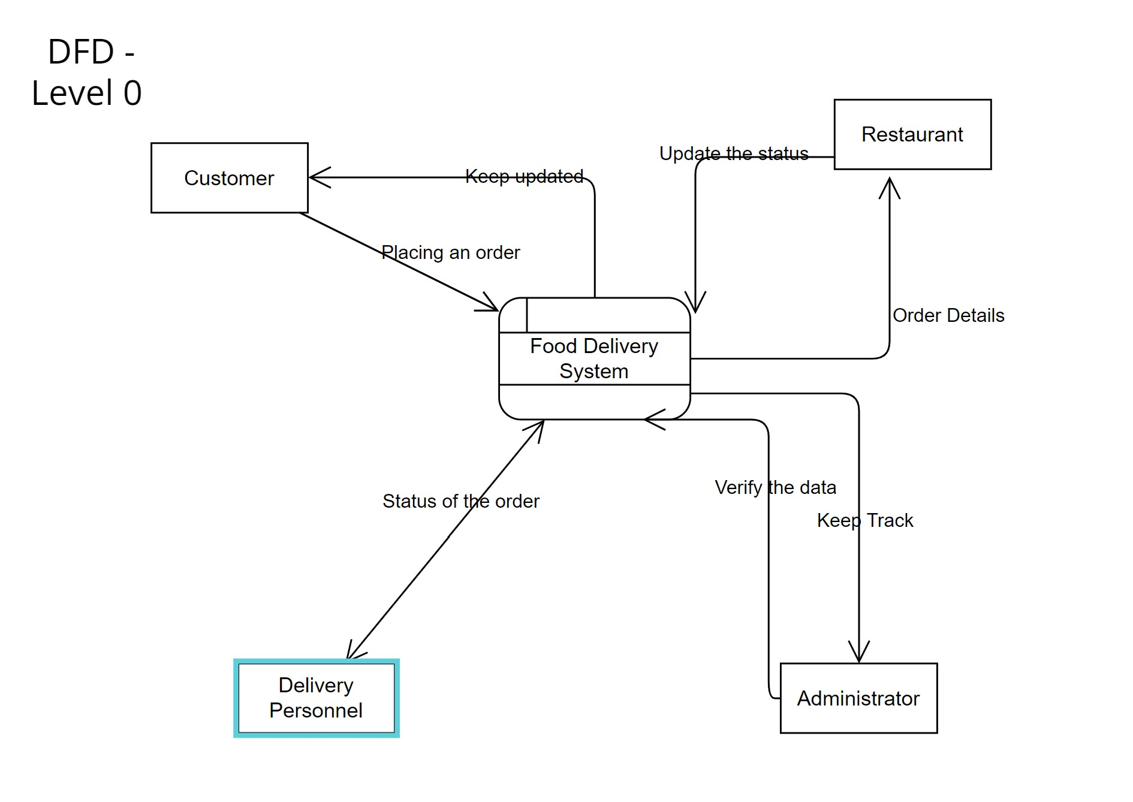

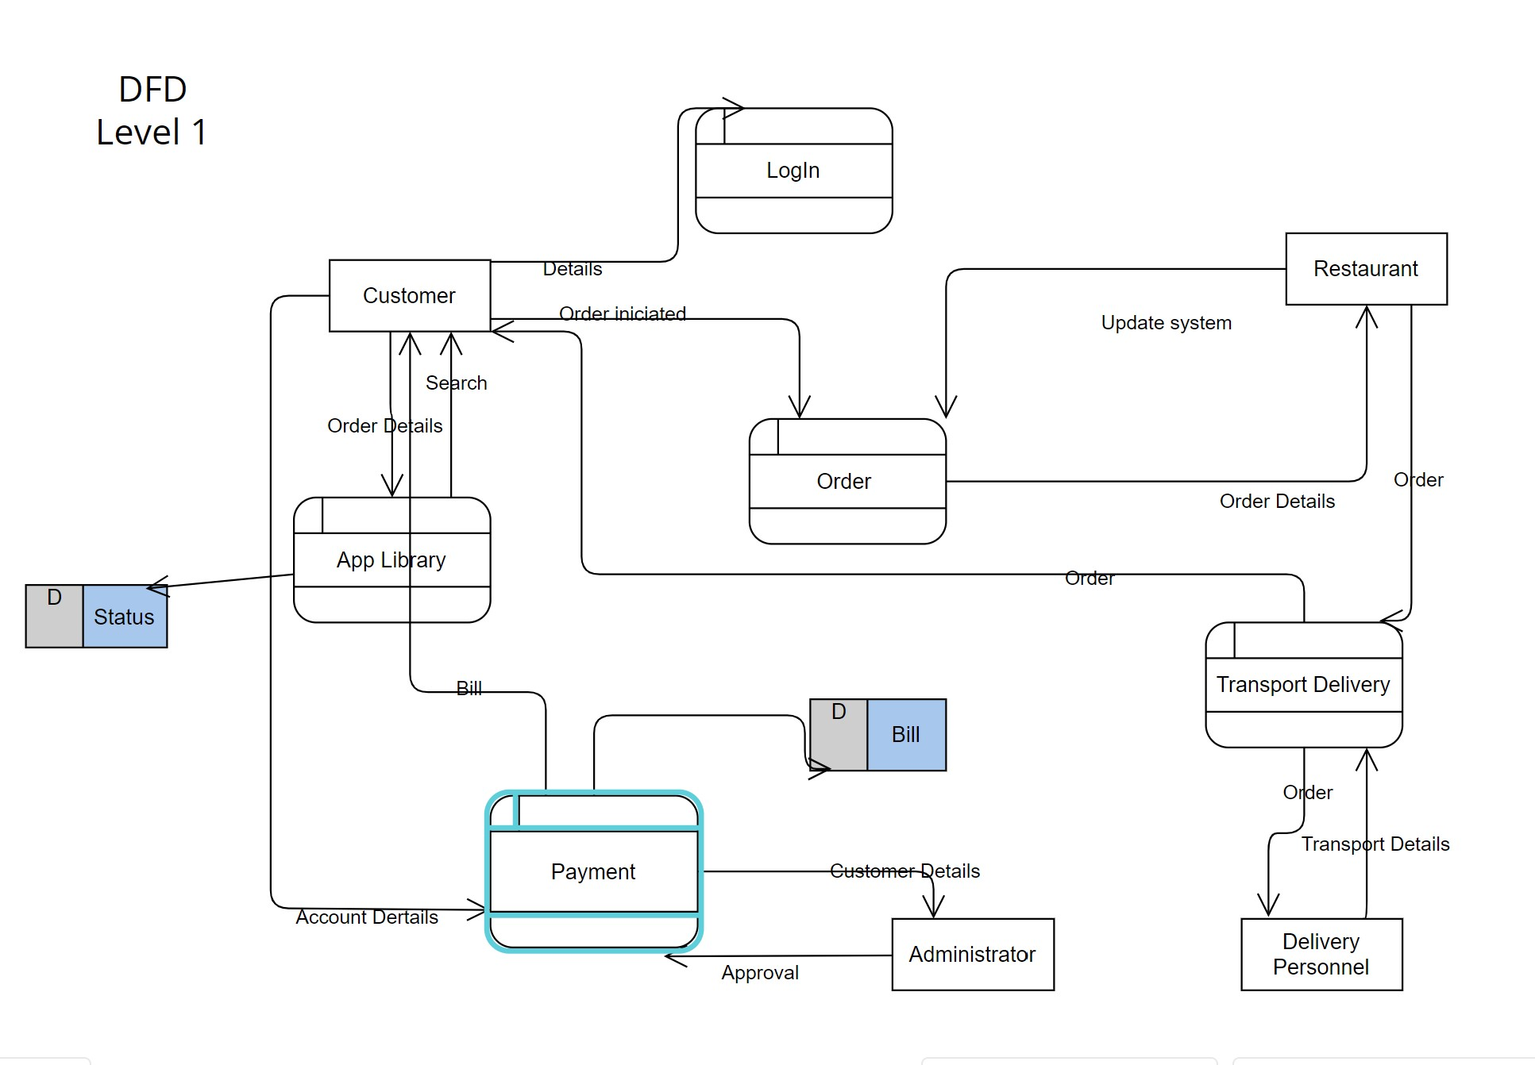

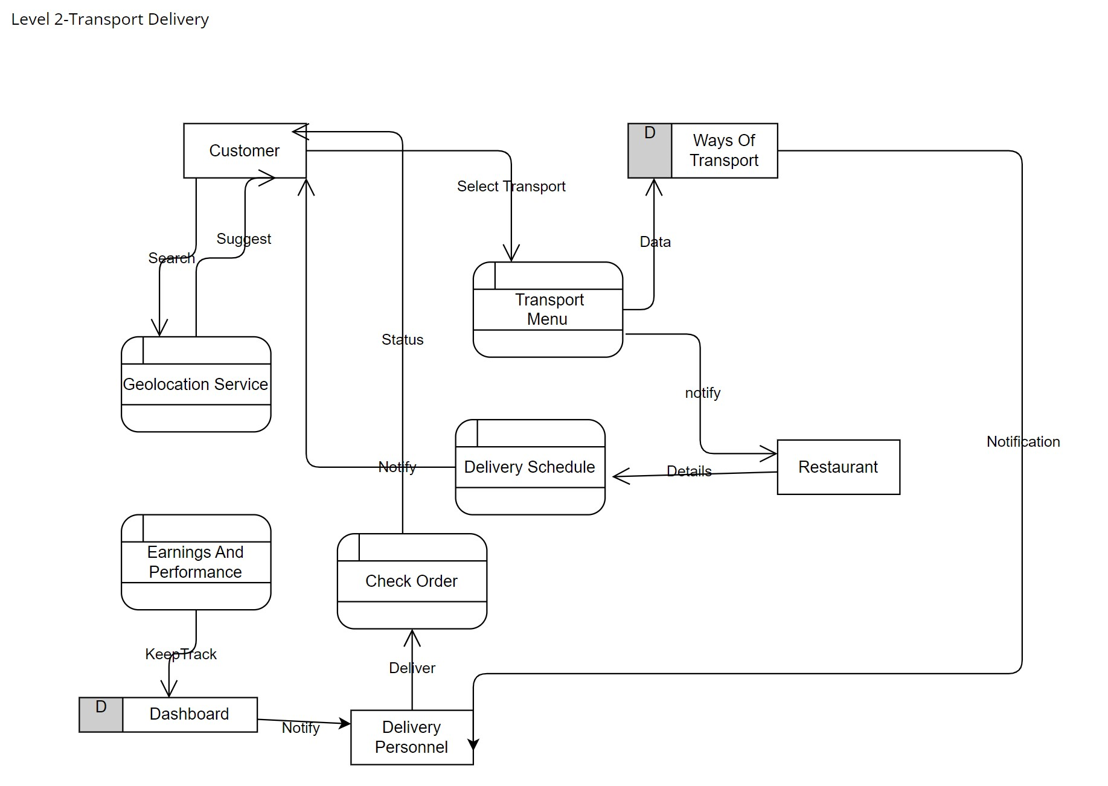

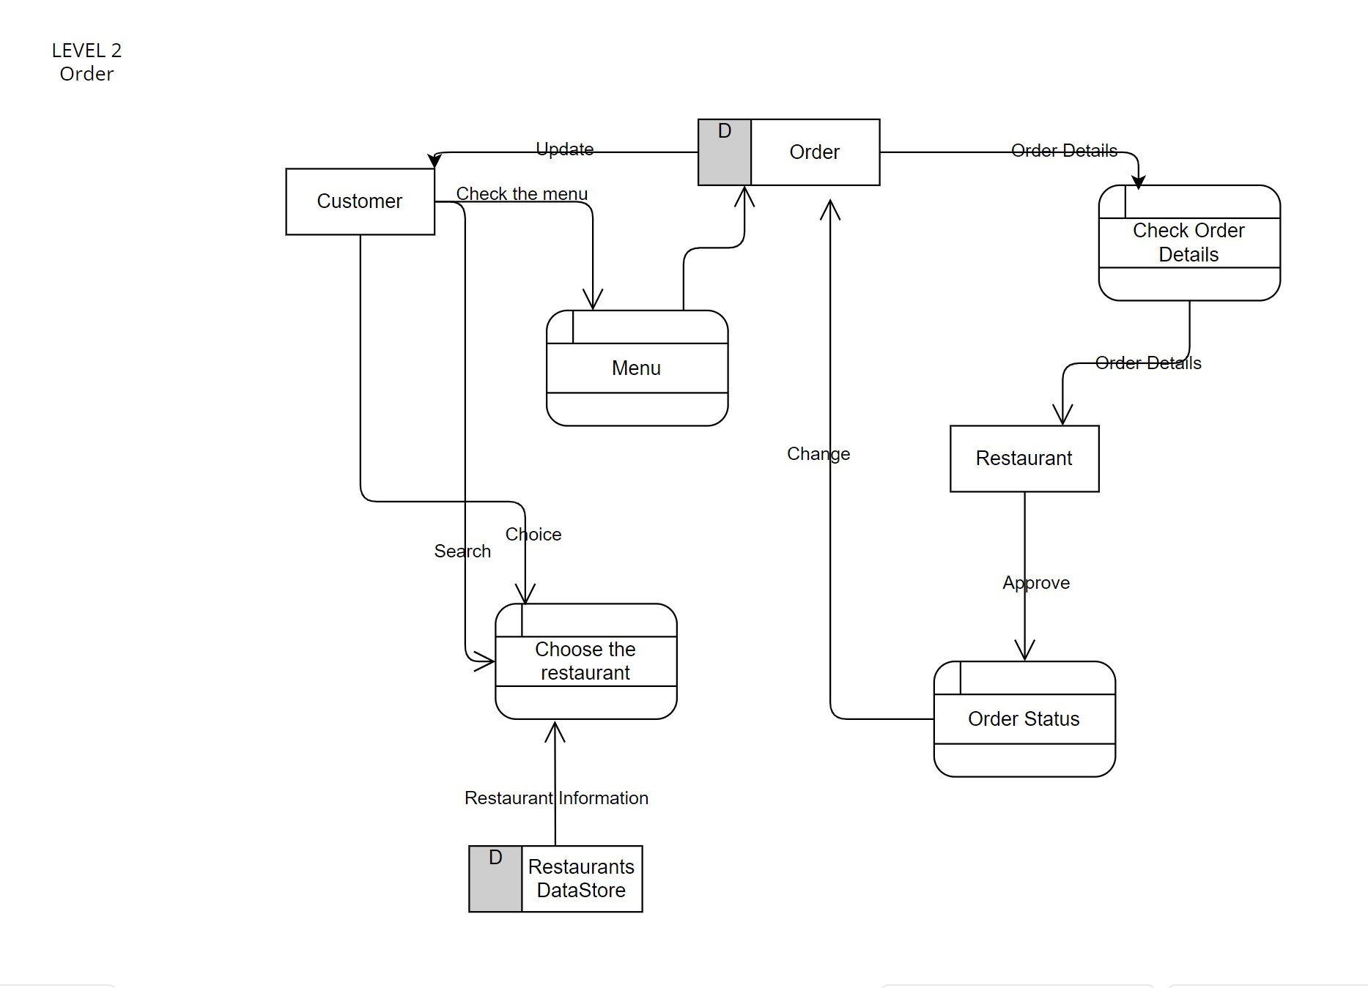

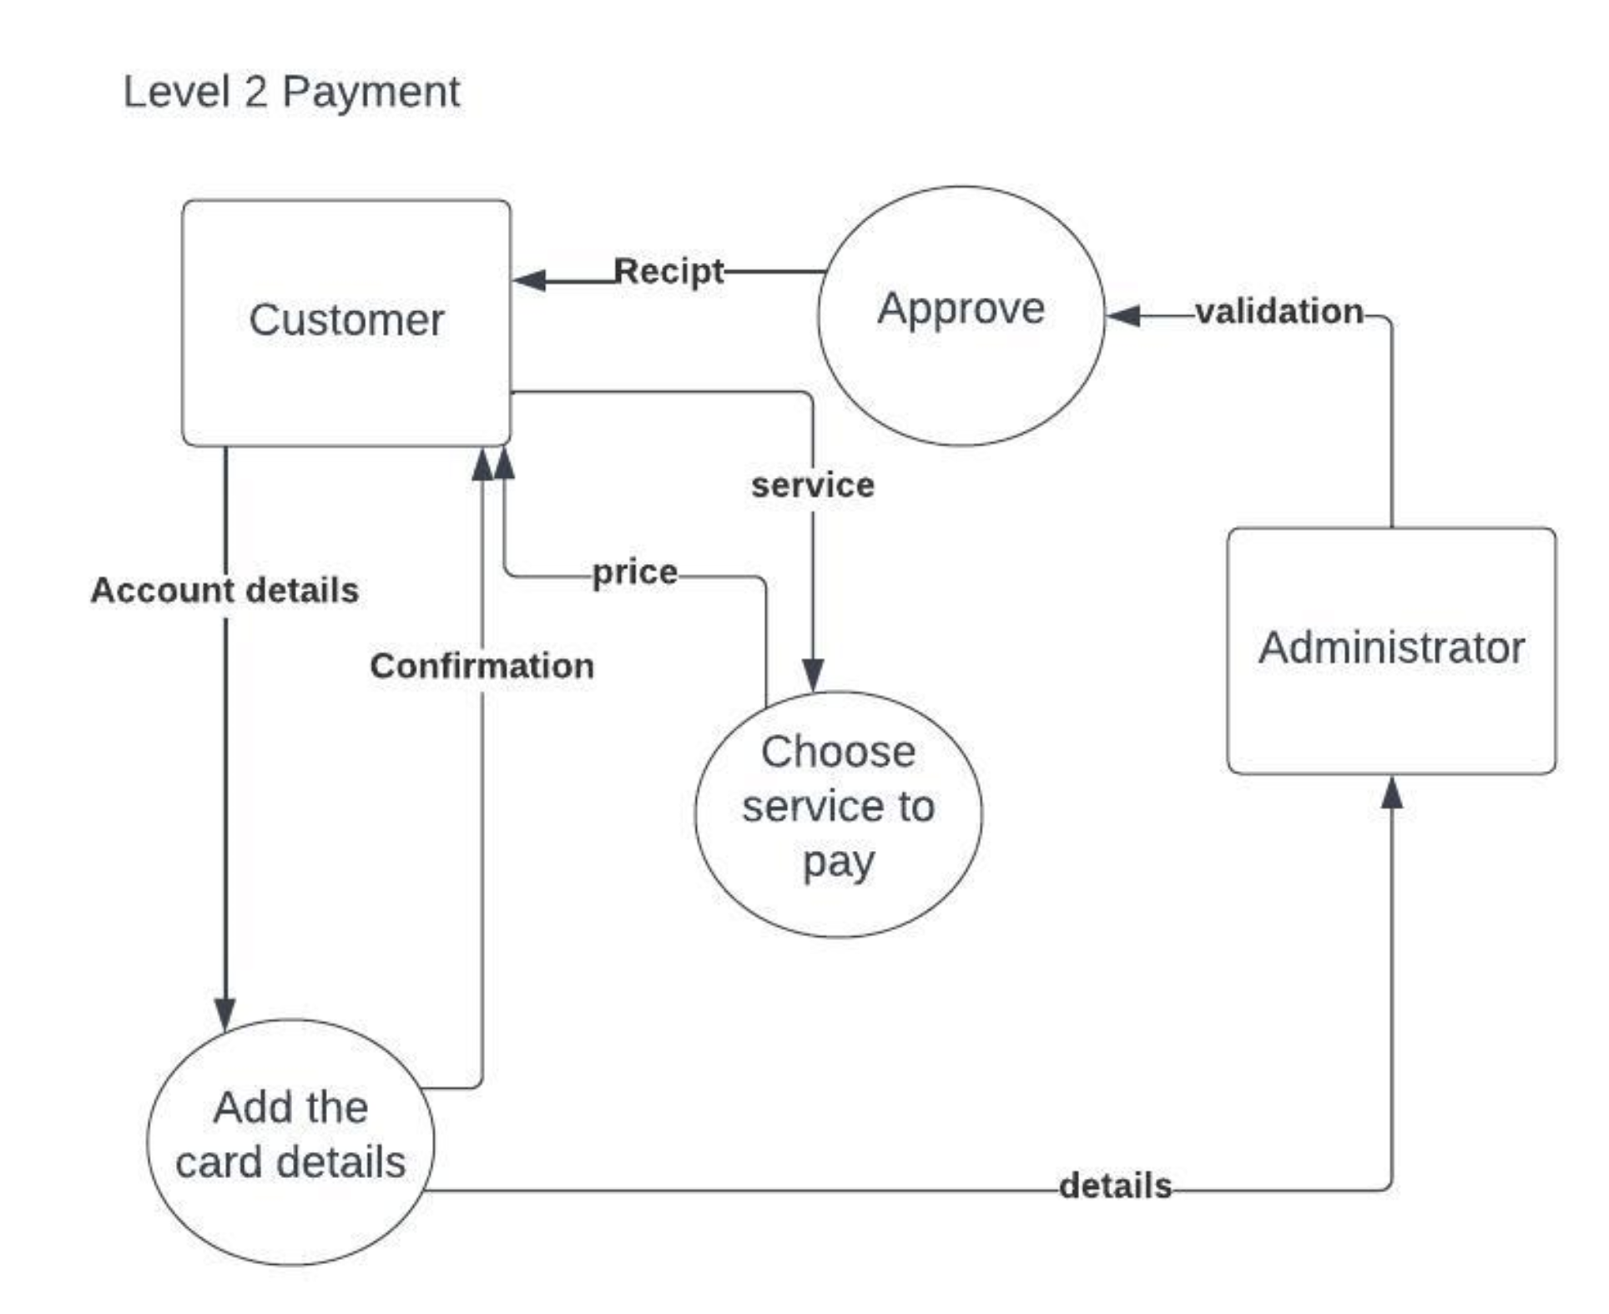

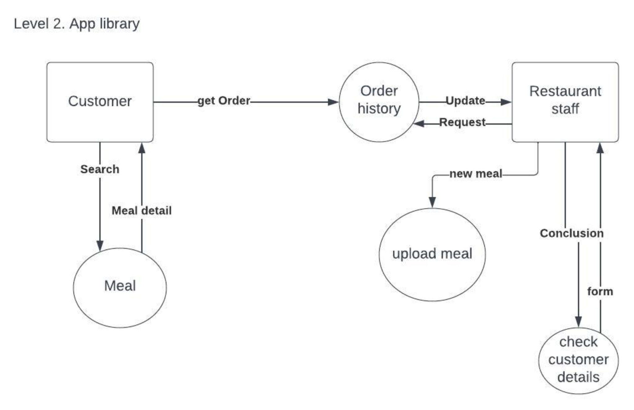

**4.5 Entity-Relationship Diagram**

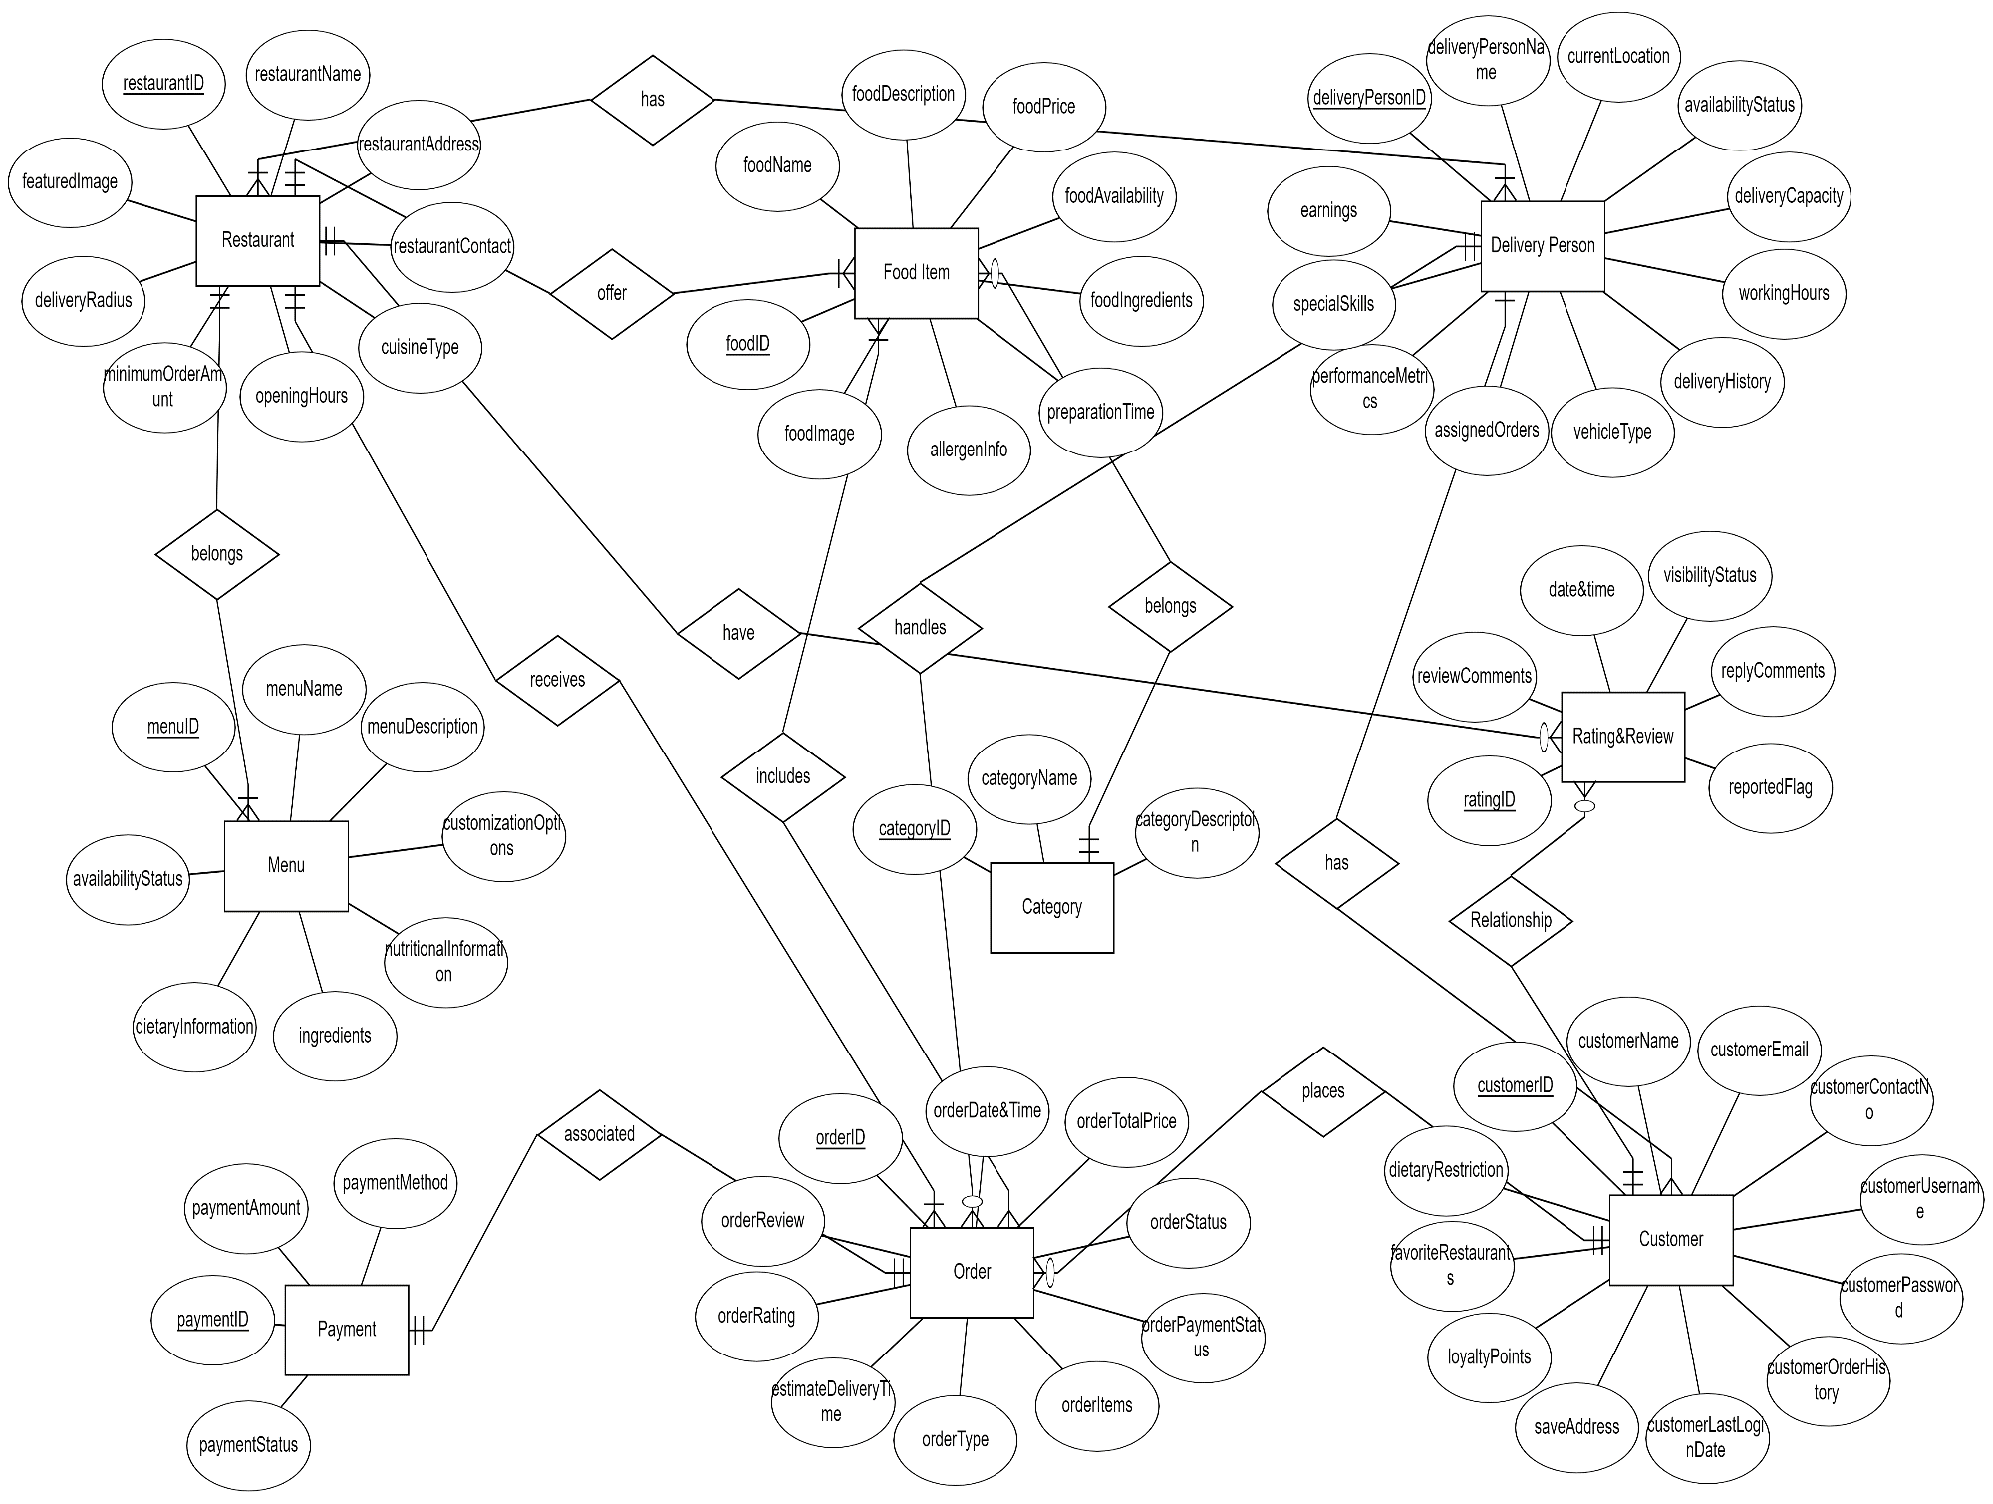

**4.6 Activity Diagrams**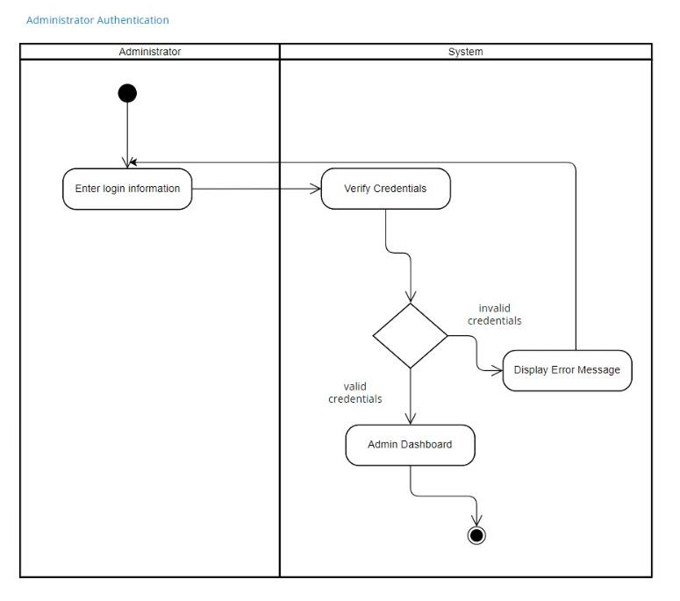

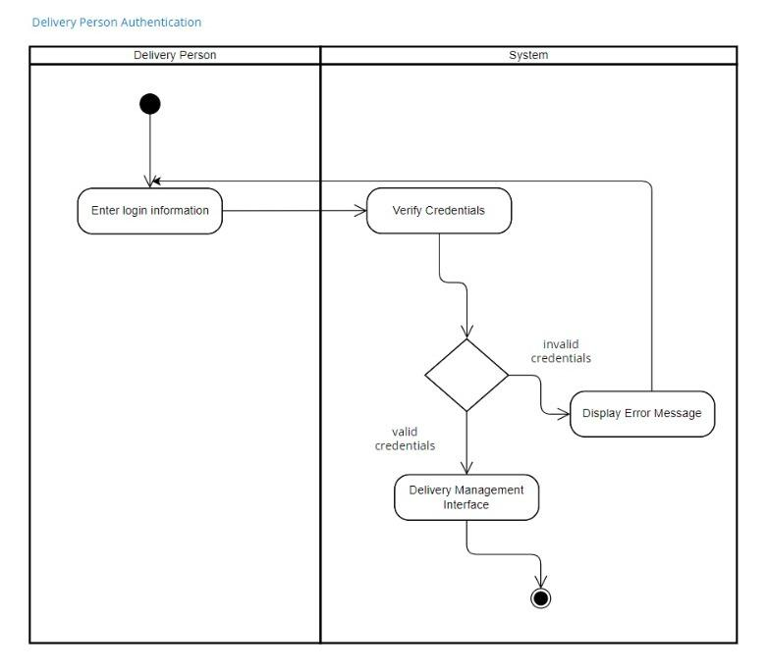

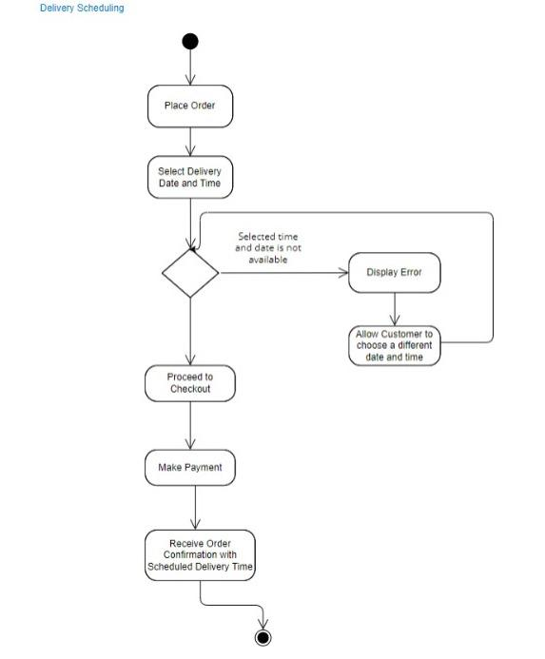

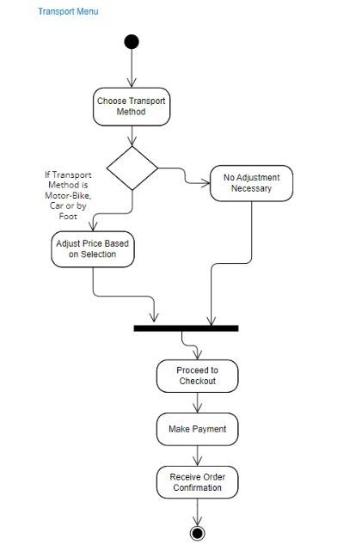

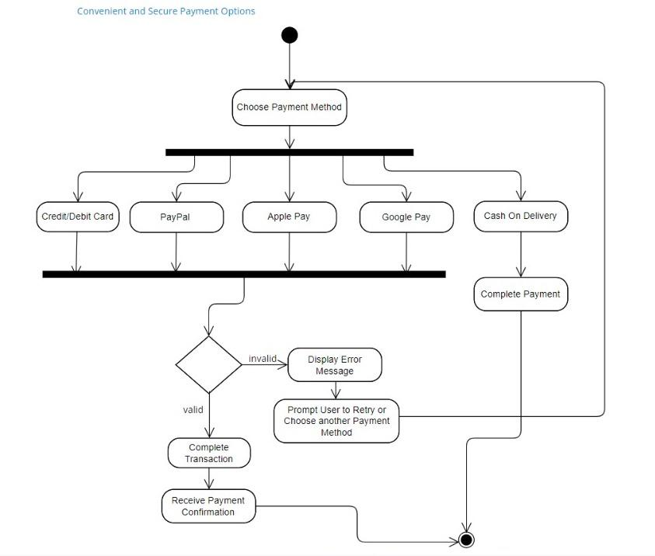

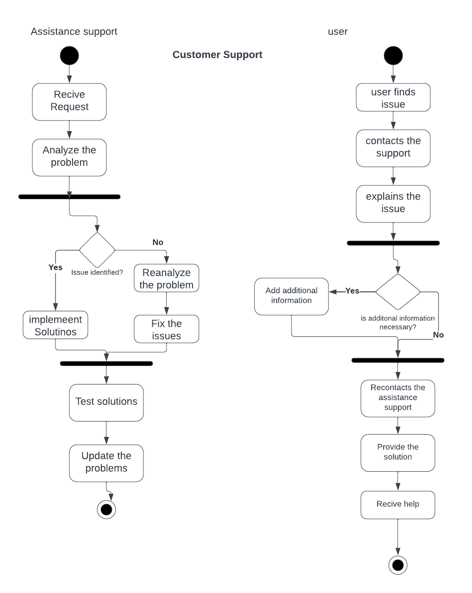

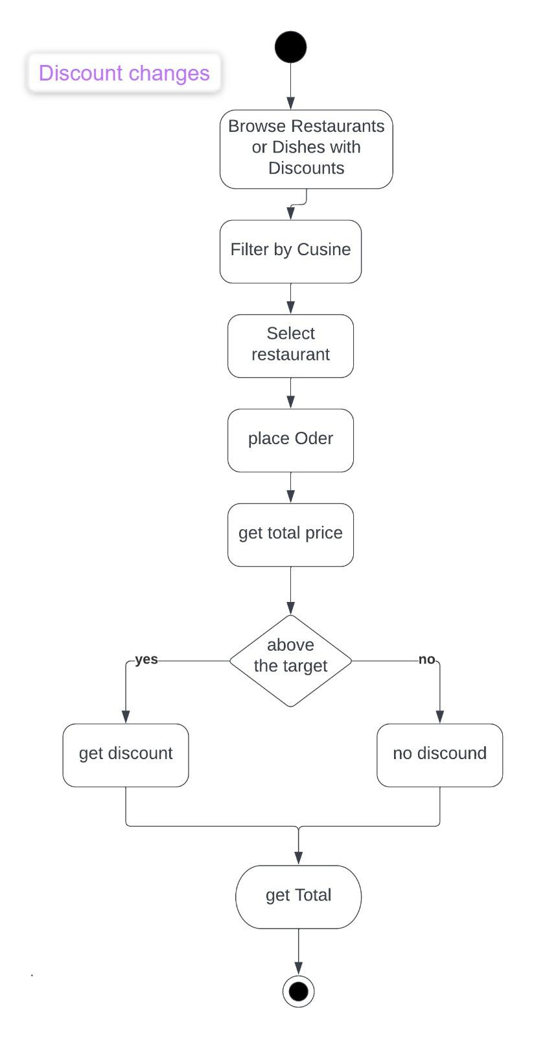

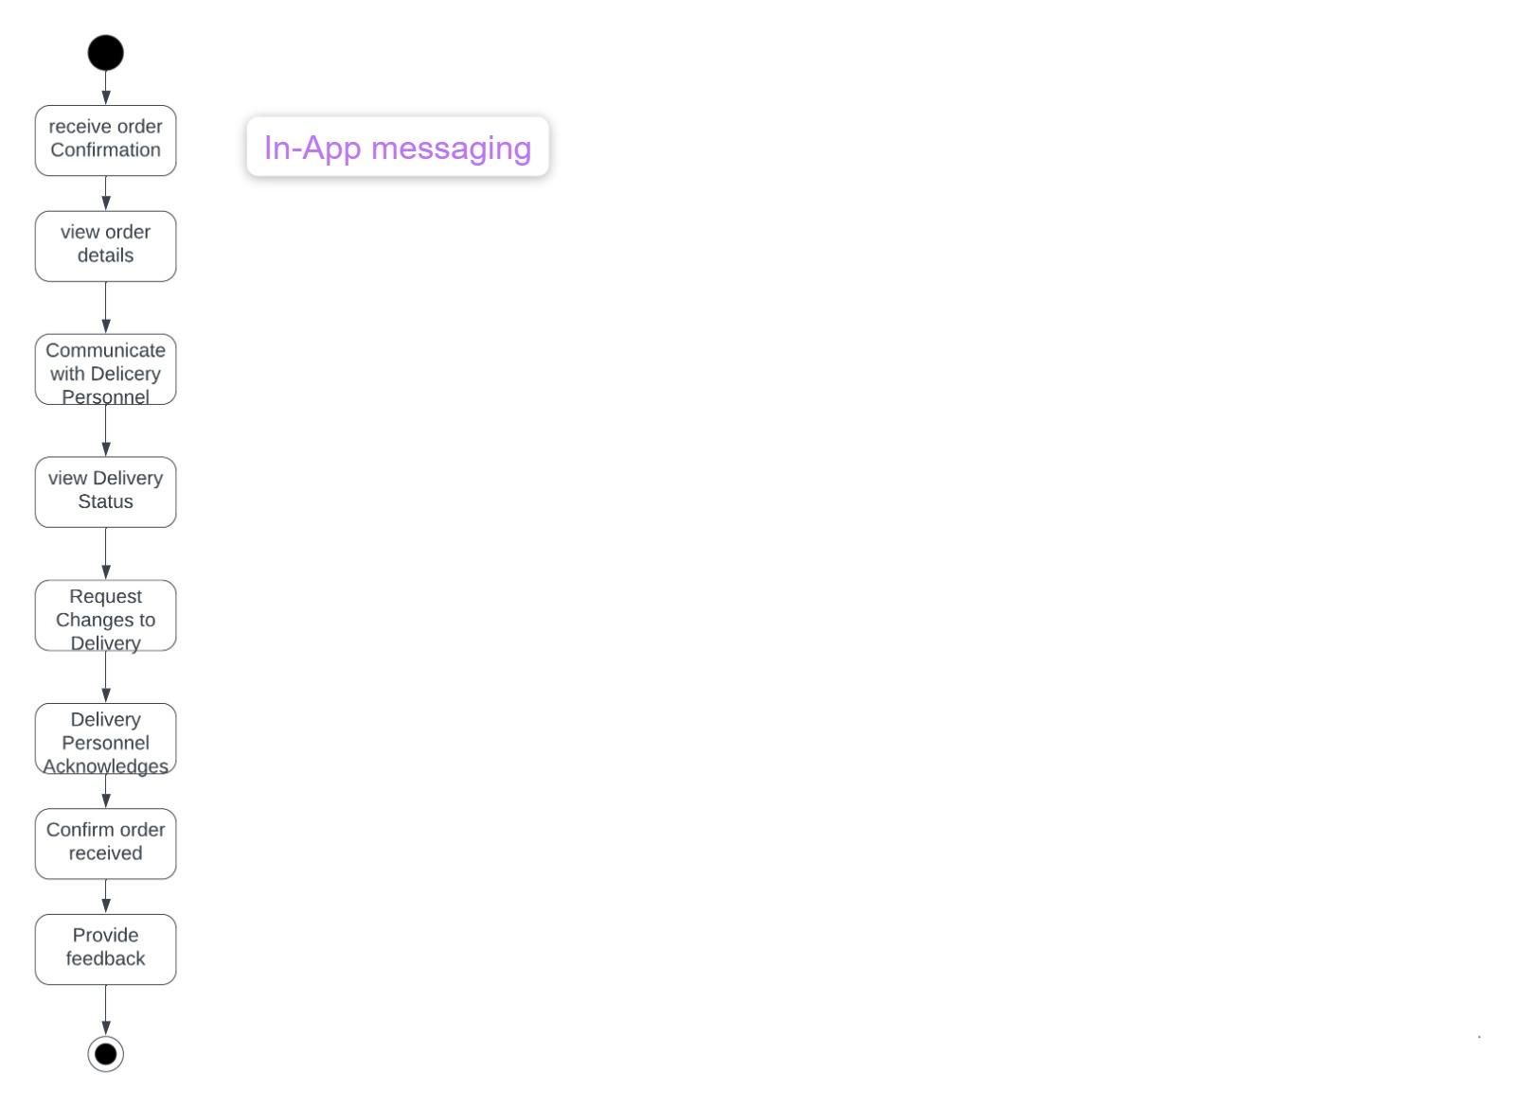

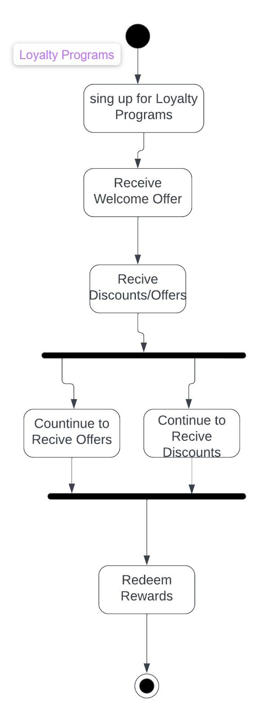

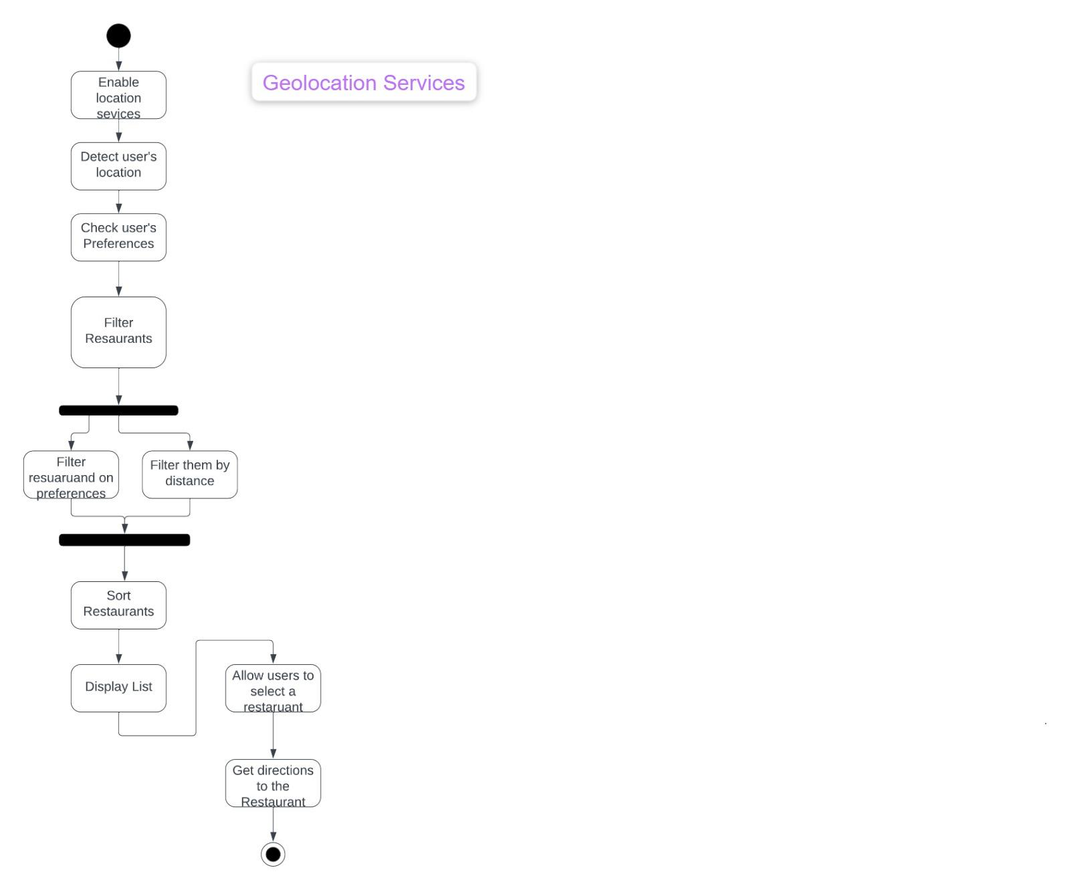

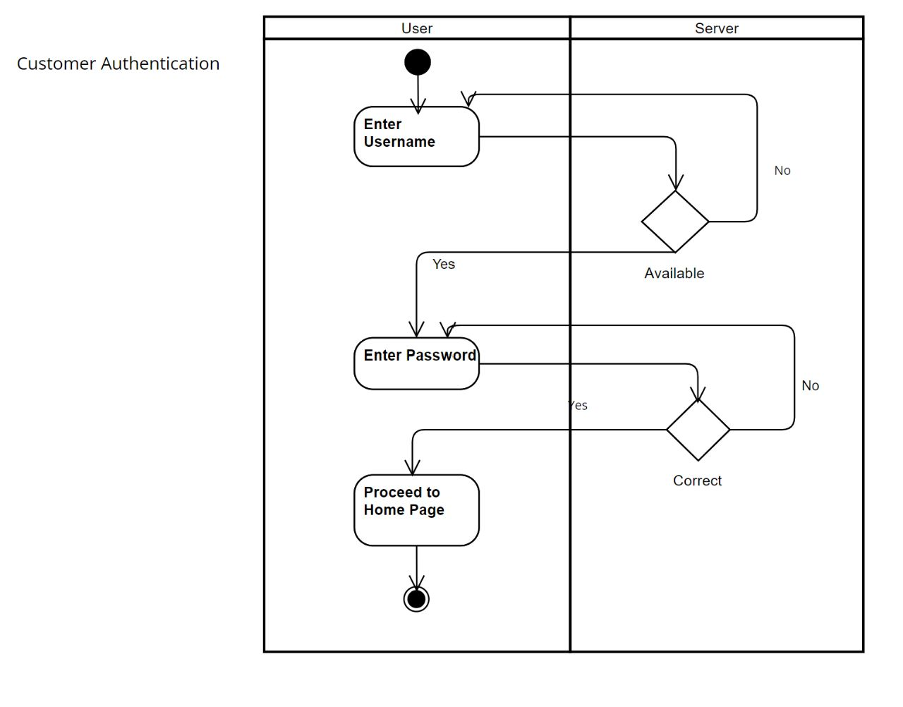

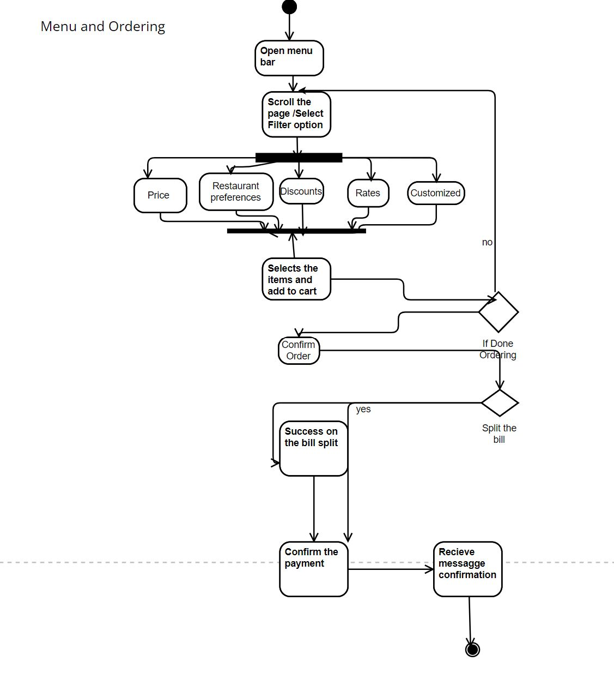

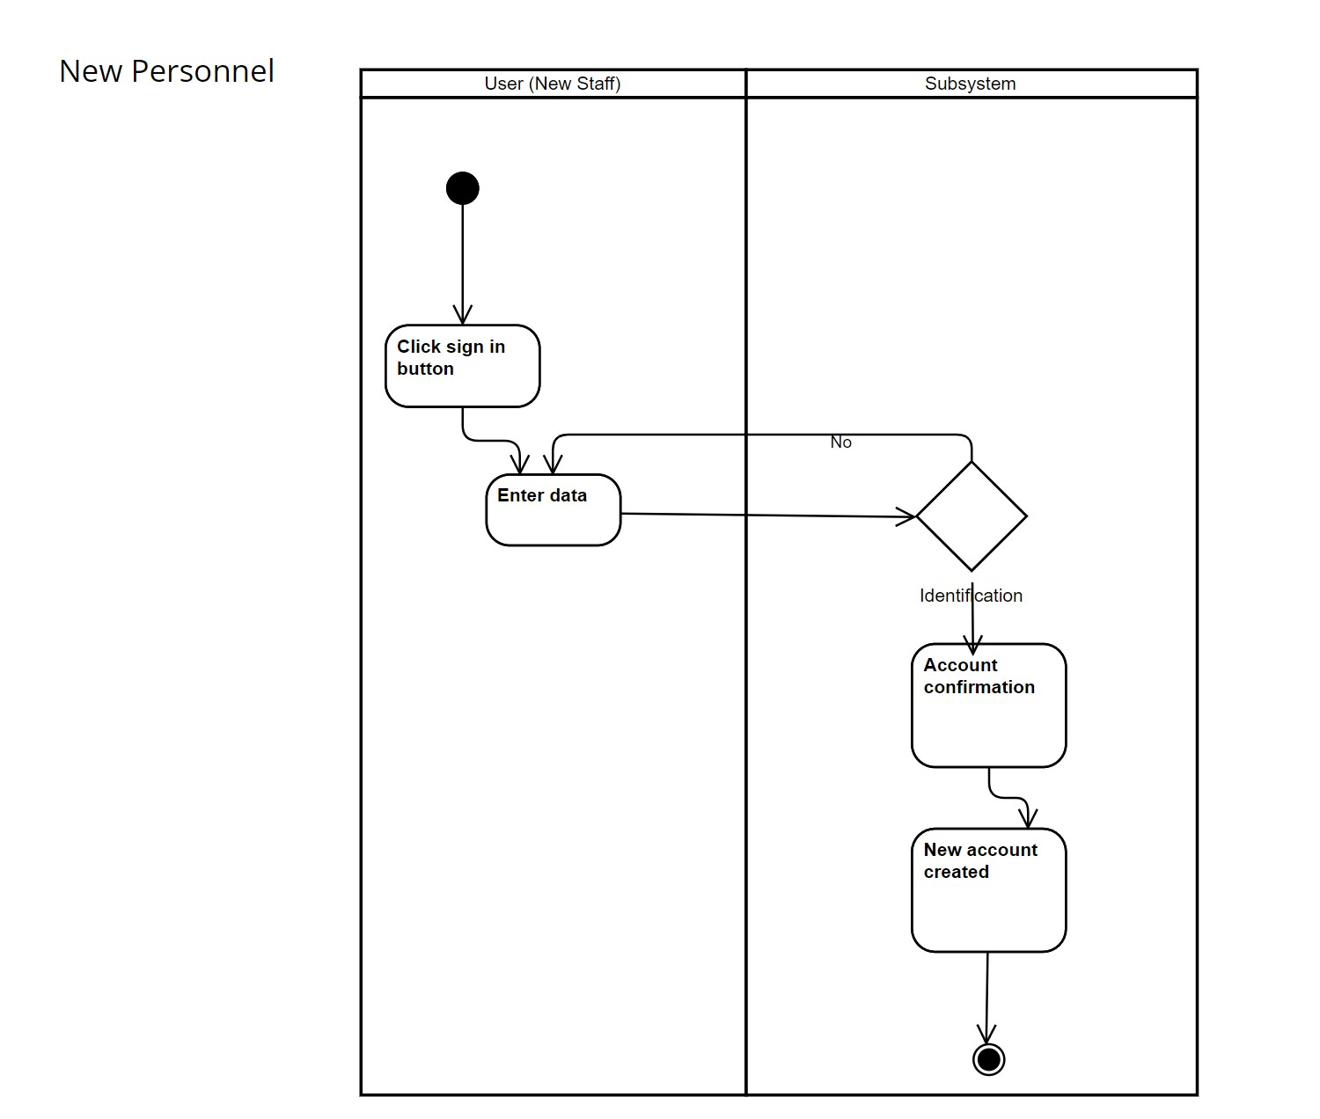

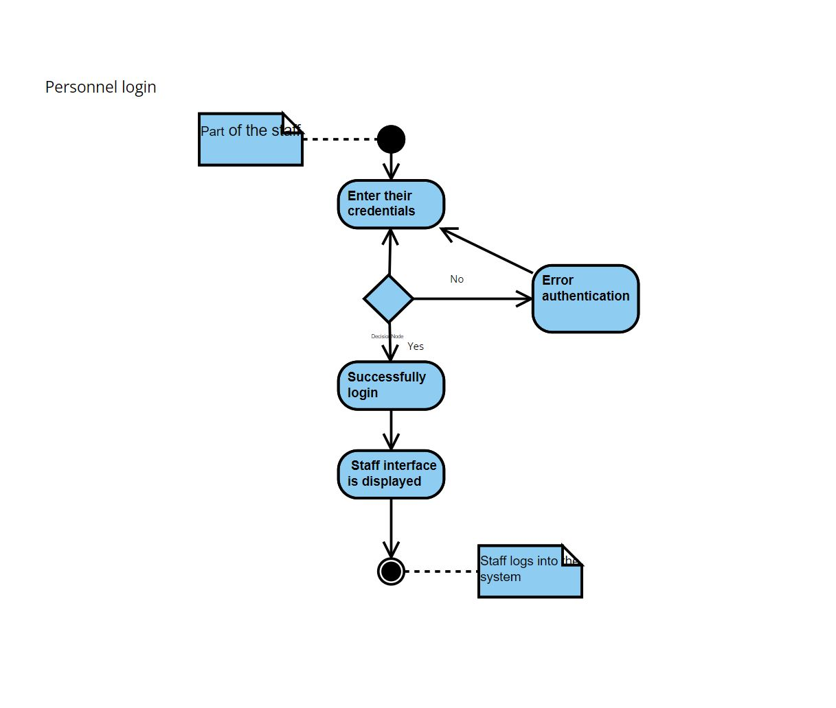

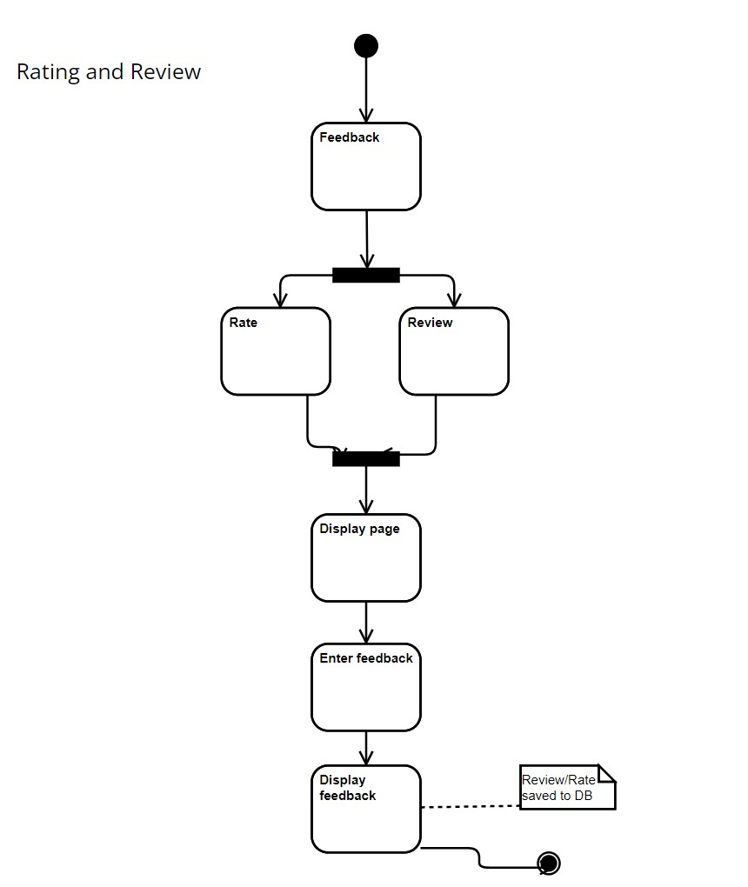

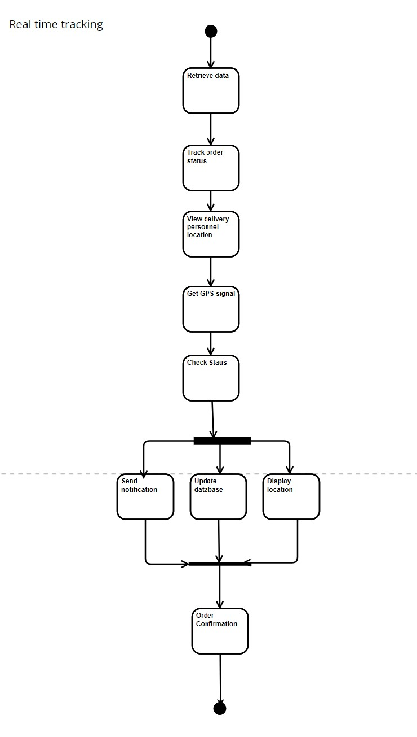

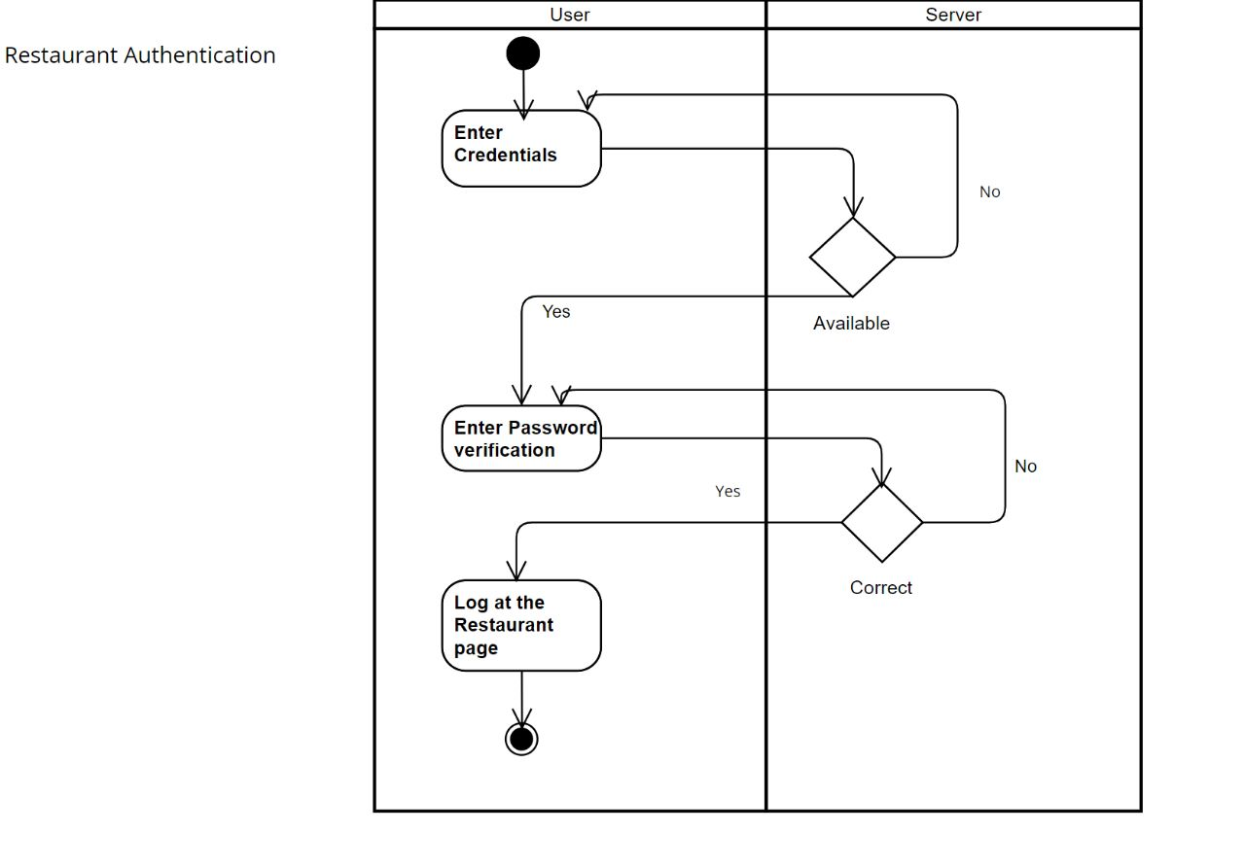

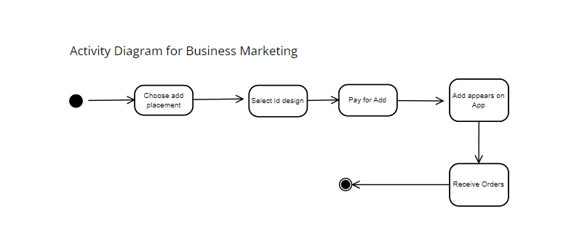

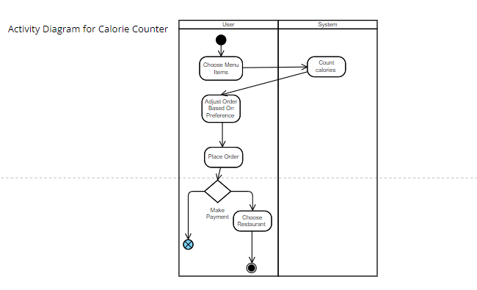

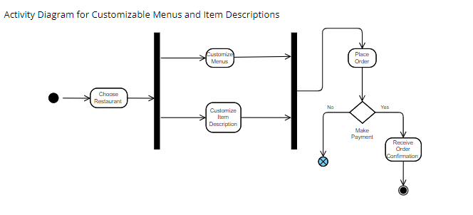

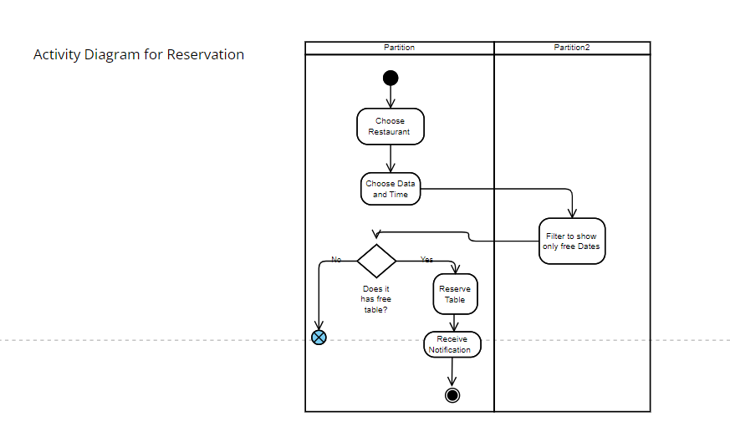

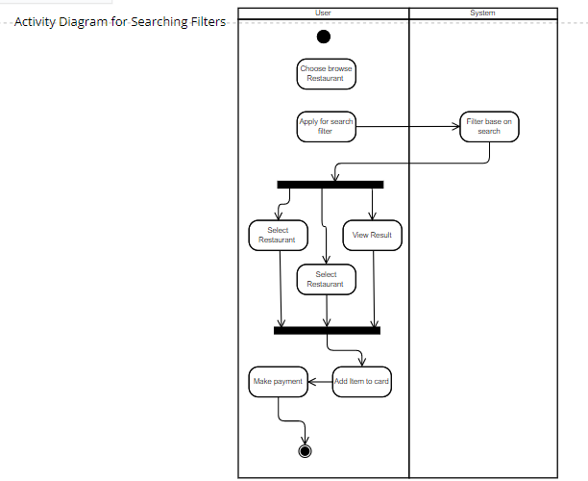**Searching Filters**

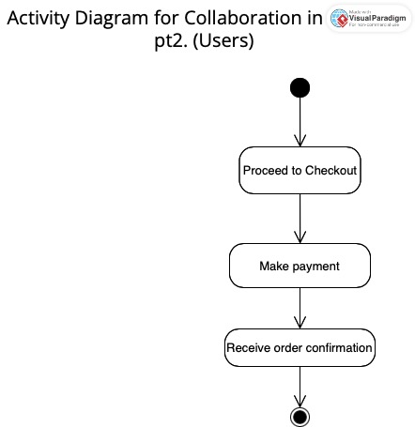

**AfterPayment**

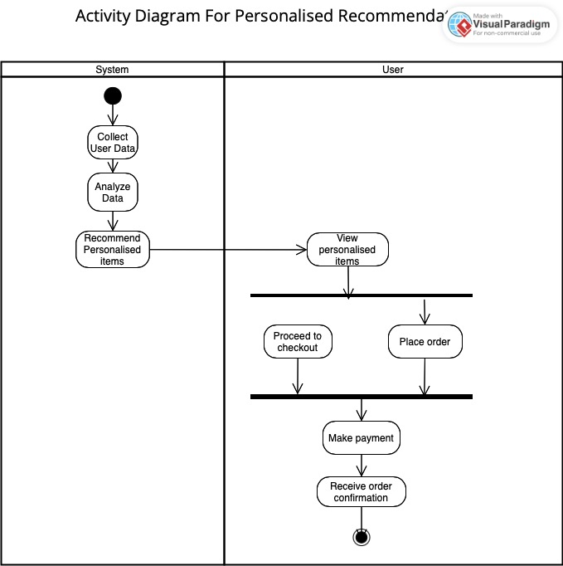**Personalized Recommandations**

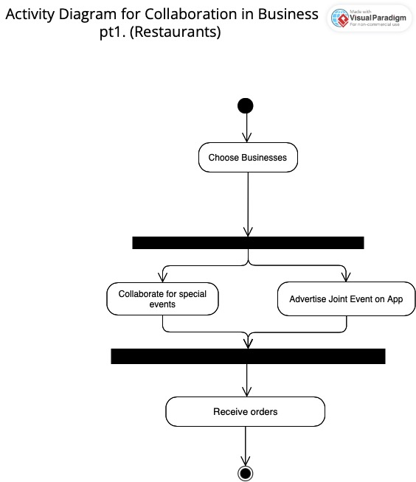**Collaboration in Business**

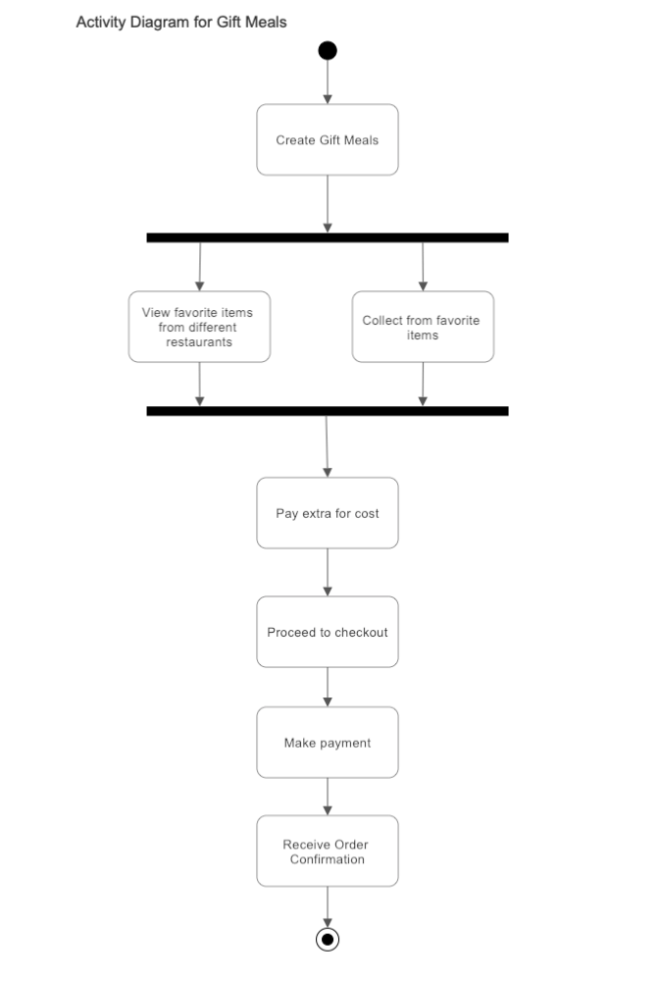

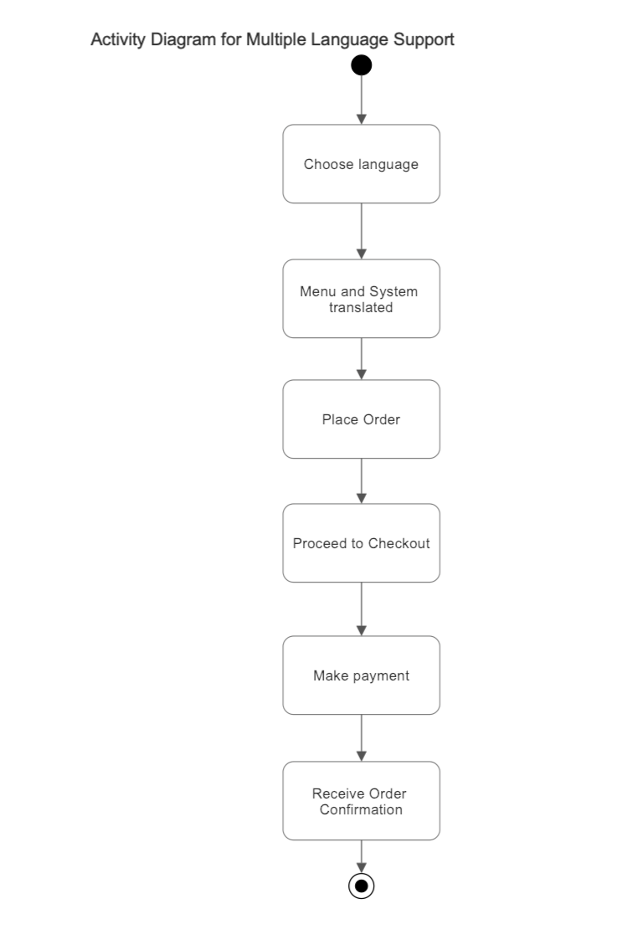

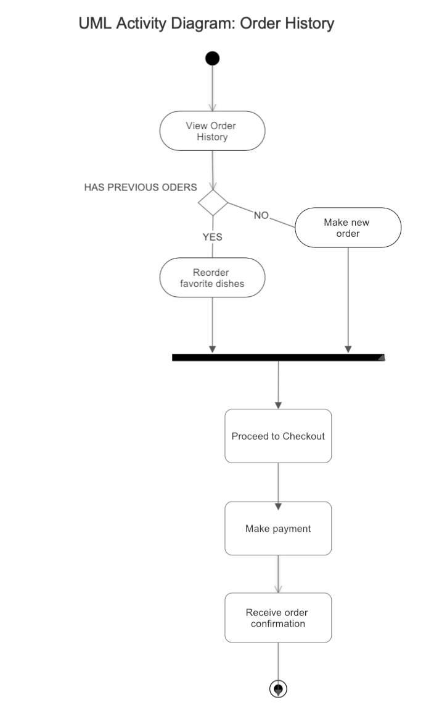

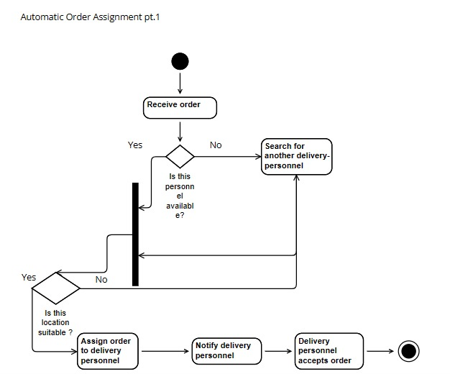

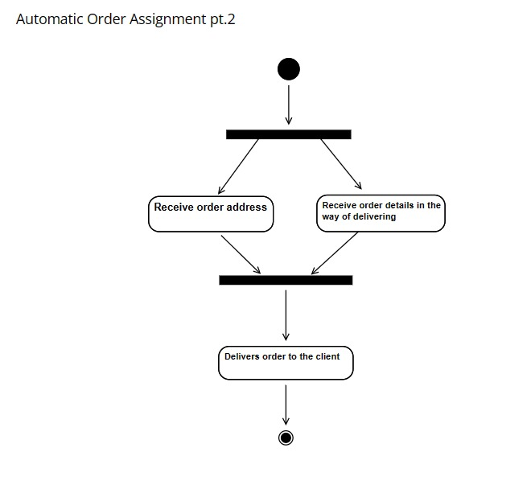

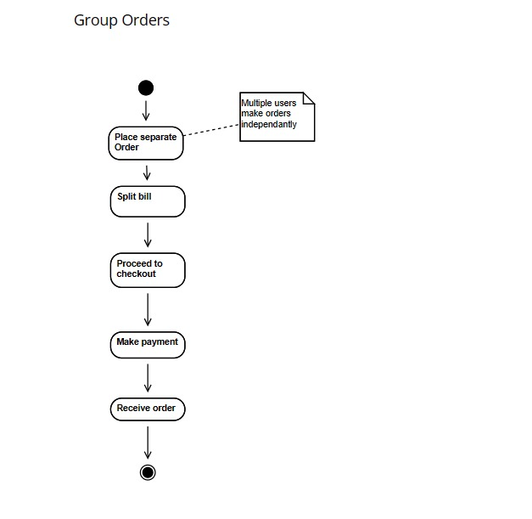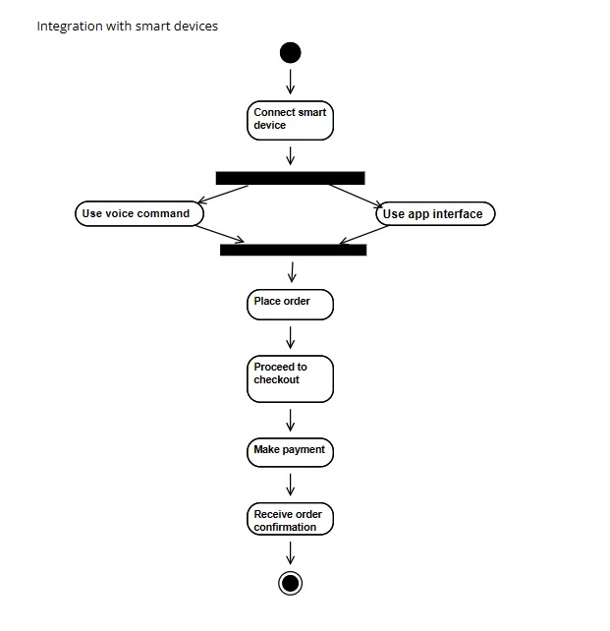

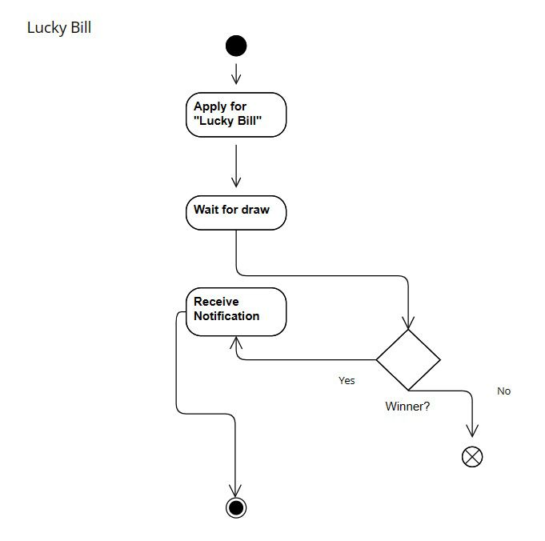

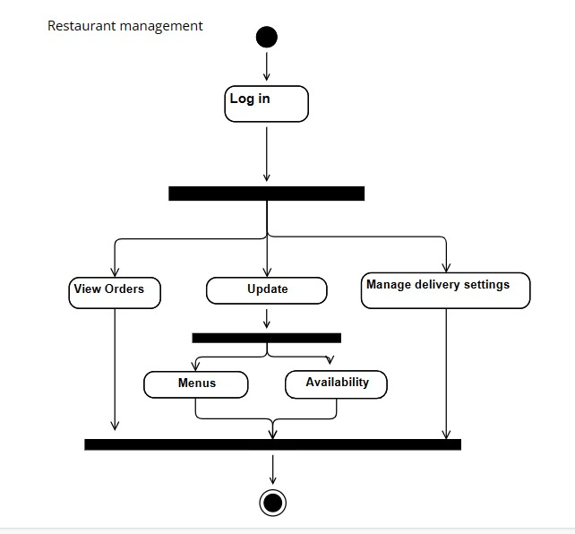

**4.7 State Diagram**

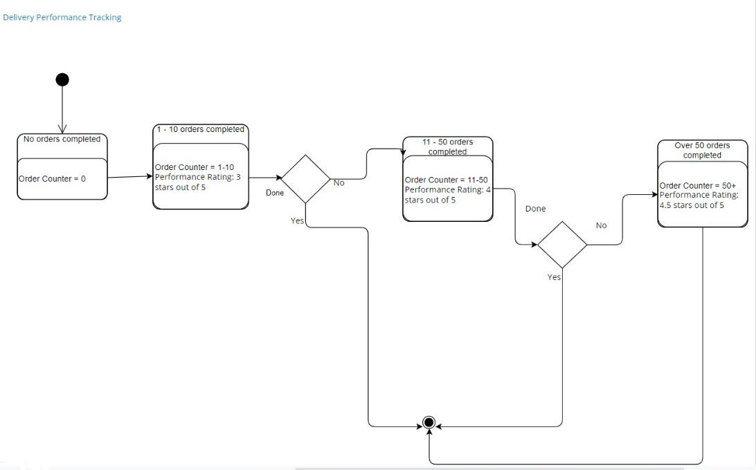

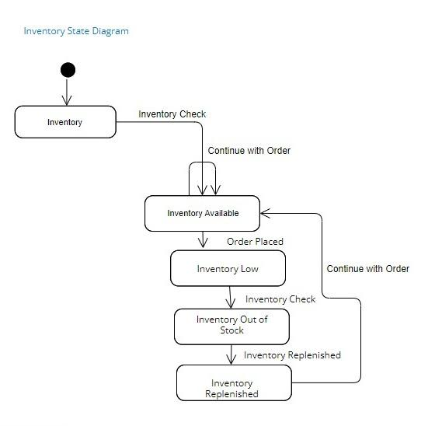

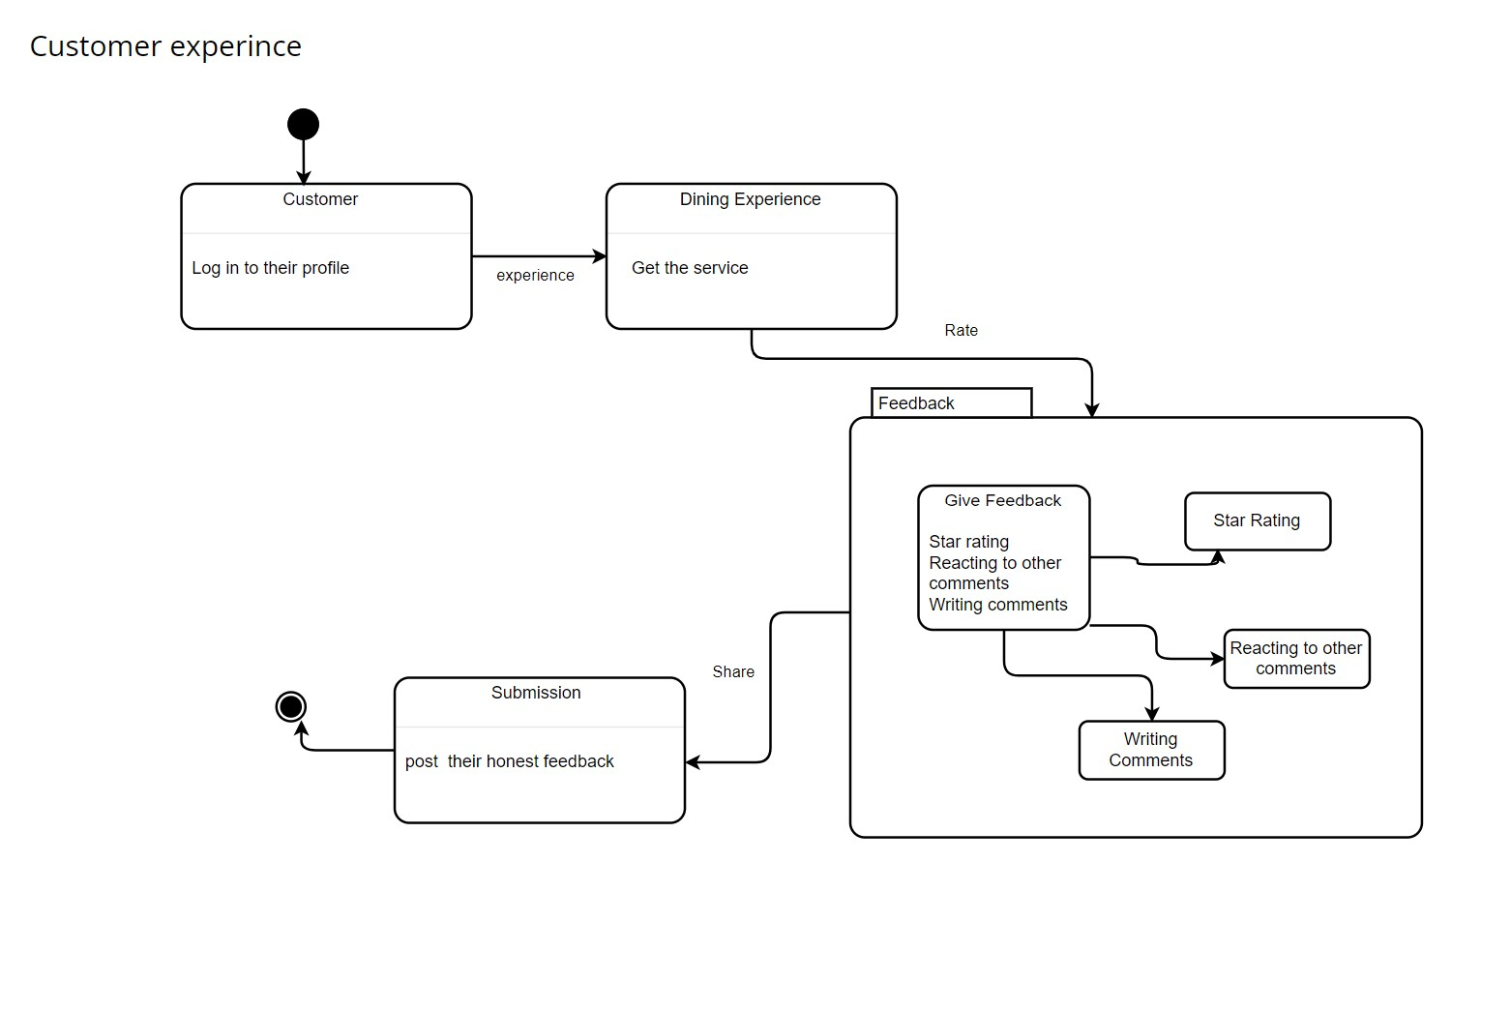

**-Order processing**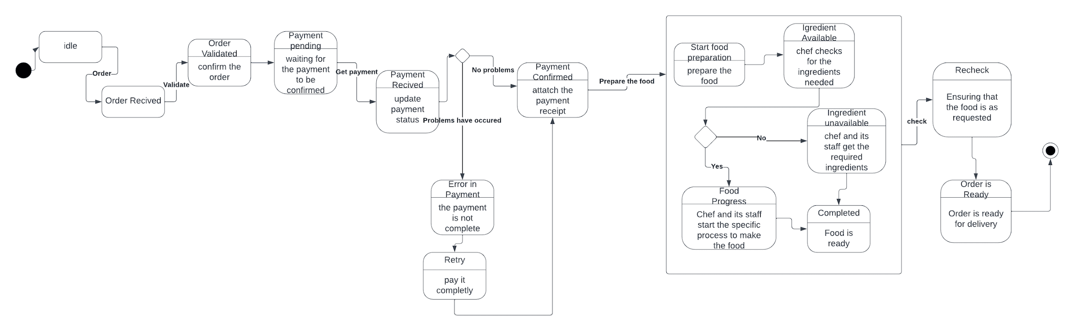

**- restaurant order**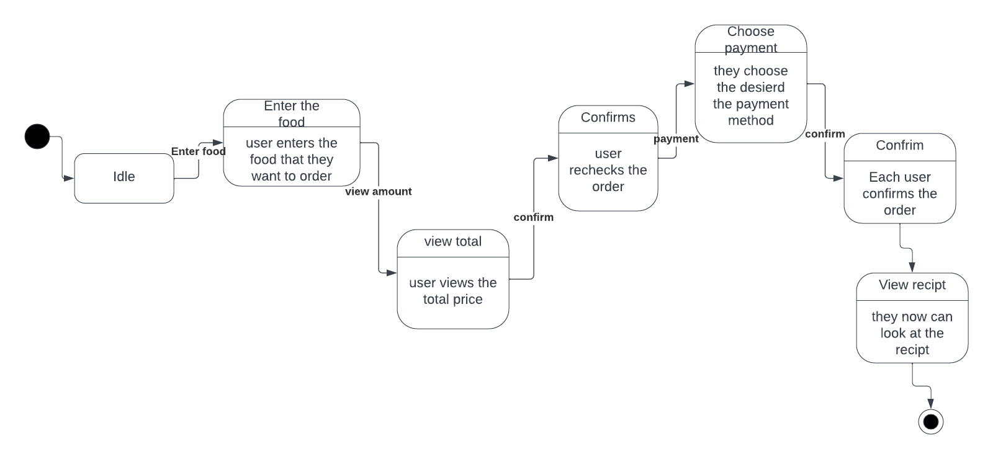

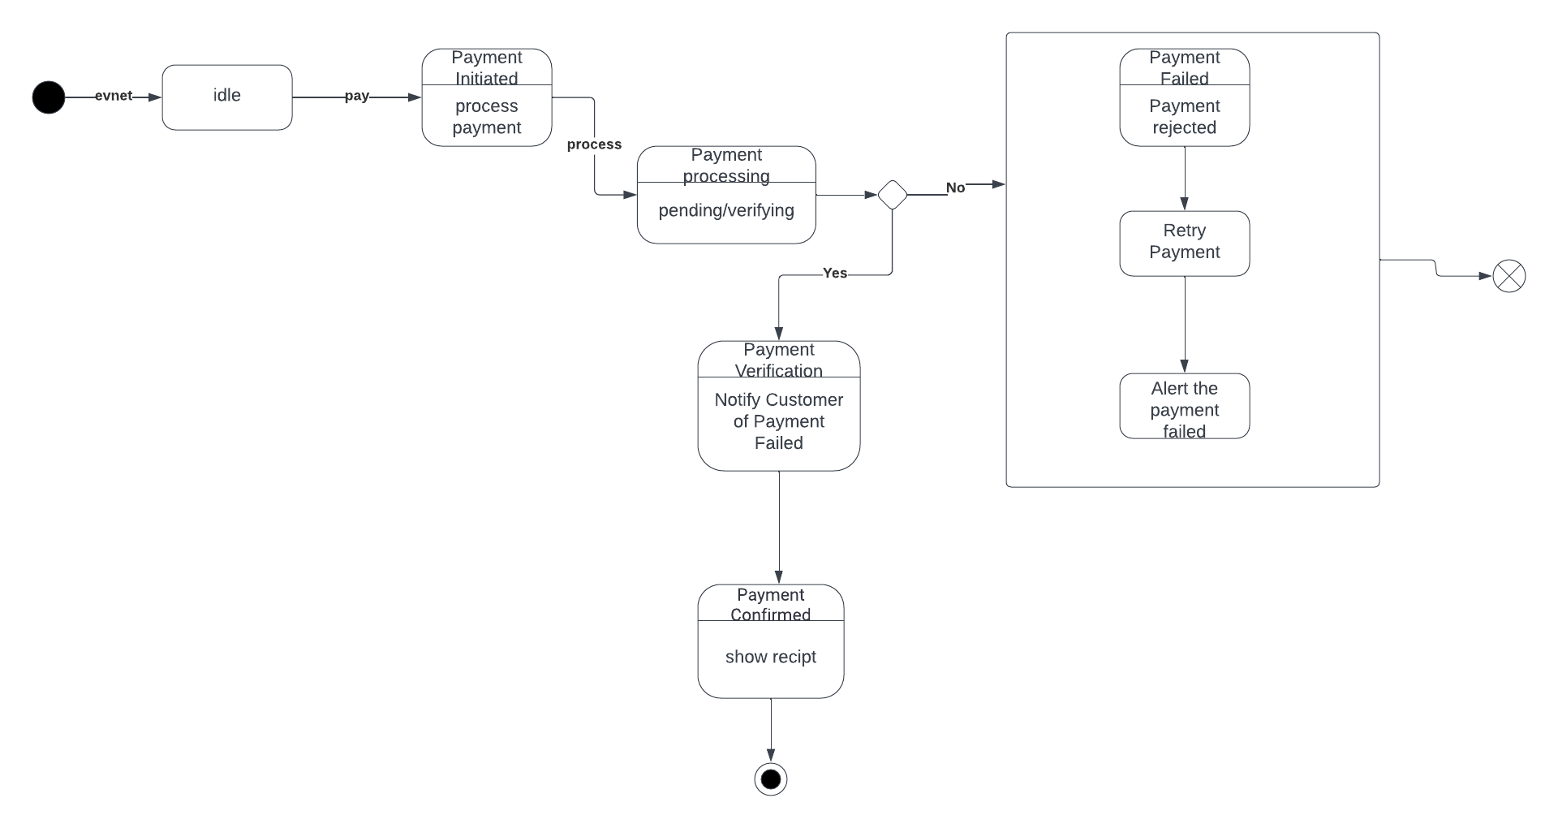**-Payment**

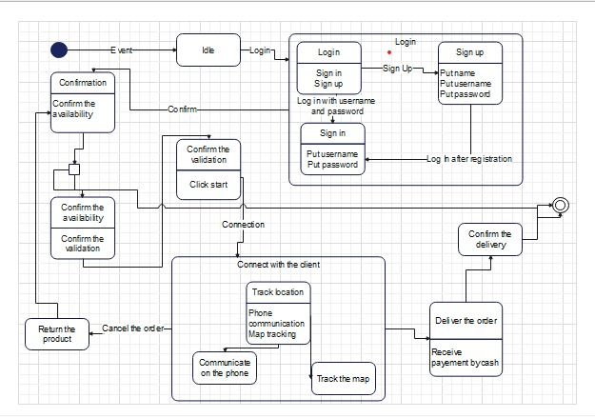**- Delivery State Diagram**

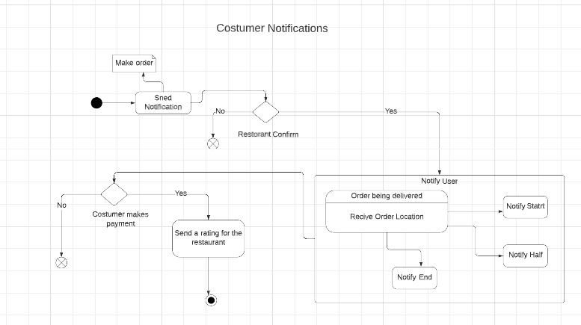**-State diagram for Costumer Notifications**

**-State diagram for Delivery Person Notification**

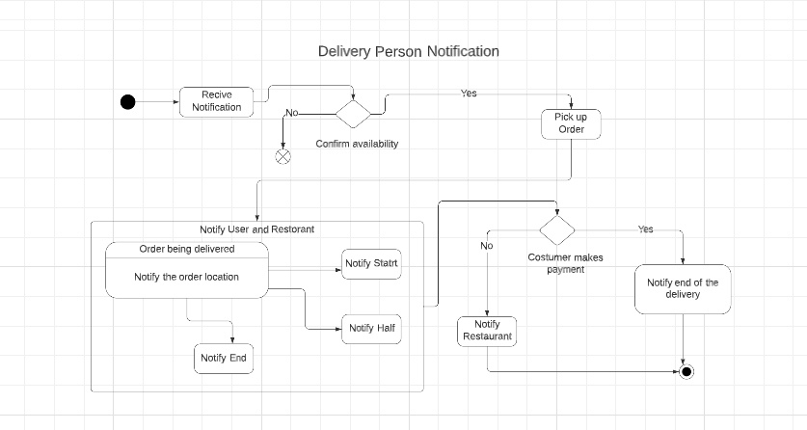

**State diagram for Delivery Person Notification**



**4.8 Sequence Diagrams**

* 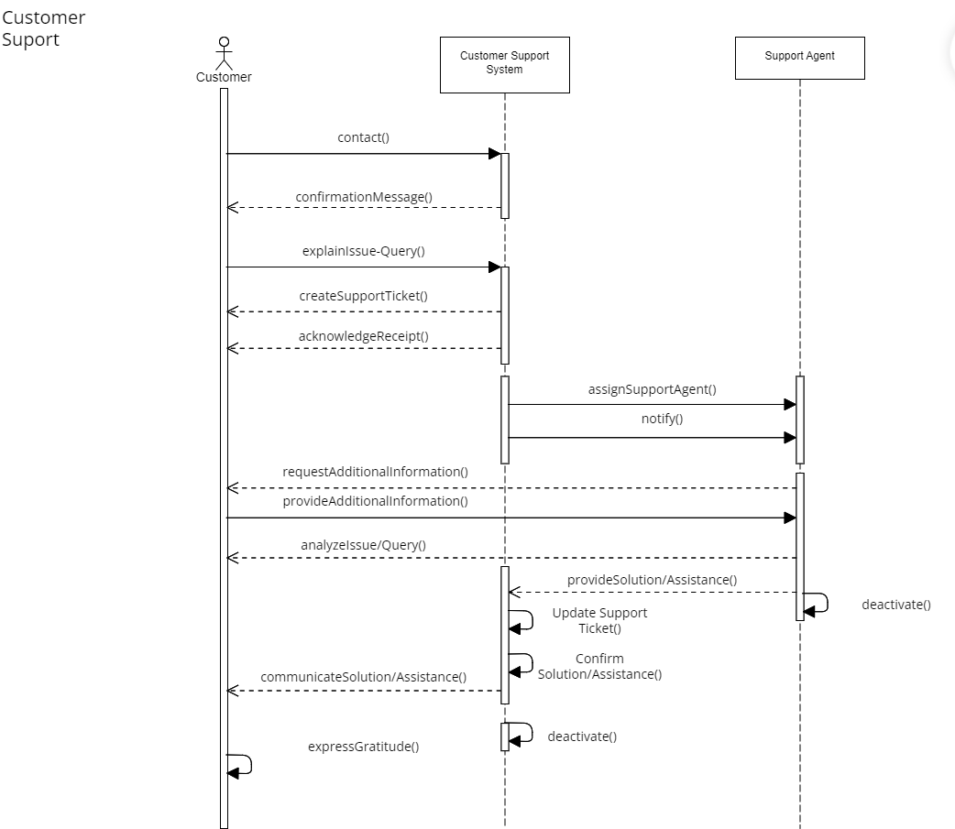**Customer Support**
* **Loyalty Program** 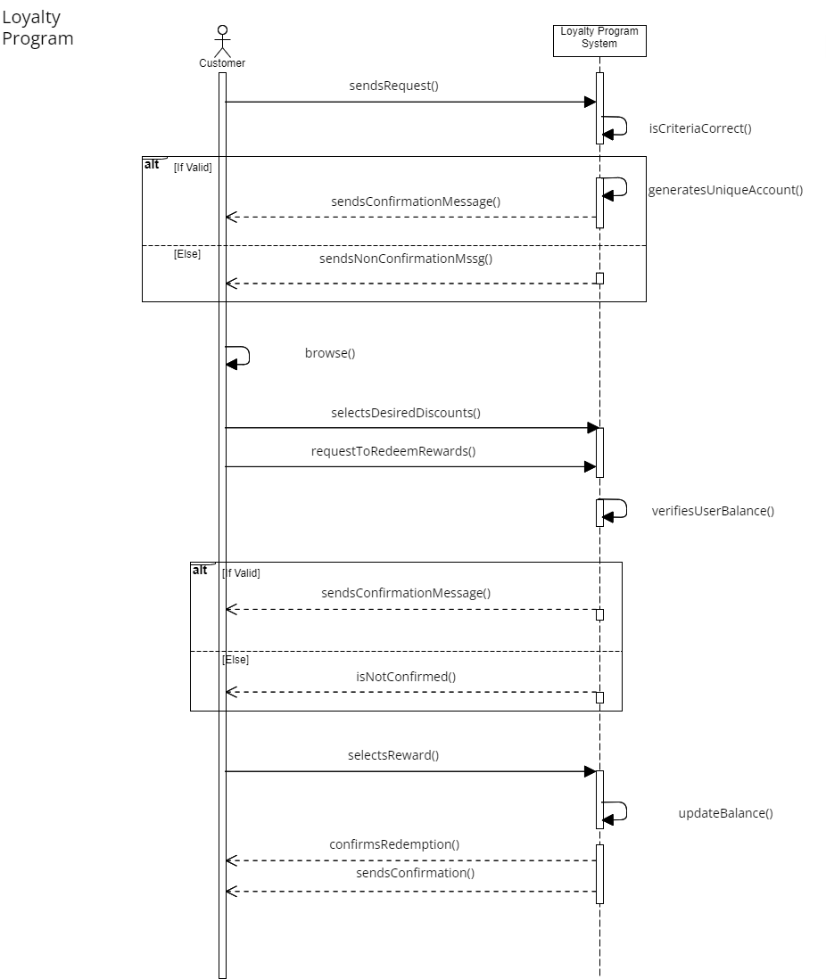
* **Discount Chances**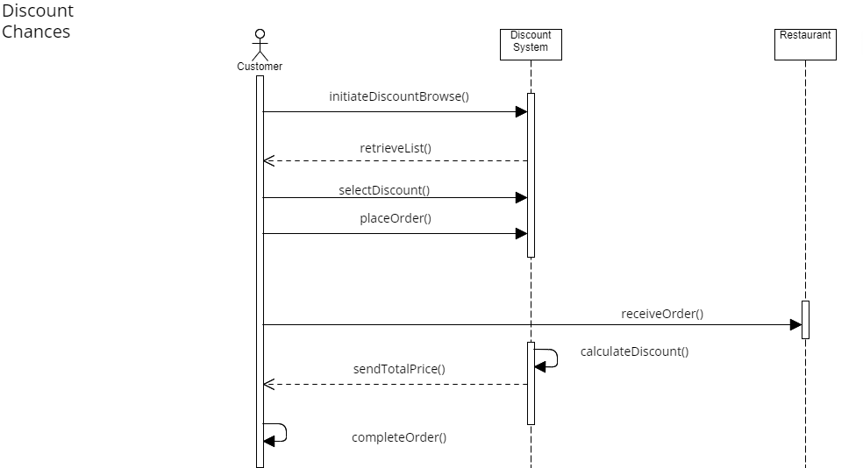

* **Geolocation Service** 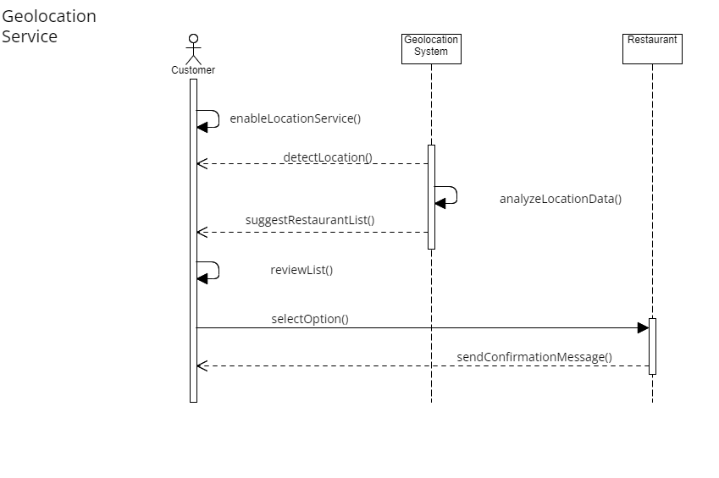

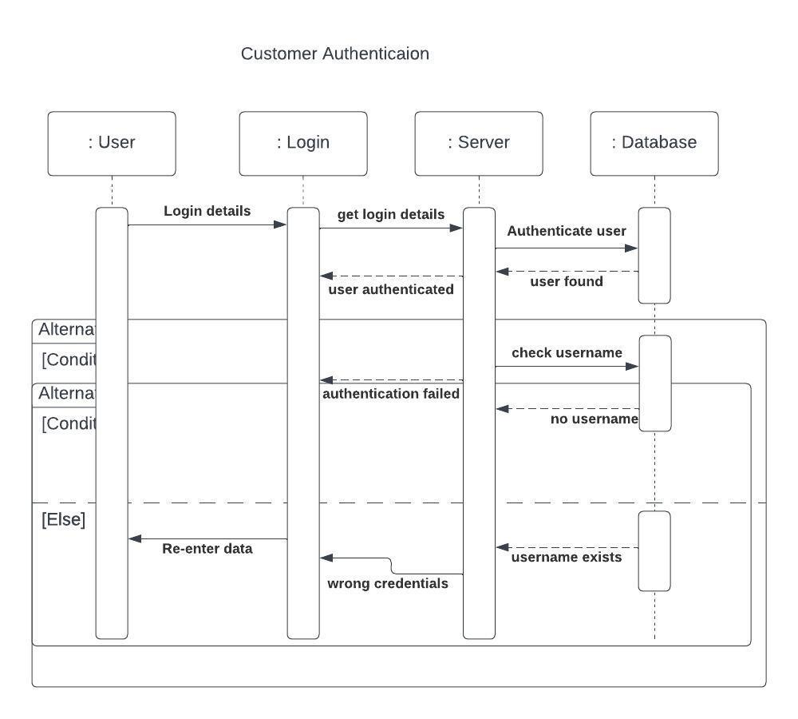

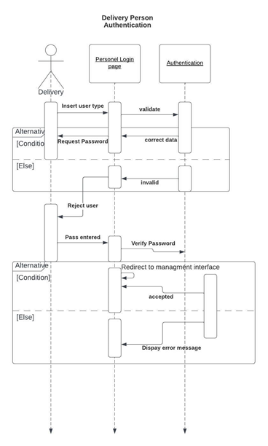

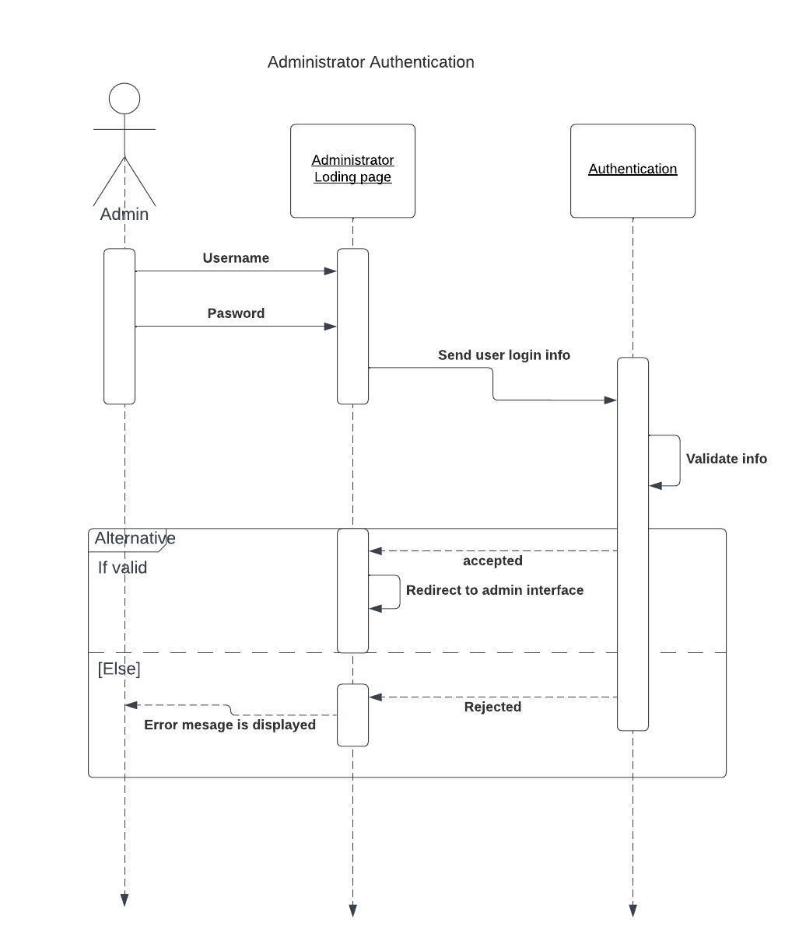

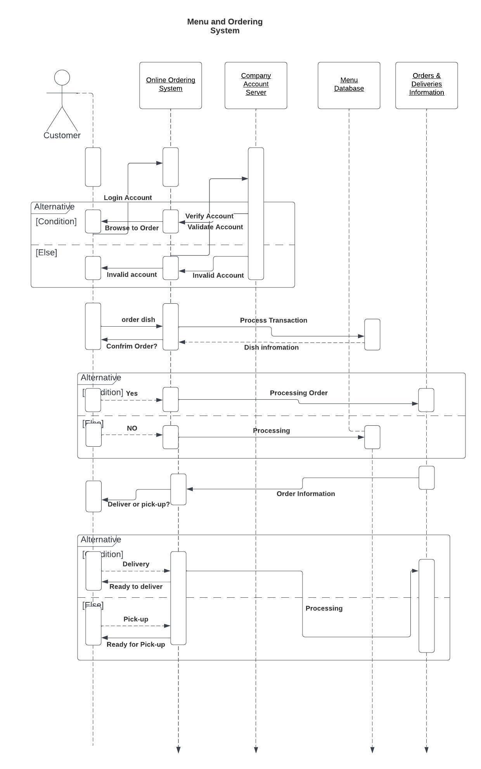

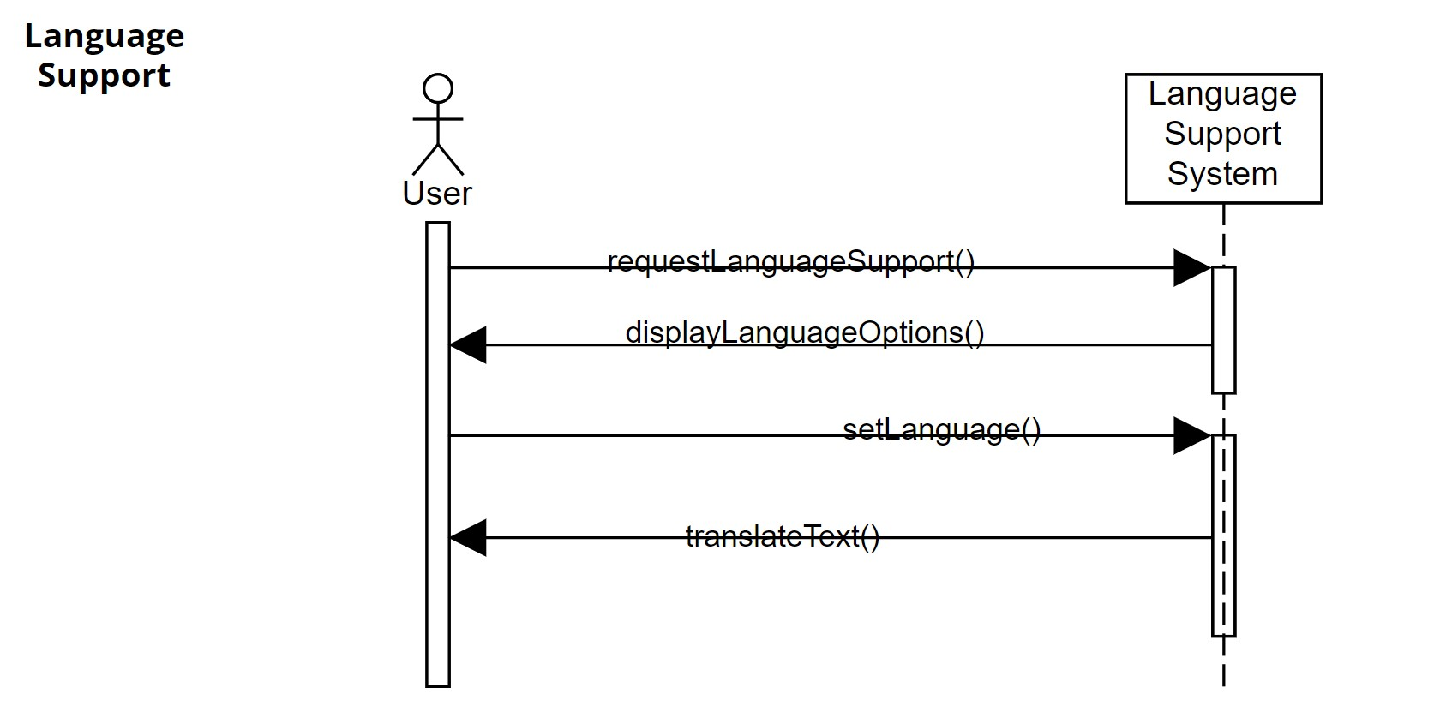

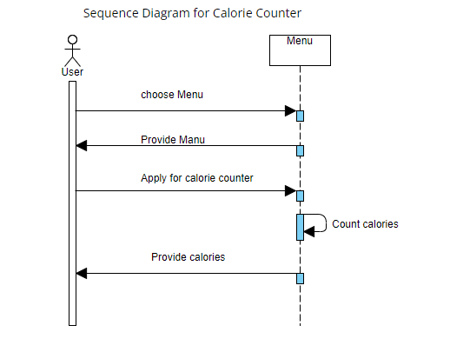

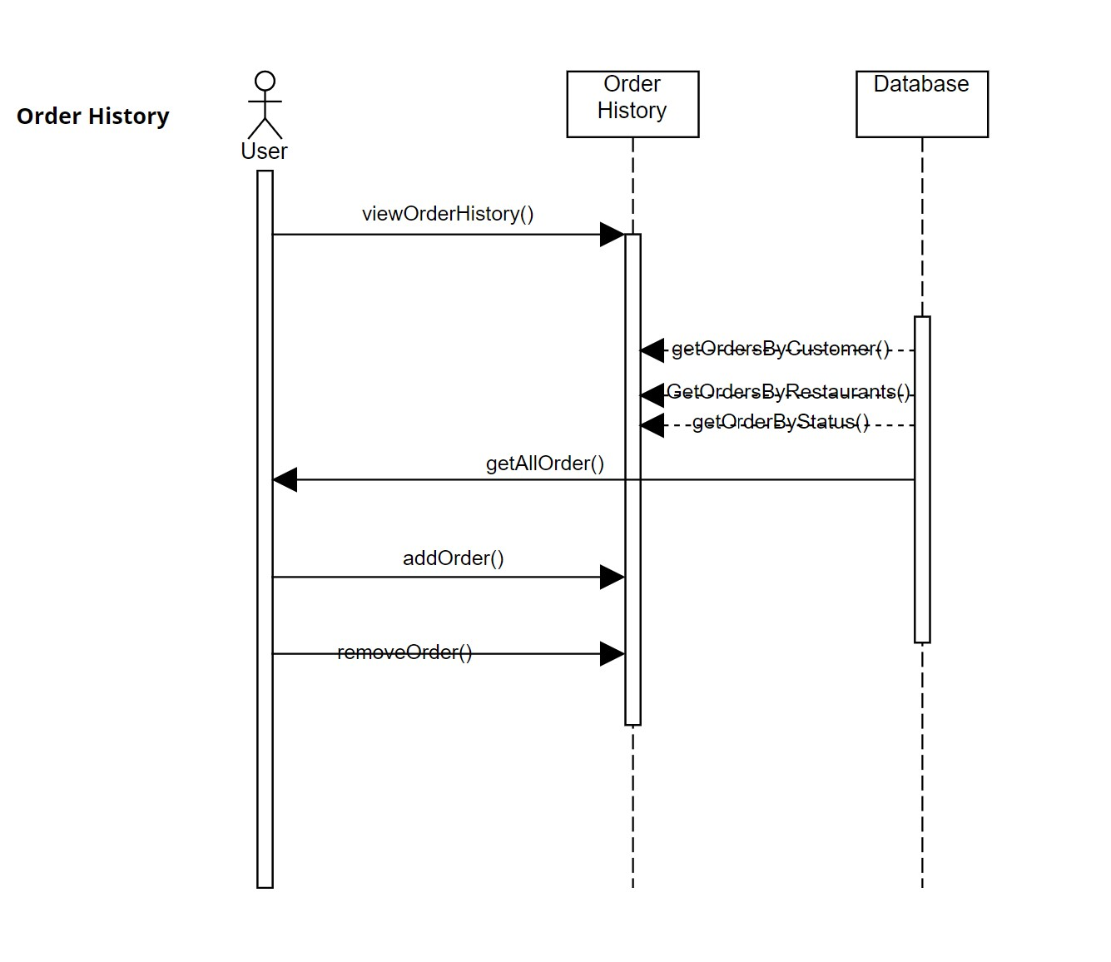

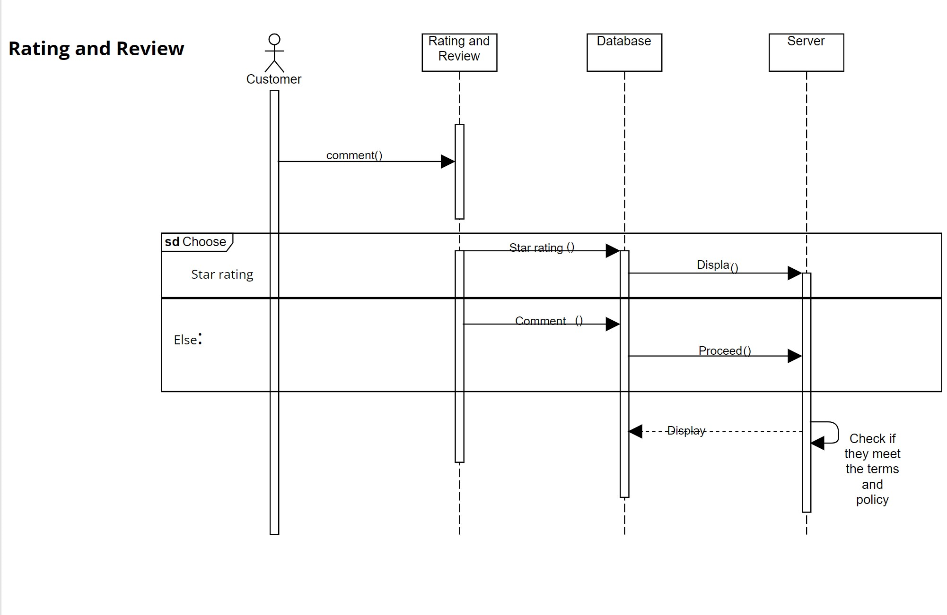

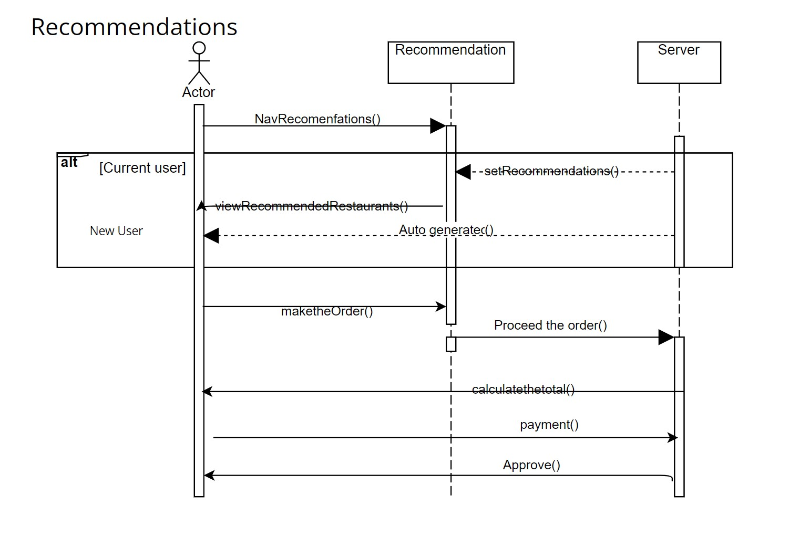

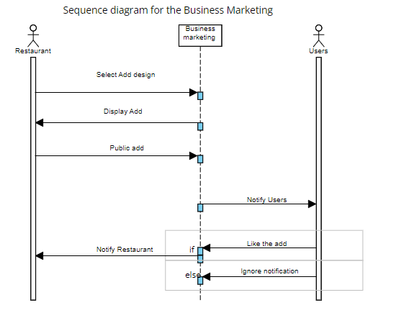

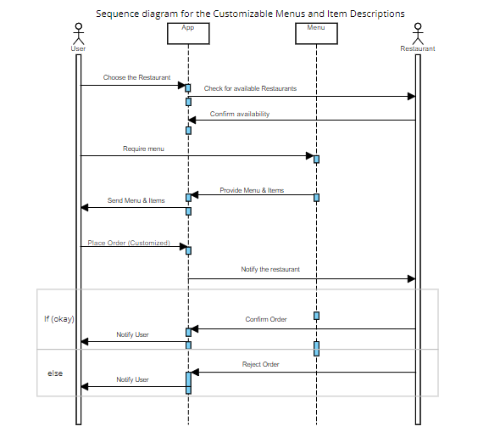

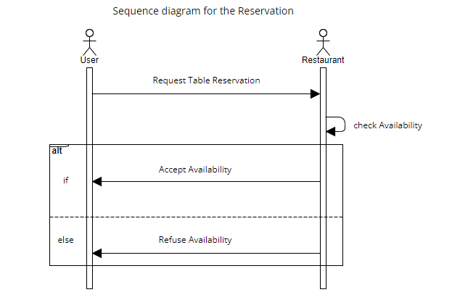

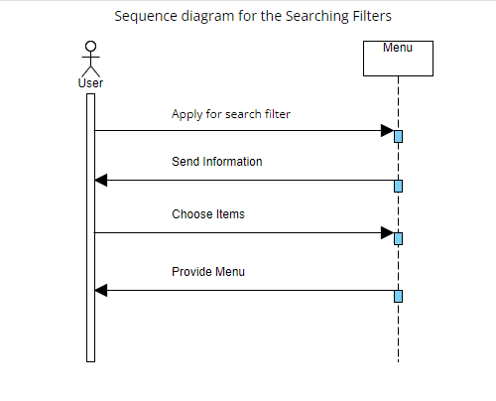

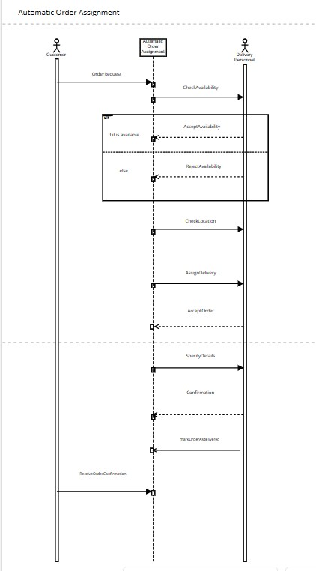

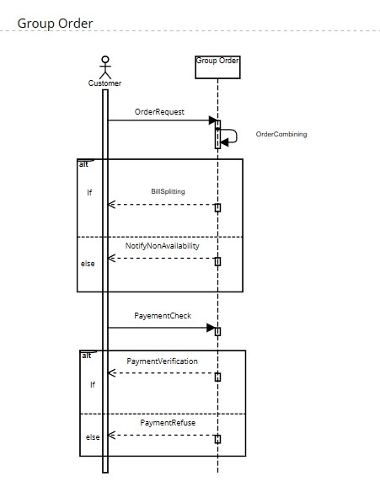

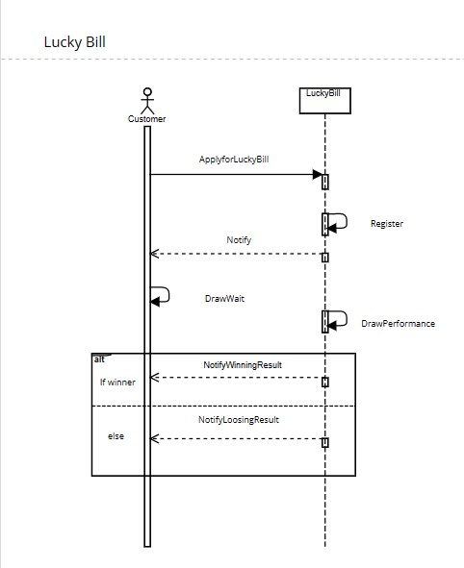

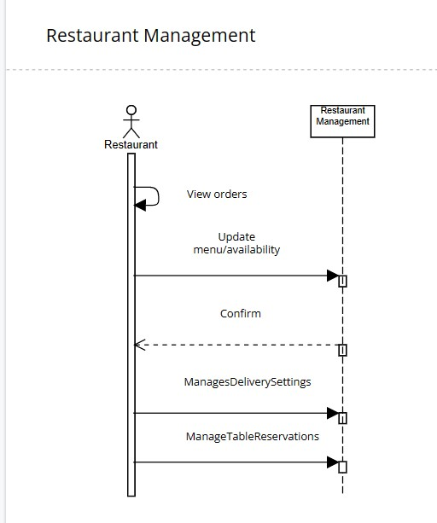

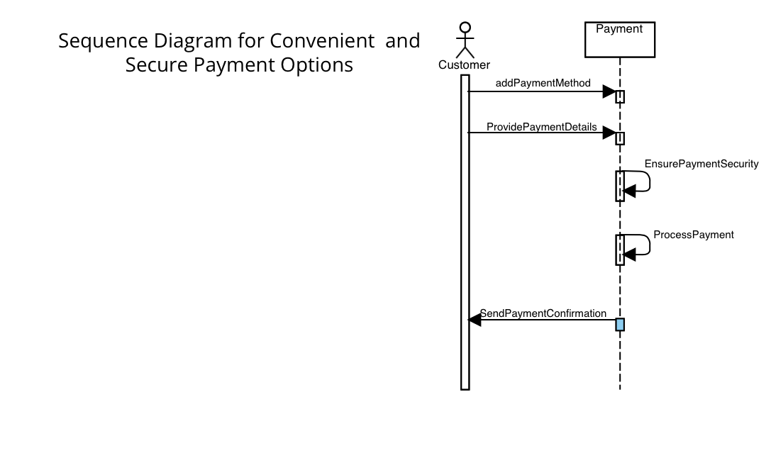

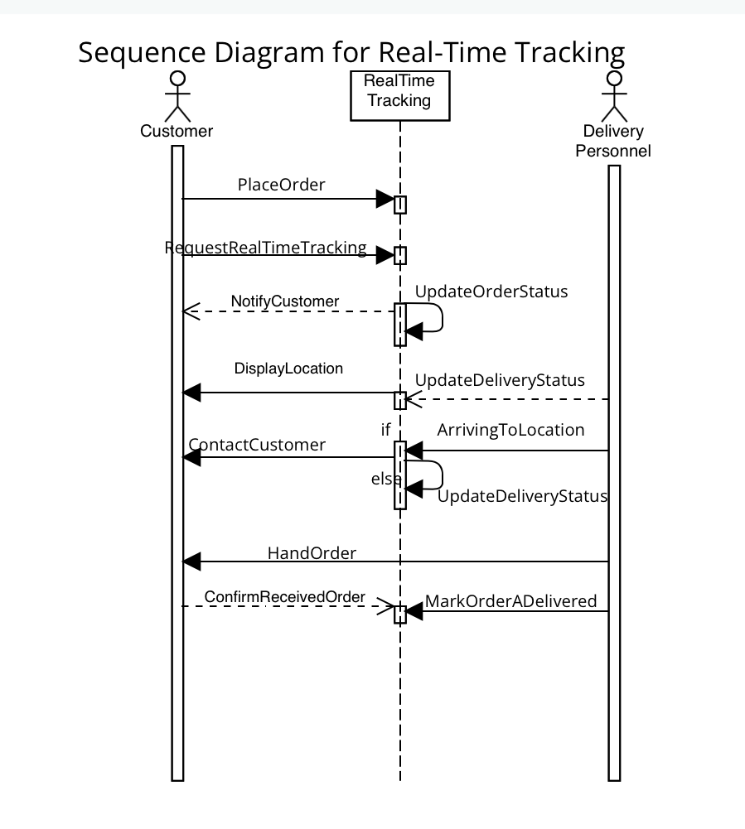

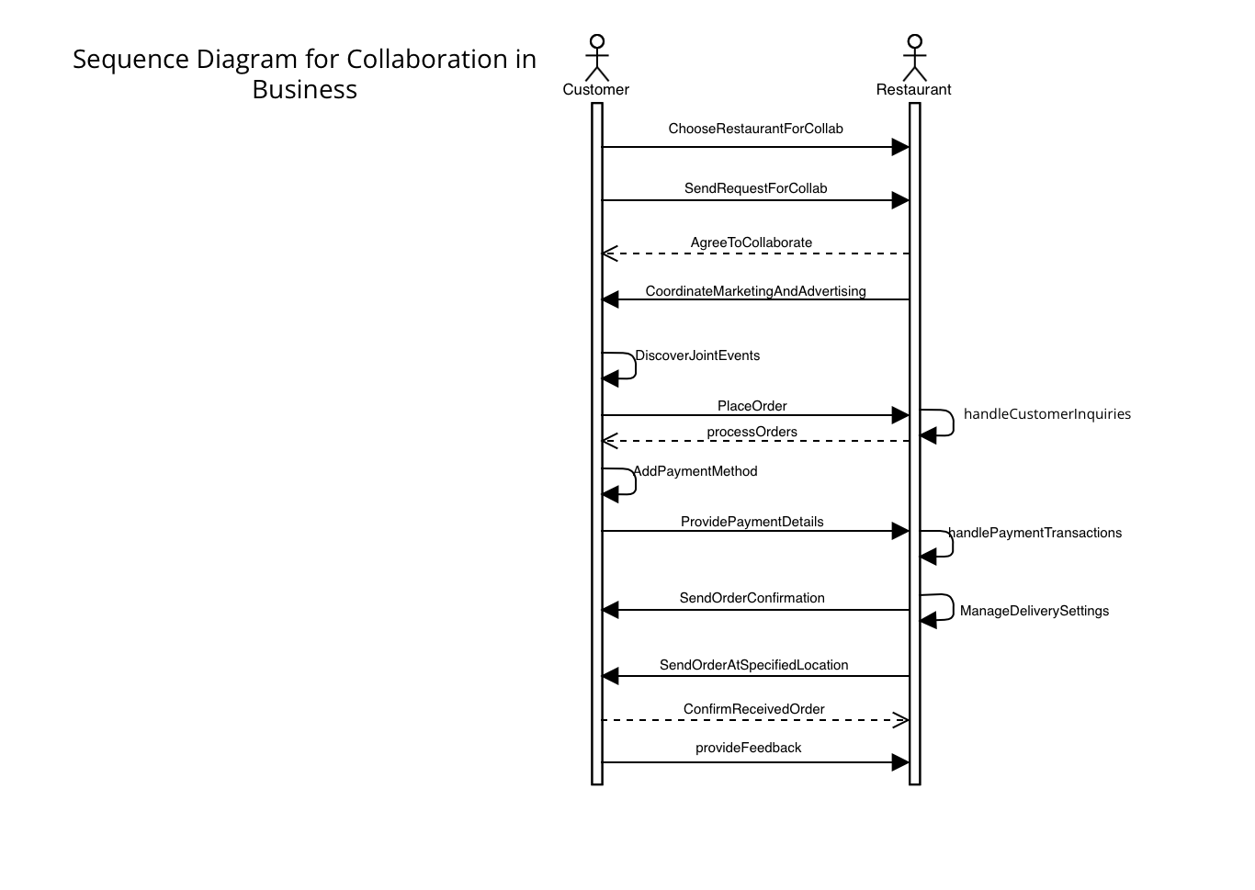

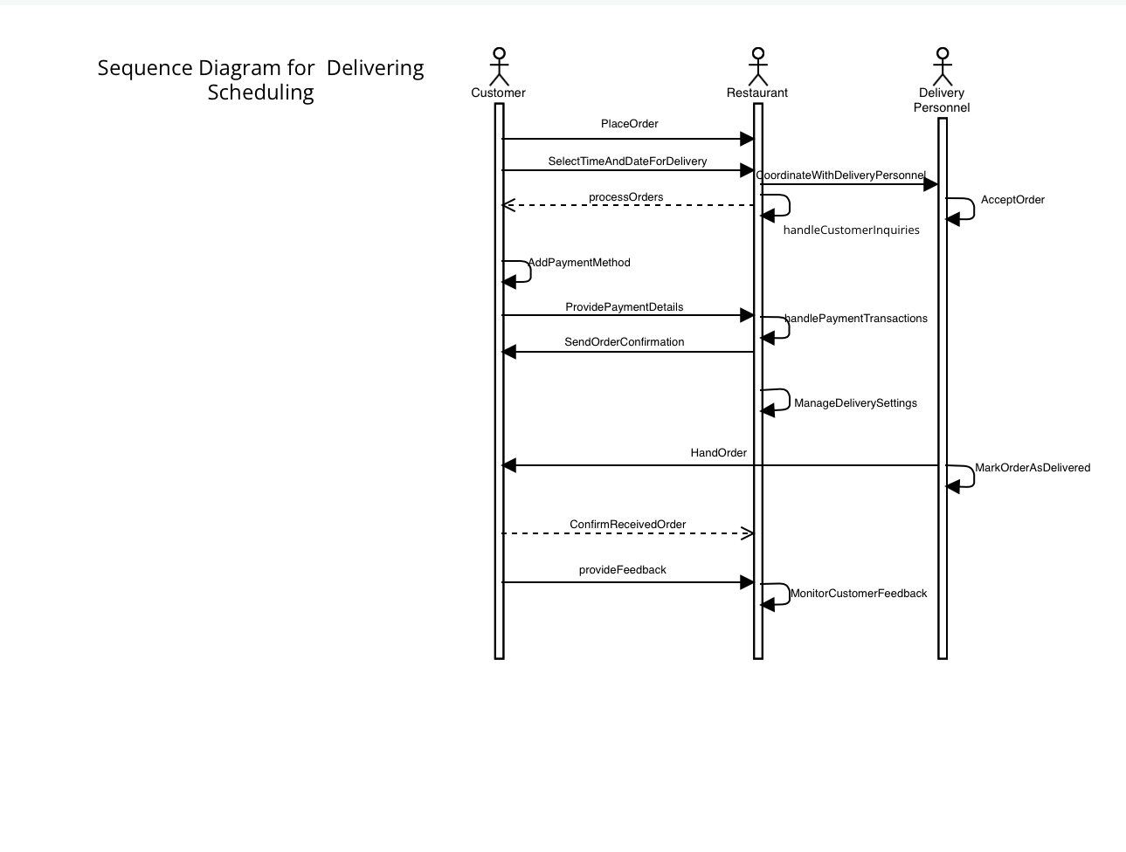

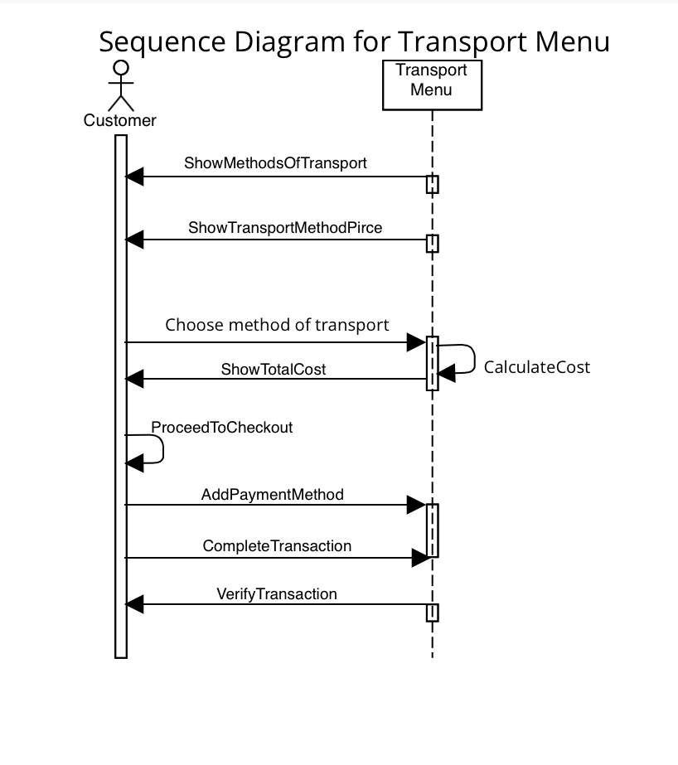

**4.9 Collaboration Diagrams**

**- Delivery Tracking**

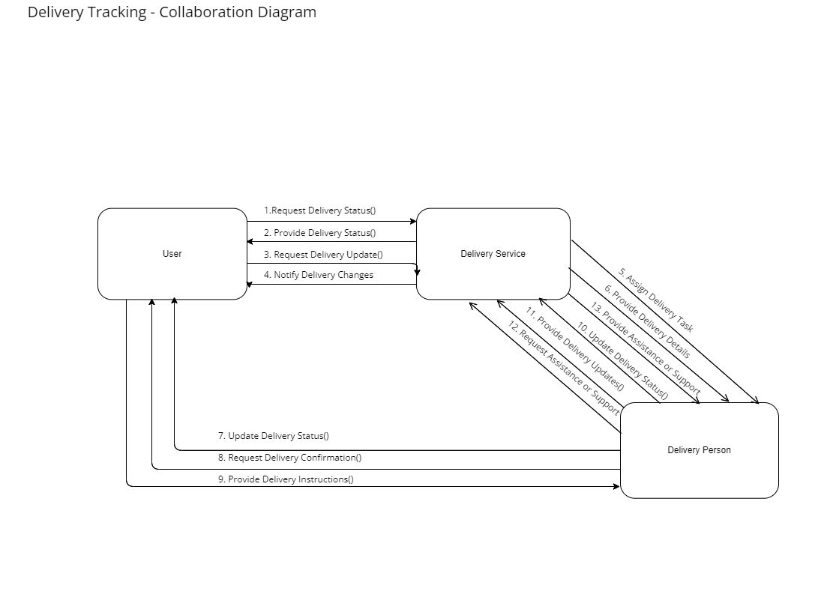

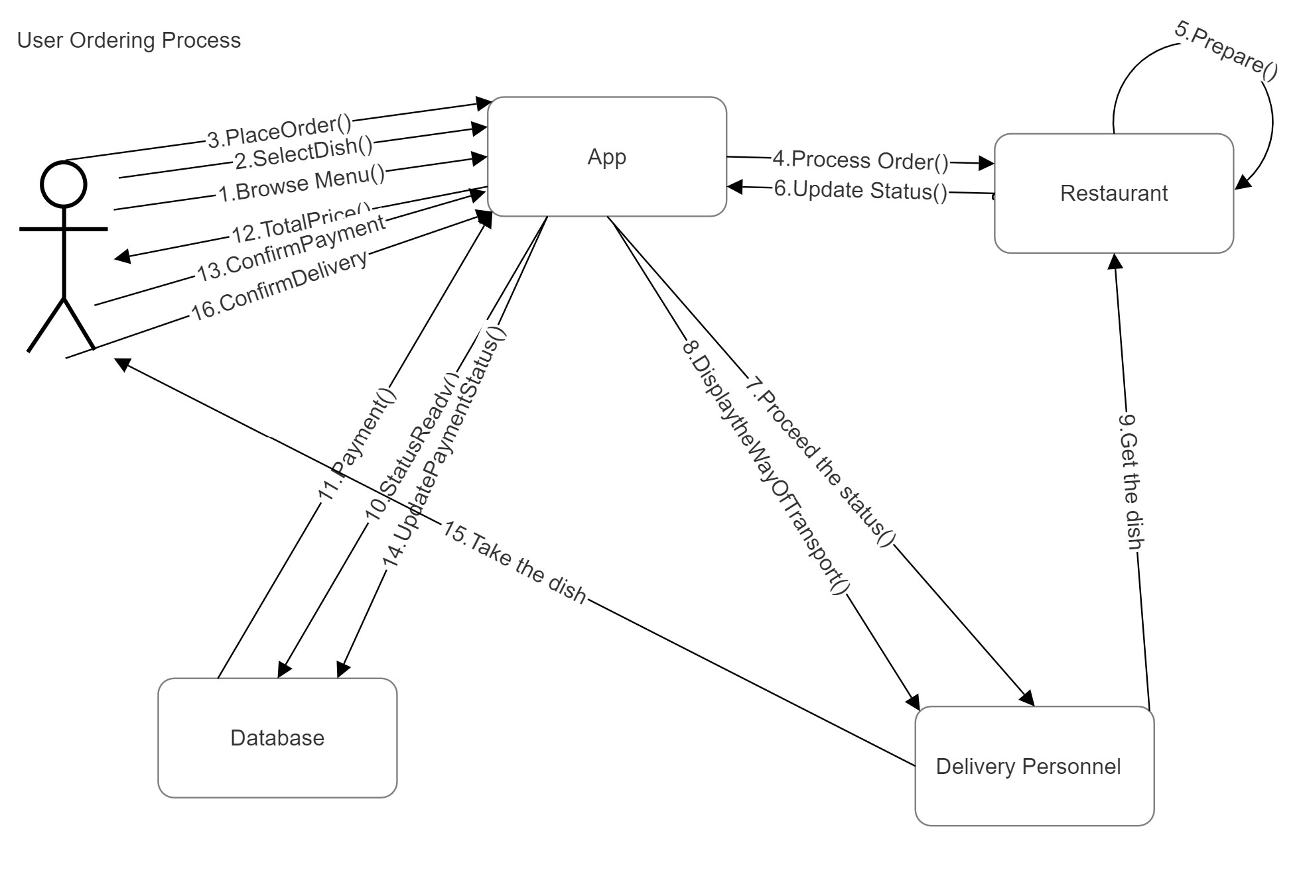

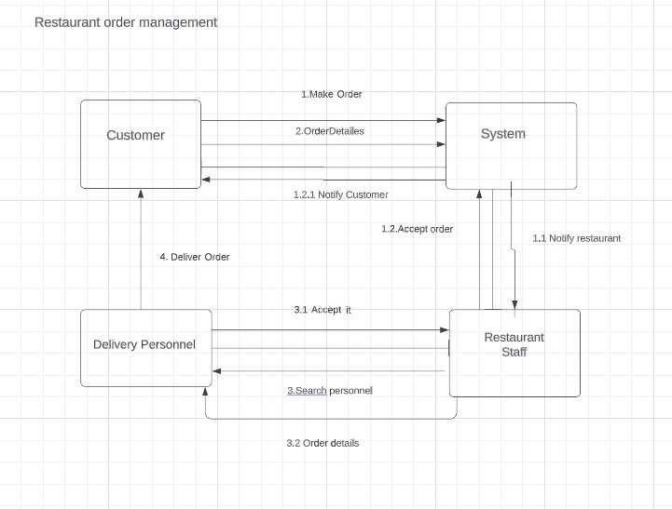

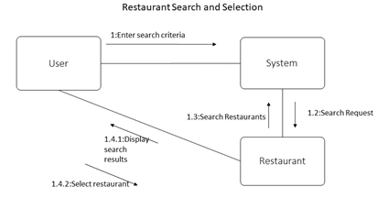

**4.10 Class Diagram**

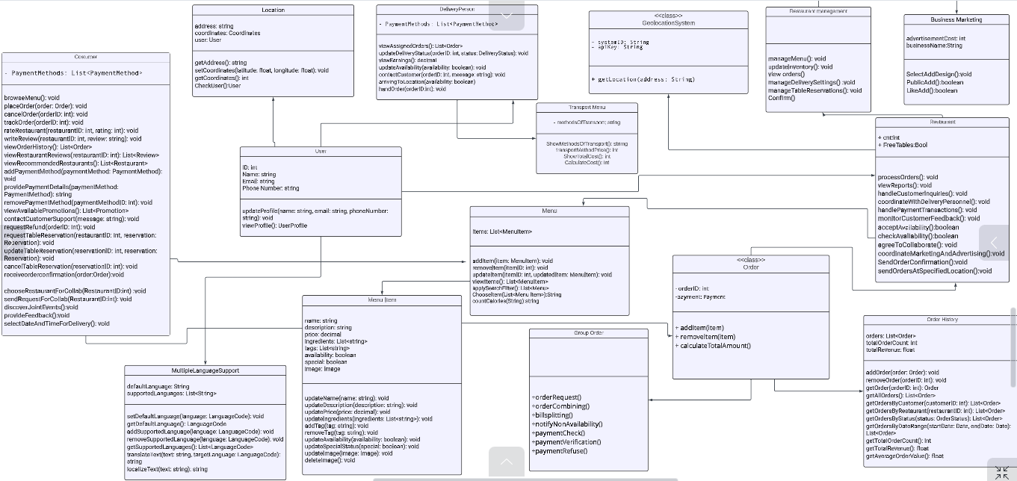**- General class diagram**

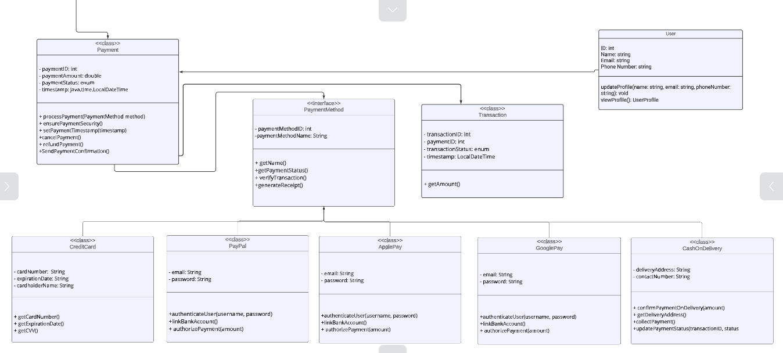 **-Derived class diagram 1**

**- Derived class diagram 2**

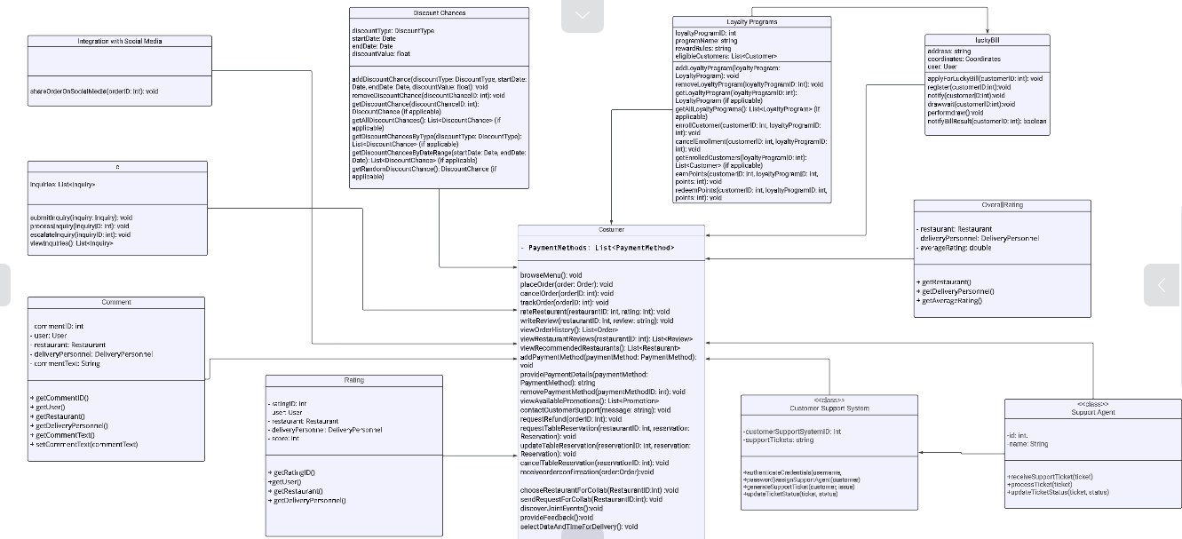

**5.Design-Patterns**

**Creational Design Patterns:**

1. FACTORY METHOD: This pattern provides an interface for creating objects, but lets subclasses decide which class to instantiate. It encapsulates object creation logic, allowing the client code to work with an abstract interface.
2. ABSTRACT FACTORY: This pattern provides an interface for creating families of related or dependent objects without specifying their concrete classes. It encapsulates a group of factory methods and allows clients to create objects without specifying their concrete types.
3. PROTOTYPE: This pattern involves creating a new object by cloning an existing one. It allows you to create new objects without explicitly specifying their classes, providing a way to create objects based on existing ones.
4. SINGLETON: This pattern ensures that a class has only one instance and provides a global point of access to that instance. It is commonly used for managing resources that should have a single instance throughout the application.
5. BUILDER: This pattern separates the construction of a complex object from its representation, allowing the same construction process to create different representations. It provides a step-by-step approach to construct objects.

**Behavioral Design Patterns:**

1. OBSERVER: This pattern defines a one-to-many dependency between objects, so that when one object changes its state, all its dependents are notified and updated automatically. It establishes a loosely coupled relationship between objects.
2. STATE: This pattern allows an object to alter its behavior when its internal state changes. It encapsulates the state-specific behavior into separate classes, making it easier to add new states without modifying existing code.

**Structural Design Patterns:**

1. ADAPTER: This pattern converts the interface of a class into another interface that clients expect. It allows incompatible classes to work together by providing a common interface.
2. BRIDGE: This pattern decouples an abstraction from its implementation, allowing both to vary independently. It separates the abstraction and implementation hierarchies, making them easier to modify and extend.
3. DECORATOR: This pattern dynamically adds or modifies the behavior of an object at runtime without affecting other instances of the same class. It provides a flexible alternative to subclassing for extending functionality.

**1.Strategy pattern**

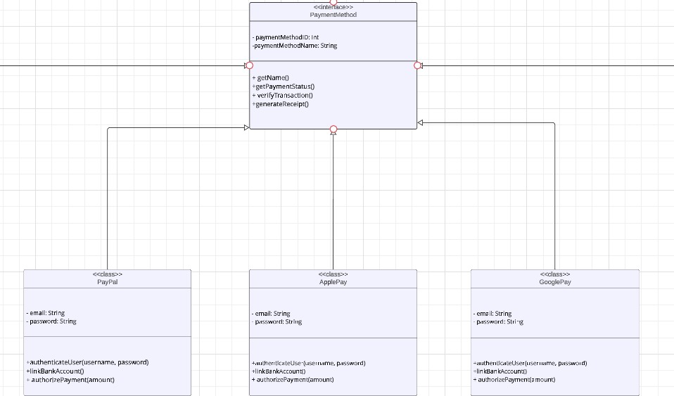

**2.**

**2.Decorator pattern**

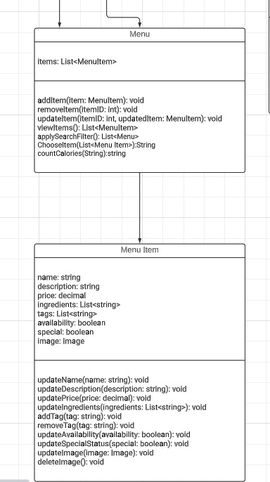

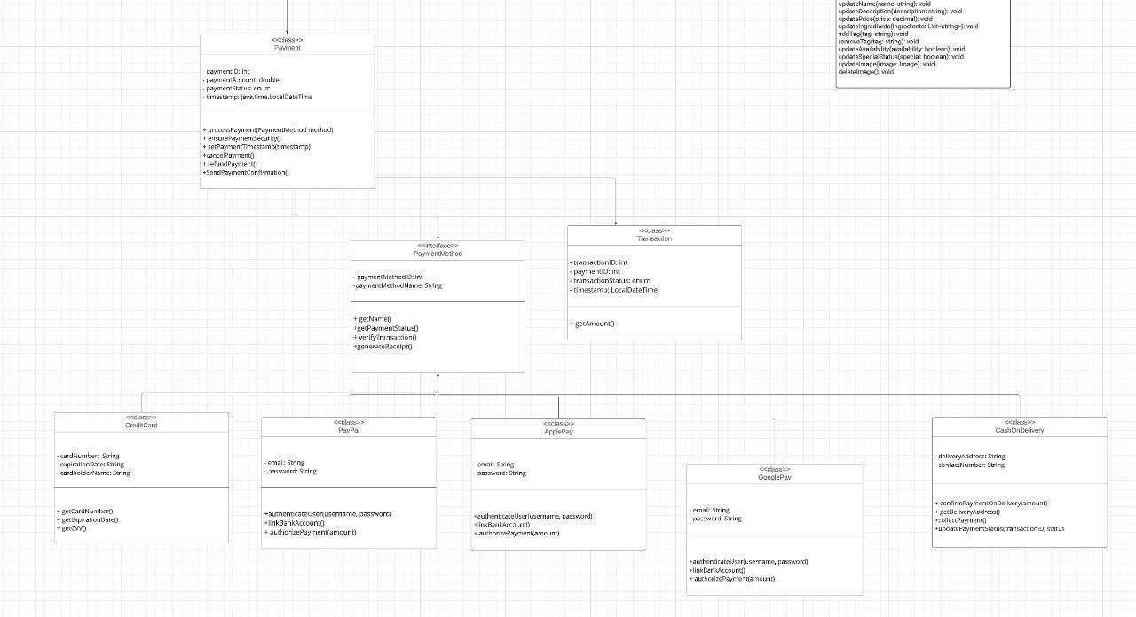**3. Chain of responsibility pattern**

4. Singleton Pattern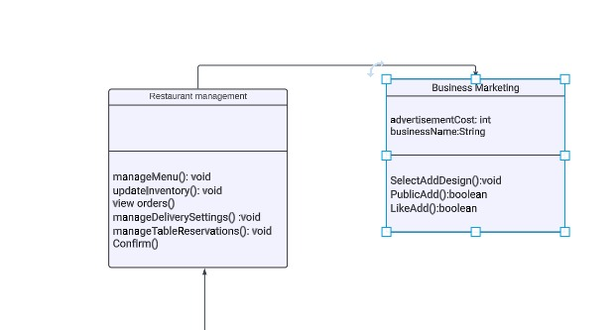

5. Order class facilitates

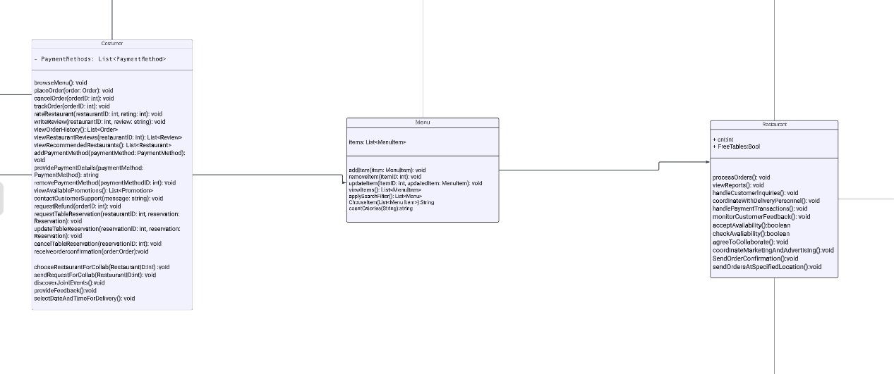

**4. State pattern**